LINEAR REGRESSION

Model Representation

To establish notation for future use, we’ll use x^{(i)}*x*(*i*) to denote the “input” variables (living area in this example), also called input features, and y^{(i)}*y*(*i*) to denote the “output” or target variable that we are trying to predict (price). A pair (x^{(i)} , y^{(i)} )(*x*(*i*),*y*(*i*)) is called a training example, and the dataset that we’ll be using to learn—a list of m training examples (*x*(*i*),*y*(*i*));*i*=1,...,*m*—is called a training set. Note that the superscript “(i)” in the notation is simply an index into the training set, and has nothing to do with exponentiation. We will also use X to denote the space of input values, and Y to denote the space of output values. In this example, X = Y = ℝ.

Cost Function

We can measure the accuracy of our hypothesis function by using a **cost function**. This takes an average difference (actually a fancier version of an average) of all the results of the hypothesis with inputs from x's and the actual output y's.

*J*(*θ*0,*θ*1)=12*m*∑*i*=1*m*(*y*^*i*−*yi*)2=12*m*∑*i*=1*m*(*hθ*(*xi*)−*yi*)2

To break it apart, it is \frac{1}{2}21​ *x*¯ where *x*¯ is the mean of the squares of h_\theta (x_{i}) - y_{i}*hθ*​(*xi*​)−*yi*​ , or the difference between the predicted value and the actual value.

This function is otherwise called the "Squared error function", or "Mean squared error". The mean is halved \left(\frac{1}{2}\right)(21​) as a convenience for the computation of the gradient descent, as the derivative term of the square function will cancel out the \frac{1}{2}21​term. The following image summarizes what the cost function does:



Cost Function - Intuition I

If we try to think of it in visual terms, our training data set is scattered on the x-y plane. We are trying to make a straight line (defined by h_\theta(x)*hθ*​(*x*)) which passes through these scattered data points.

Our objective is to get the best possible line. The best possible line will be such so that the average squared vertical distances of the scattered points from the line will be the least. Ideally, the line should pass through all the points of our training data set. In such a case, the value of J(\theta_0, \theta_1)*J*(*θ*0​,*θ*1​) will be 0. The following example shows the ideal situation where we have a cost function of 0.



When \theta_1 = 1*θ*1​=1, we get a slope of 1 which goes through every single data point in our model. Conversely, when \theta_1 = 0.5*θ*1​=0.5, we see the vertical distance from our fit to the data points increase.



This increases our cost function to 0.58. Plotting several other points yields to the following graph:



Thus as a goal, we should try to minimize the cost function. In this case, \theta_1 = 1*θ*1​=1 is our global minimum.

Cost Function - Intuition II

A contour plot is a graph that contains many contour lines. A contour line of a two variable function has a constant value at all points of the same line. An example of such a graph is the one to the right below.



Taking any color and going along the 'circle', one would expect to get the same value of the cost function. For example, the three green points found on the green line above have the same value for J(\theta_0,\theta_1)*J*(*θ*0​,*θ*1​) and as a result, they are found along the same line. The circled x displays the value of the cost function for the graph on the left when \theta_0*θ*0​ = 800 and \theta_1*θ*1​= -0.15. Taking another h(x) and plotting its contour plot, one gets the following graphs:



When \theta_0*θ*0​ = 360 and \theta_1*θ*1​ = 0, the value of J(\theta_0,\theta_1)*J*(*θ*0​,*θ*1​) in the contour plot gets closer to the center thus reducing the cost function error. Now giving our hypothesis function a slightly positive slope results in a better fit of the data.



The graph above minimizes the cost function as much as possible and consequently, the result of \theta_1*θ*1​ and \theta_0*θ*0​ tend to be around 0.12 and 250 respectively. Plotting those values on our graph to the right seems to put our point in the center of the inner most 'circle'.

Gradient Descent

So we have our hypothesis function and we have a way of measuring how well it fits into the data. Now we need to estimate the parameters in the hypothesis function. That's where gradient descent comes in.

Imagine that we graph our hypothesis function based on its fields \theta_0*θ*0​ and \theta_1*θ*1​ (actually we are graphing the cost function as a function of the parameter estimates). We are not graphing x and y itself, but the parameter range of our hypothesis function and the cost resulting from selecting a particular set of parameters.

We put \theta_0*θ*0​ on the x axis and \theta_1*θ*1​ on the y axis, with the cost function on the vertical z axis. The points on our graph will be the result of the cost function using our hypothesis with those specific theta parameters. The graph below depicts such a setup.



We will know that we have succeeded when our cost function is at the very bottom of the pits in our graph, i.e. when its value is the minimum. The red arrows show the minimum points in the graph.

The way we do this is by taking the derivative (the tangential line to a function) of our cost function. The slope of the tangent is the derivative at that point and it will give us a direction to move towards. We make steps down the cost function in the direction with the steepest descent. The size of each step is determined by the parameter α, which is called the learning rate.

For example, the distance between each 'star' in the graph above represents a step determined by our parameter α. A smaller α would result in a smaller step and a larger α results in a larger step. The direction in which the step is taken is determined by the partial derivative of J(\theta_0,\theta_1)*J*(*θ*0​,*θ*1​). Depending on where one starts on the graph, one could end up at different points. The image above shows us two different starting points that end up in two different places.

The gradient descent algorithm is:

repeat until convergence:

*θj*:=*θj*−*α*∂∂*θjJ*(*θ*0,*θ*1)

where

j=0,1 represents the feature index number.

At each iteration j, one should simultaneously update the parameters \theta_1, \theta_2,...,\theta_n*θ*1​,*θ*2​,...,*θn*​. Updating a specific parameter prior to calculating another one on the j^{(th)}*j*(*th*) iteration would yield to a wrong implementation.



# Gradient Descent Intuition

In this video we explored the scenario where we used one parameter \theta_1*θ*1​ and plotted its cost function to implement a gradient descent. Our formula for a single parameter was :

Repeat until convergence:

|  |
| --- |
| \theta_1:=\theta_1-\alpha \frac{d}{d\theta_1} J(\theta_1)*θ*1​:=*θ*1​−*αdθ*1​*d*​*J*(*θ*1​) |

Regardless of the slope's sign for \frac{d}{d\theta_1} J(\theta_1)*dθ*1​*d*​*J*(*θ*1​), \theta_1*θ*1​ eventually converges to its minimum value. The following graph shows that when the slope is negative, the value of \theta_1*θ*1​ increases and when it is positive, the value of \theta_1*θ*1​ decreases.



On a side note, we should adjust our parameter \alpha*α* to ensure that the gradient descent algorithm converges in a reasonable time. Failure to converge or too much time to obtain the minimum value imply that our step size is wrong.



### **How does gradient descent converge with a fixed step size \alpha*α*?**

The intuition behind the convergence is that \frac{d}{d\theta_1} J(\theta_1)*dθ*1​*d*​*J*(*θ*1​) approaches 0 as we approach the bottom of our convex function. At the minimum, the derivative will always be 0 and thus we get:

|  |
| --- |
| \theta_1:=\theta_1-\alpha * 0*θ*1​:=*θ*1​−*α*∗0 |



Gradient Descent For Linear Regression

**Note:** [At 6:15 "h(x) = -900 - 0.1x" should be "h(x) = 900 - 0.1x"]

When specifically applied to the case of linear regression, a new form of the gradient descent equation can be derived. We can substitute our actual cost function and our actual hypothesis function and modify the equation to :

|  |
| --- |
| repeat until convergence: {*θ*0:=*θ*1:=}*θ*0−*α*1*m*∑*i*=1*m*(*hθ*(*xi*)−*yi*)*θ*1−*α*1*m*∑*i*=1*m*((*hθ*(*xi*)−*yi*)*xi*) |

where m is the size of the training set, \theta_0*θ*0​ a constant that will be changing simultaneously with \theta_1*θ*1​ and x_{i}, y_{i}*xi*​,*yi*​are values of the given training set (data).

Note that we have separated out the two cases for \theta_j*θj*​ into separate equations for \theta_0*θ*0​ and \theta_1*θ*1​; and that for \theta_1*θ*1​ we are multiplying x_{i}*xi*​at the end due to the derivative. The following is a derivation of ∂∂*θjJ*(*θ*) for a single example :

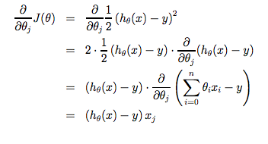

The point of all this is that if we start with a guess for our hypothesis and then repeatedly apply these gradient descent equations, our hypothesis will become more and more accurate.

So, this is simply gradient descent on the original cost function J. This method looks at every example in the entire training set on every step, and is called **batch gradient descent**. Note that, while gradient descent can be susceptible to local minima in general, the optimization problem we have posed here for linear regression has only one global, and no other local, optima; thus gradient descent always converges (assuming the learning rate α is not too large) to the global minimum. Indeed, J is a convex quadratic function. Here is an example of gradient descent as it is run to minimize a quadratic function.



The ellipses shown above are the contours of a quadratic function. Also shown is the trajectory taken by gradient descent, which was initialized at (48,30). The x’s in the figure (joined by straight lines) mark the successive values of θ that gradient descent went through as it converged to its minimum.

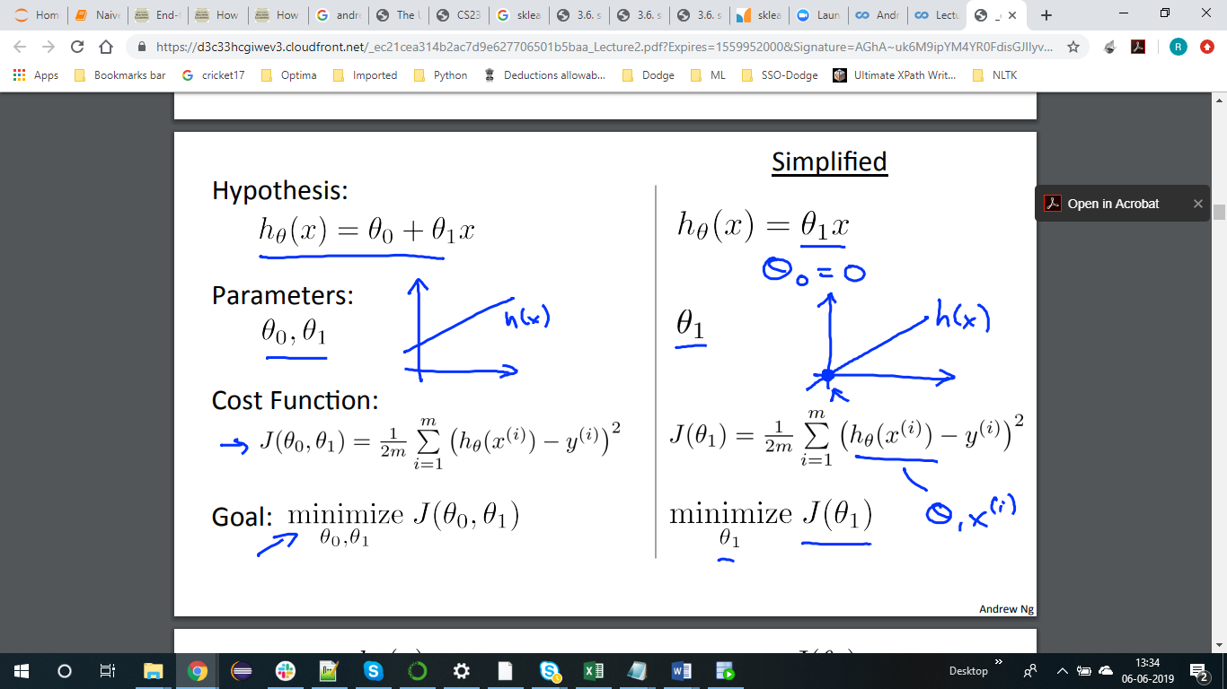

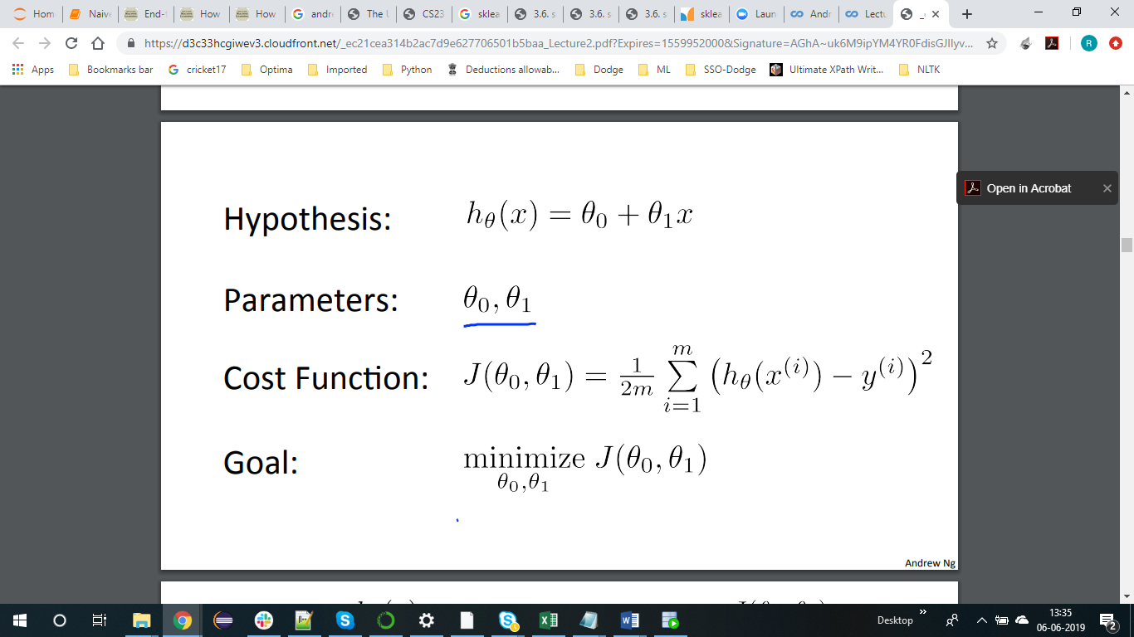

# Matrices and Vectors

Matrices are 2-dimensional arrays:

|  |
| --- |
| ⎡⎣⎢⎢⎢*adgjbehkcfil*⎤⎦⎥⎥⎥ |

The above matrix has four rows and three columns, so it is a 4 x 3 matrix.

A vector is a matrix with one column and many rows:

|  |
| --- |
| ⎡⎣⎢⎢*wxyz*⎤⎦⎥⎥ |

So vectors are a subset of matrices. The above vector is a 4 x 1 matrix.

**Notation and terms**:

* A_{ij}*Aij*​ refers to the element in the ith row and jth column of matrix A.
* A vector with 'n' rows is referred to as an 'n'-dimensional vector.
* v_i*vi*​ refers to the element in the ith row of the vector.
* In general, all our vectors and matrices will be 1-indexed. Note that for some programming languages, the arrays are 0-indexed.
* Matrices are usually denoted by uppercase names while vectors are lowercase.
* "Scalar" means that an object is a single value, not a vector or matrix.
* R refers to the set of scalar real numbers.
* Rn refers to the set of n-dimensional vectors of real numbers.

# Matrix-Vector Multiplication

We map the column of the vector onto each row of the matrix, multiplying each element and summing the result.

|  |
| --- |
| ⎡⎣*acebdf*⎤⎦∗[*xy*]=⎡⎣⎢*a*∗*x*+*b*∗*yc*∗*x*+*d*∗*ye*∗*x*+*f*∗*y*⎤⎦⎥ |

The result is a **vector**. The number of **columns** of the matrix must equal the number of **rows** of the vector.

An **m x n matrix** multiplied by an **n x 1 vector** results in an **m x 1 vector**.

# Matrix-Matrix Multiplication

We multiply two matrices by breaking it into several vector multiplications and concatenating the result.

|  |
| --- |
| ⎡⎣*acebdf*⎤⎦∗[*wyxz*]=⎡⎣⎢*a*∗*w*+*b*∗*yc*∗*w*+*d*∗*ye*∗*w*+*f*∗*ya*∗*x*+*b*∗*zc*∗*x*+*d*∗*ze*∗*x*+*f*∗*z*⎤⎦⎥ |

An **m x n matrix** multiplied by an **n x o matrix** results in an **m x o** matrix. In the above example, a 3 x 2 matrix times a 2 x 2 matrix resulted in a 3 x 2 matrix.

To multiply two matrices, the number of **columns** of the first matrix must equal the number of **rows** of the second matrix.

Matrix Multiplication Properties

* Matrices are not commutative: *A*∗*B*≠*B*∗*A*
* Matrices are associative: (*A*∗*B*)∗*C*=*A*∗(*B*∗*C*)

The **identity matrix**, when multiplied by any matrix of the same dimensions, results in the original matrix. It's just like multiplying numbers by 1. The identity matrix simply has 1's on the diagonal (upper left to lower right diagonal) and 0's elsewhere.

|  |
| --- |
| ⎡⎣100010001⎤⎦ |

When multiplying the identity matrix after some matrix (A∗I), the square identity matrix's dimension should match the other matrix's **columns**. When multiplying the identity matrix before some other matrix (I∗A), the square identity matrix's dimension should match the other matrix's **rows**.

# Inverse and Transpose

The **inverse** of a matrix A is denoted A^{-1}*A*−1. Multiplying by the inverse results in the identity matrix.

A non square matrix does not have an inverse matrix. We can compute inverses of matrices in octave with the pinv(A)*pinv*(*A*) function and in Matlab with the inv(A)*inv*(*A*) function. Matrices that don't have an inverse are singular or degenerate.

The **transposition** of a matrix is like rotating the matrix 90**°** in clockwise direction and then reversing it. We can compute transposition of matrices in matlab with the transpose(A) function or A':

|  |
| --- |
| *A*=⎡⎣*acebdf*⎤⎦ |

|  |
| --- |
| *AT*=[*abcdef*] |

In other words:

A_{ij} = A^T_{ji}*Aij*​=*AjiT*​  
---------

# 

# Multiple Features

**Note:** [7:25 - \theta^T*θT* is a 1 by (n+1) matrix and not an (n+1) by 1 matrix]

Linear regression with multiple variables is also known as "multivariate linear regression".

We now introduce notation for equations where we can have any number of input variables.

|  |
| --- |
| *x*(*i*)*j*  *x*(*i*)  *m*  *n*=value of feature *j* in the *ith* training example=the input (features) of the *ith* training example=the number of training examples=the number of features |

The multivariable form of the hypothesis function accommodating these multiple features is as follows:

*hθ*(*x*)=*θ*0+*θ*1*x*1+*θ*2*x*2+*θ*3*x*3+⋯+*θnxn*

In order to develop intuition about this function, we can think about \theta_0*θ*0​ as the basic price of a house, \theta_1*θ*1​ as the price per square meter, \theta_2*θ*2​ as the price per floor, etc. x_1*x*1​ will be the number of square meters in the house, x_2*x*2​ the number of floors, etc.

Using the definition of matrix multiplication, our multivariable hypothesis function can be concisely represented as:

|  |
| --- |
| *hθ*(*x*)=[*θ*0*θ*1...*θn*]⎡⎣⎢⎢⎢*x*0*x*1⋮*xn*⎤⎦⎥⎥⎥=*θTx* |

This is a vectorization of our hypothesis function for one training example; see the lessons on vectorization to learn more.

Remark: Note that for convenience reasons in this course we assume *x*(*i*)0=1 for (*i*∈1,…,*m*). This allows us to do matrix operations with theta and x. Hence making the two vectors '\theta*θ*' and x^{(i)}*x*(*i*) match each other element-wise (that is, have the same number of elements: n+1).]

# Gradient Descent For Multiple Variables

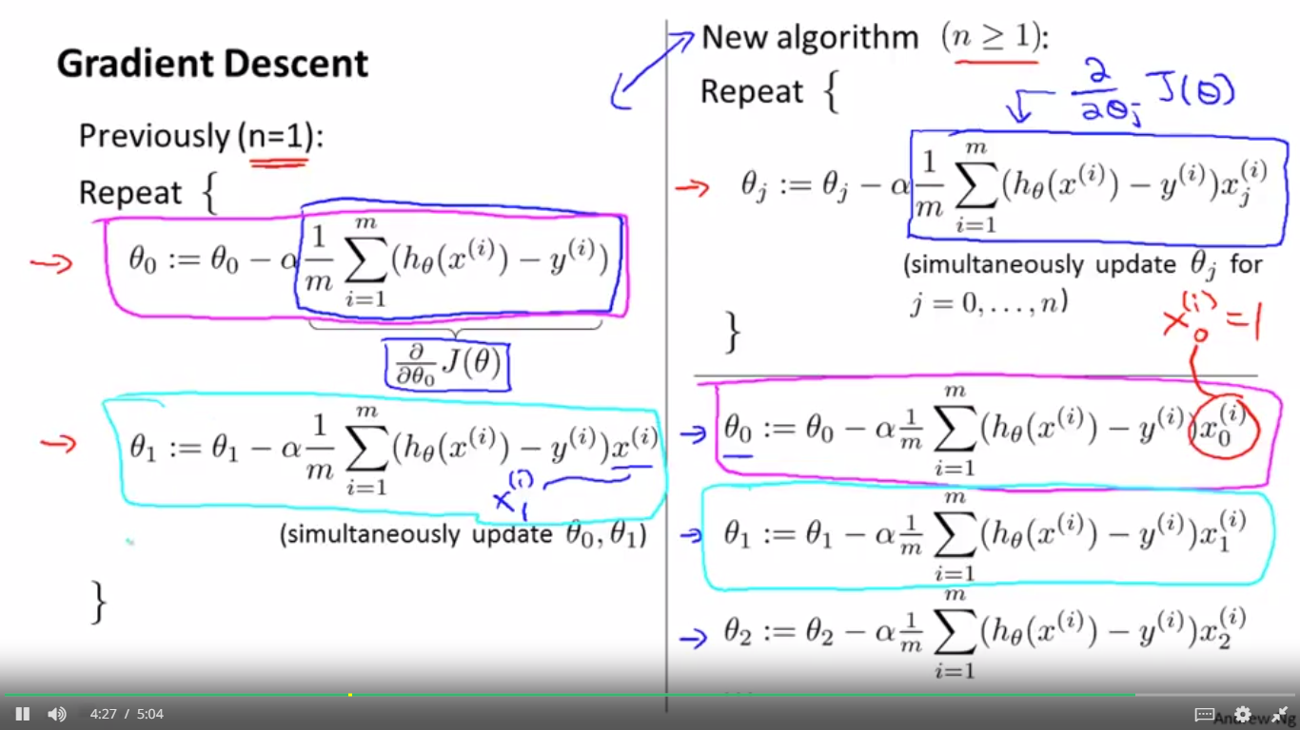

## **Gradient Descent for Multiple Variables**

The gradient descent equation itself is generally the same form; we just have to repeat it for our 'n' features:

|  |
| --- |
| }repeat until convergence:{*θ*0:=*θ*0−*α*1*m*∑*i*=1*m*(*hθ*(*x*(*i*))−*y*(*i*))⋅*x*(*i*)0*θ*1:=*θ*1−*α*1*m*∑*i*=1*m*(*hθ*(*x*(*i*))−*y*(*i*))⋅*x*(*i*)1*θ*2:=*θ*2−*α*1*m*∑*i*=1*m*(*hθ*(*x*(*i*))−*y*(*i*))⋅*x*(*i*)2⋯ |

In other words:

|  |
| --- |
| }repeat until convergence:{*θj*:=*θj*−*α*1*m*∑*i*=1*m*(*hθ*(*x*(*i*))−*y*(*i*))⋅*x*(*i*)*j*for j := 0...n |

The following image compares gradient descent with one variable to gradient descent with multiple variables:

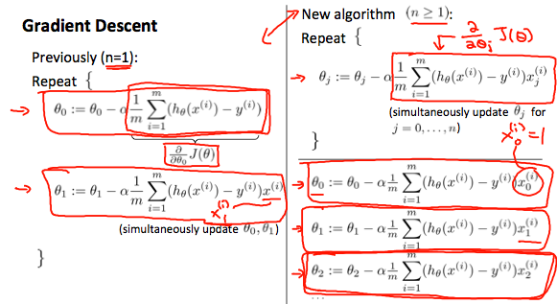

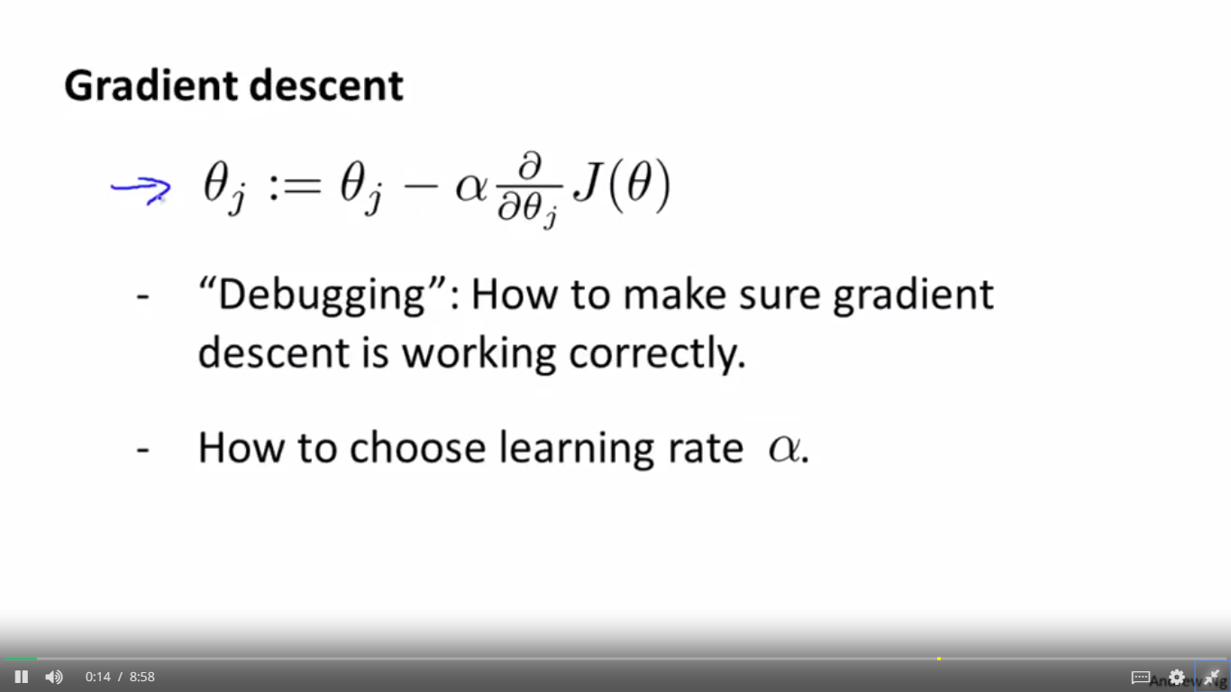

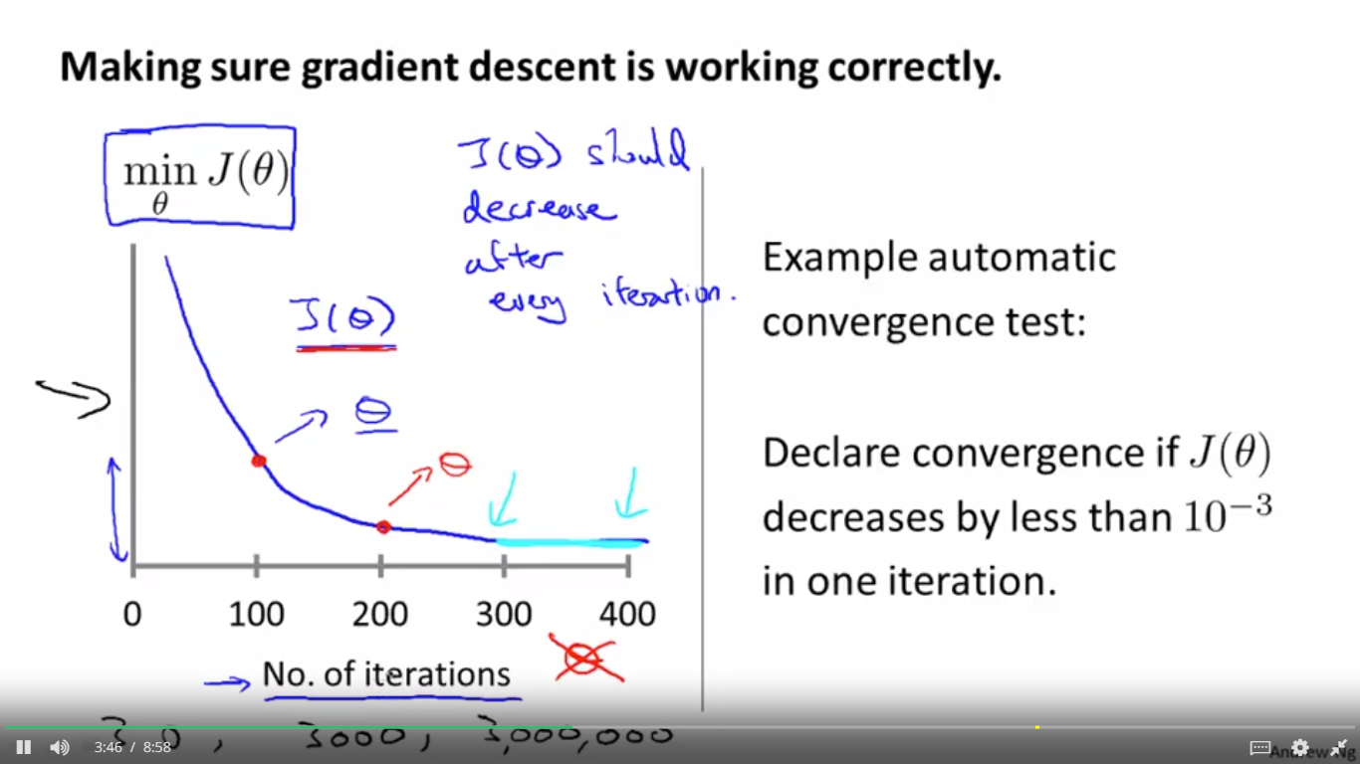

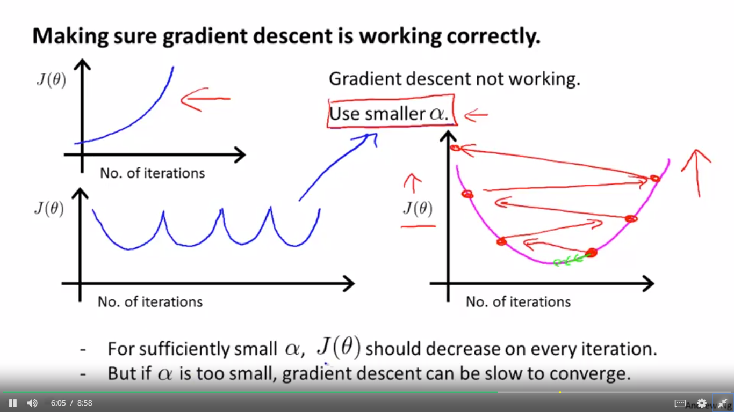

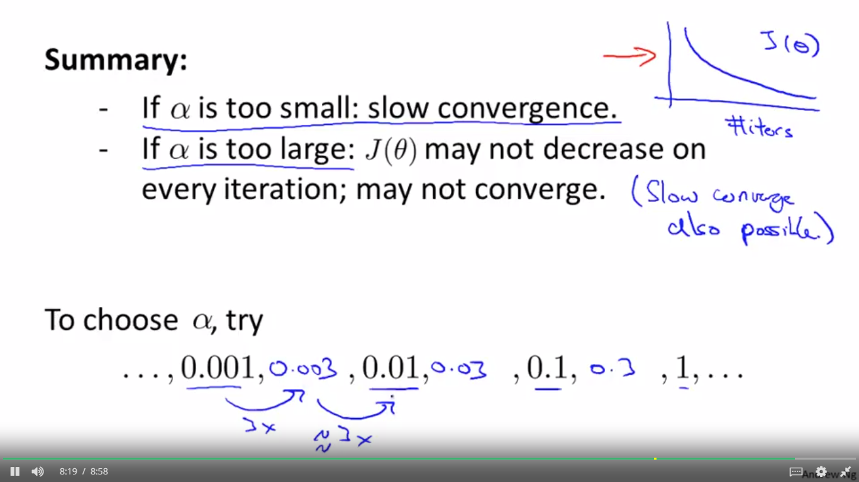

**Debugging gradient descent.** Make a plot with *number of iterations* on the x-axis. Now plot the cost function, J(θ) over the number of iterations of gradient descent. If J(θ) ever increases, then you probably need to decrease α.

**Automatic convergence test.** Declare convergence if J(θ) decreases by less than E in one iteration, where E is some small value such as 10−3. However in practice it's difficult to choose this threshold value.

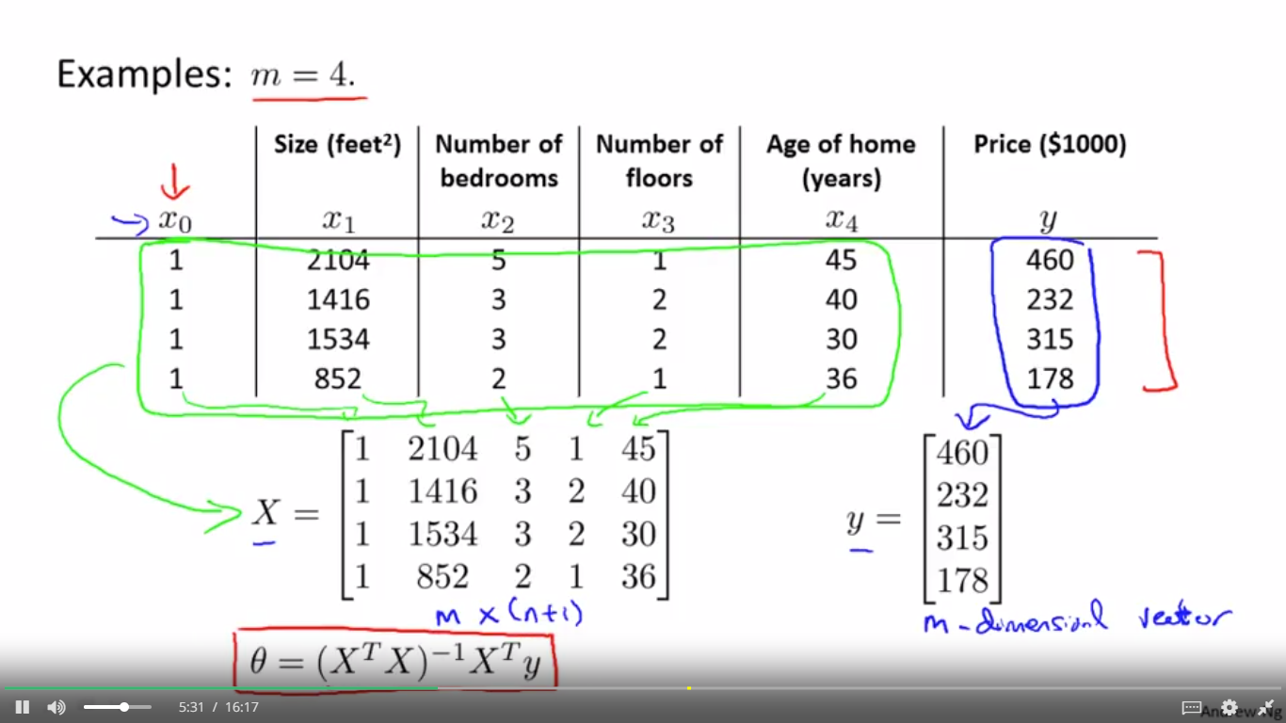

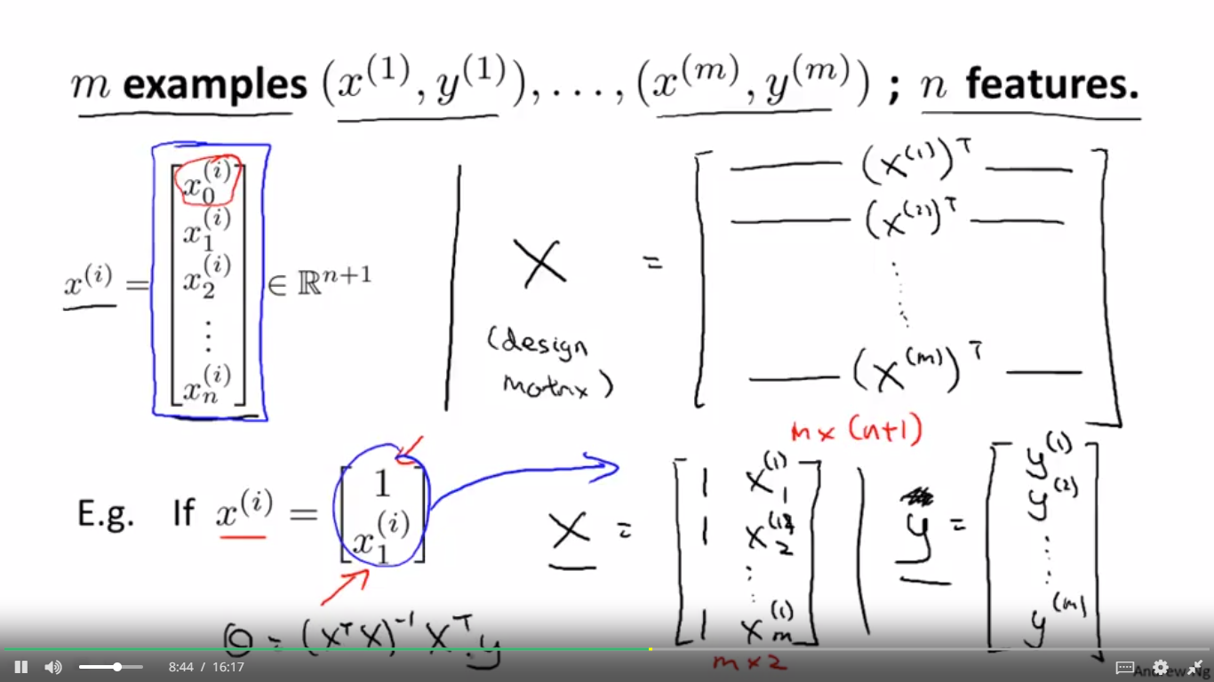

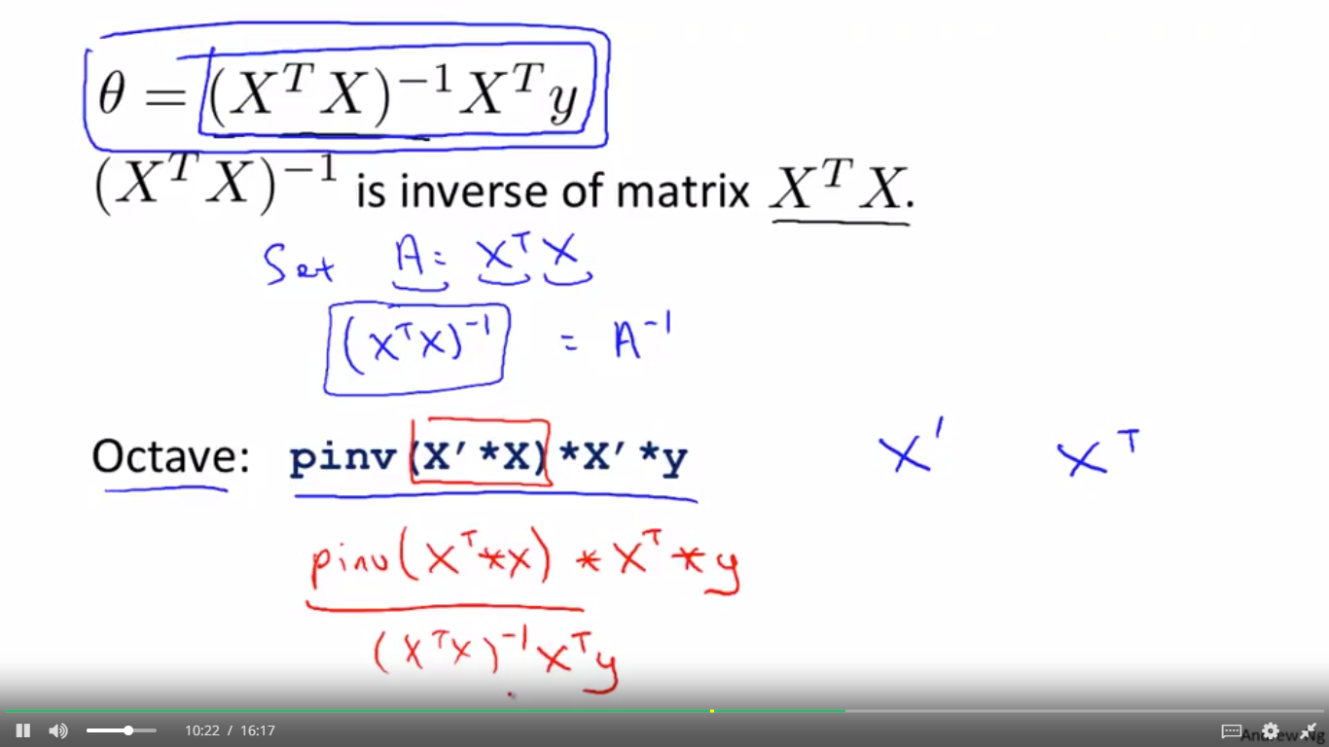

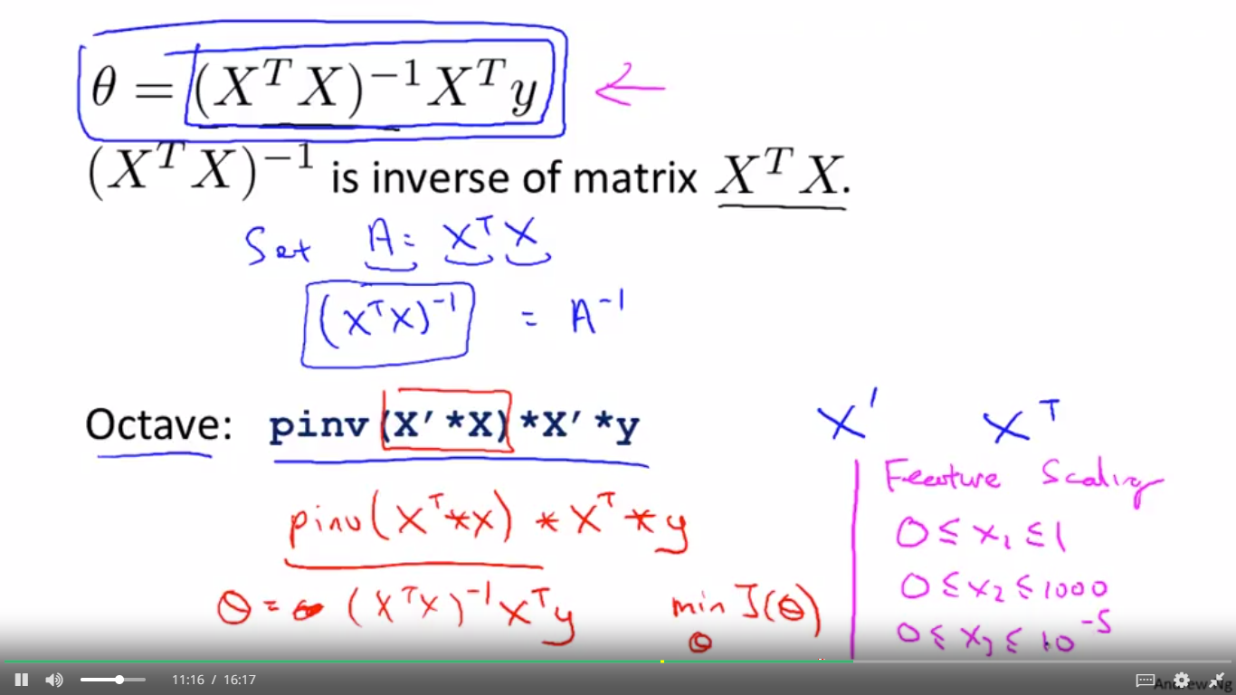

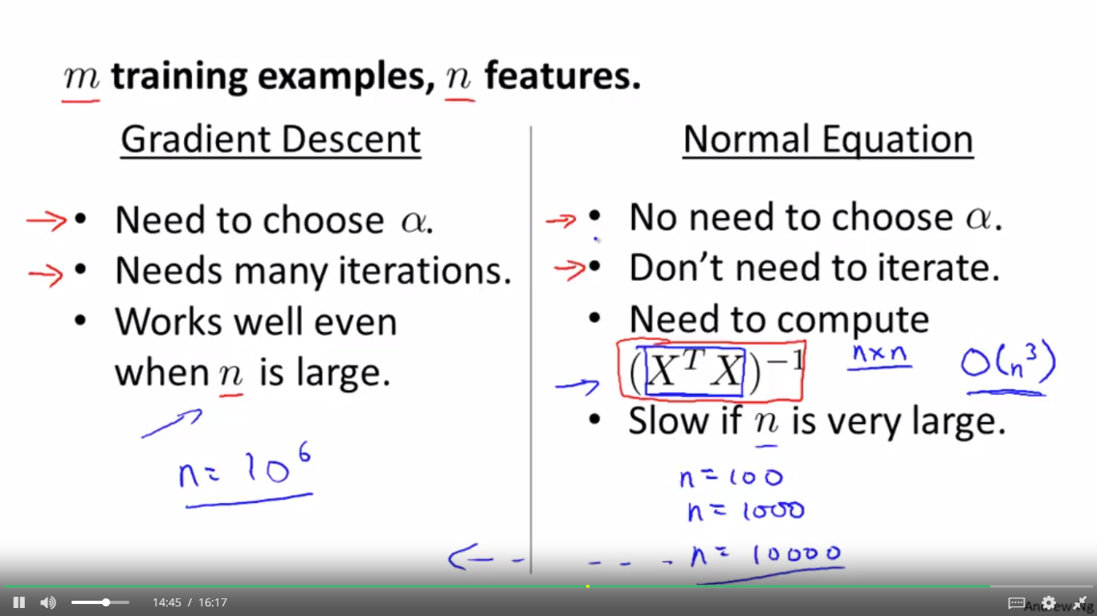

LOGISTIC REGRESSION

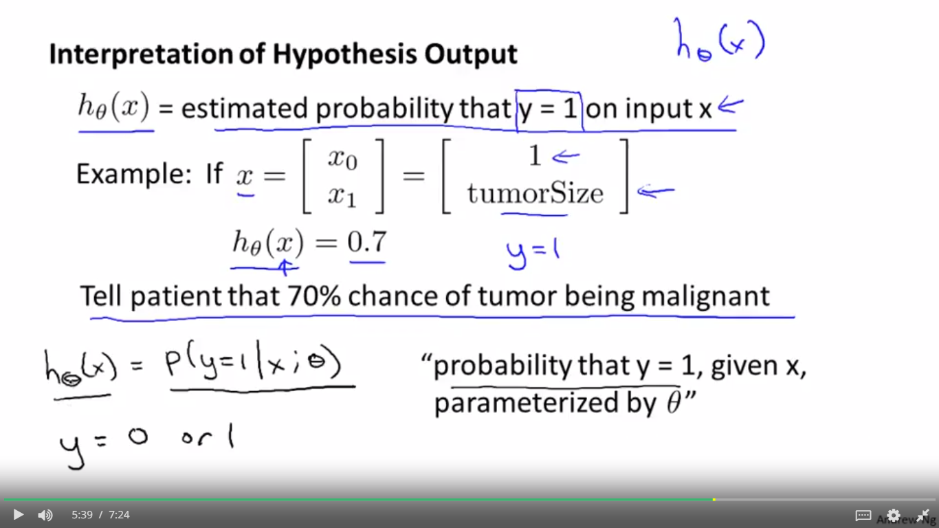



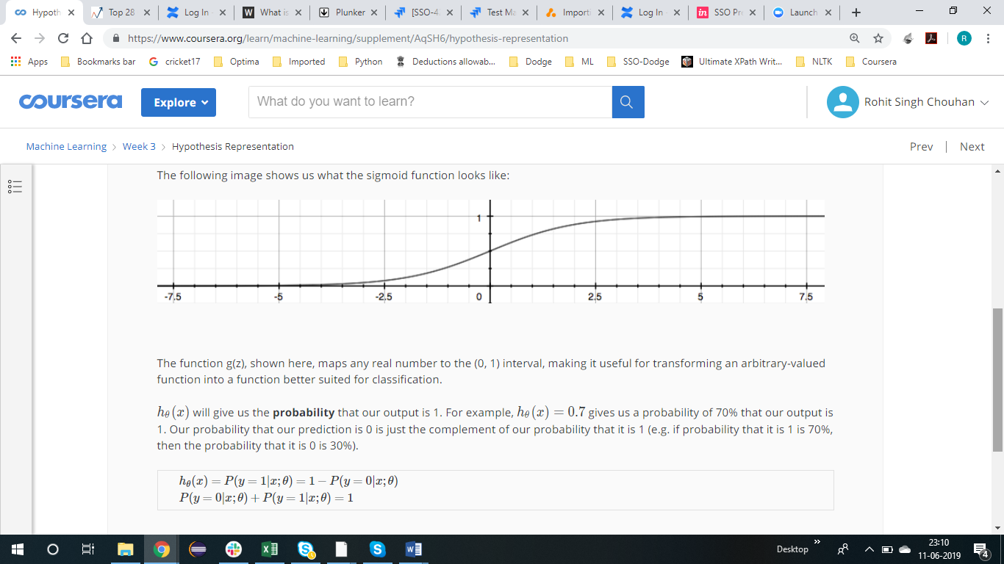 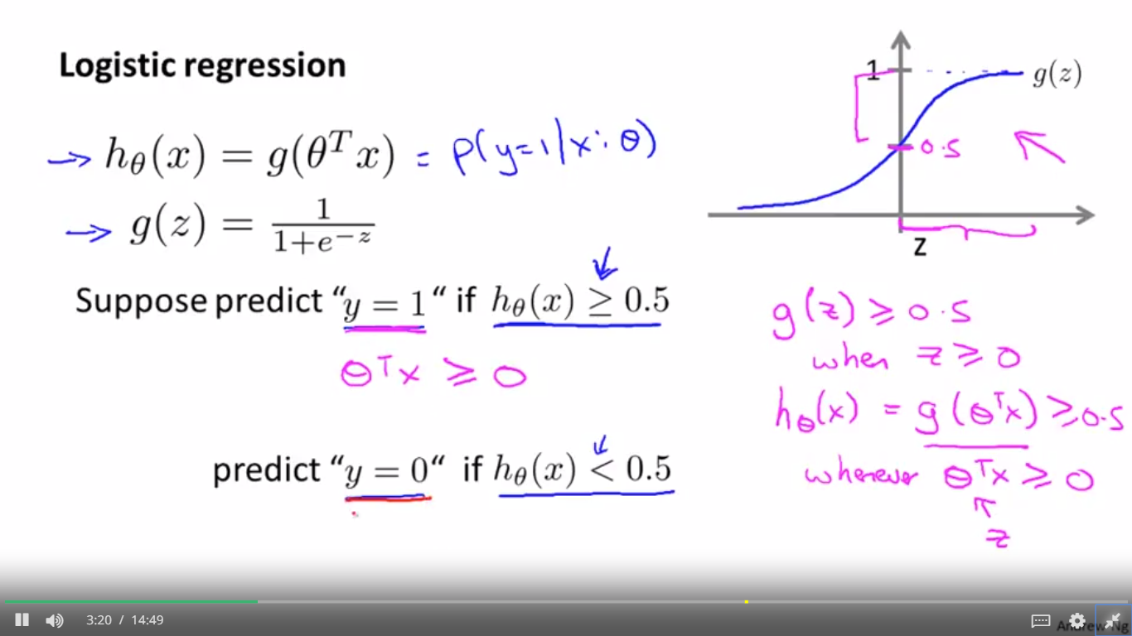

DECISION BOUNDRY

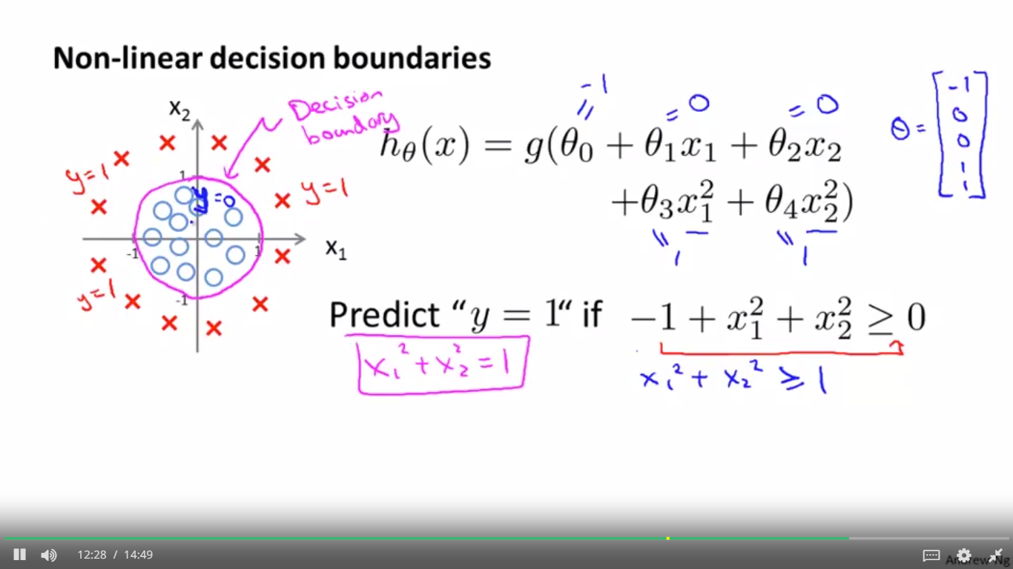 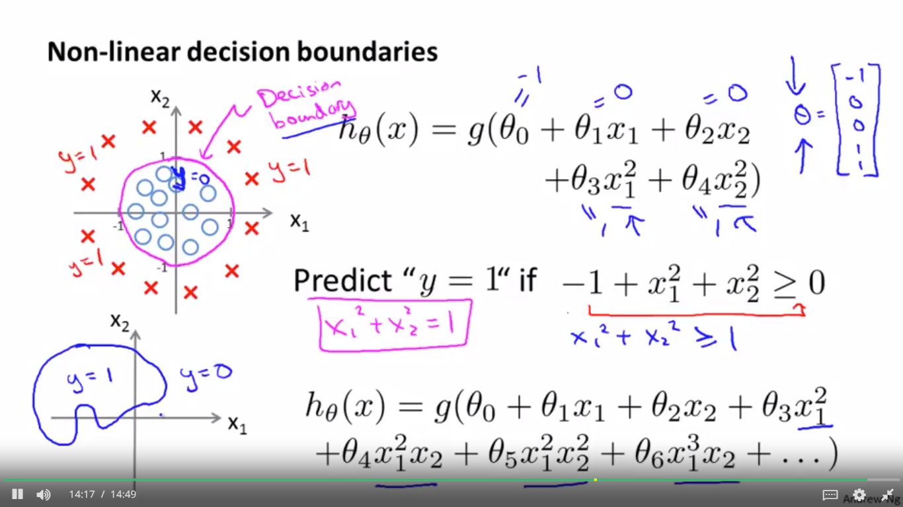 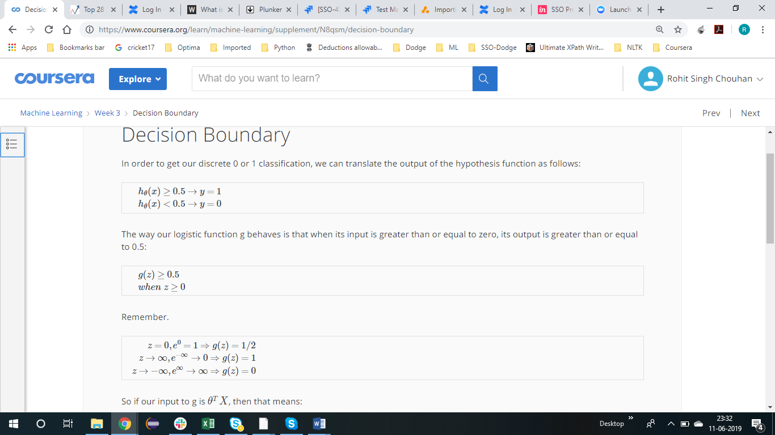  

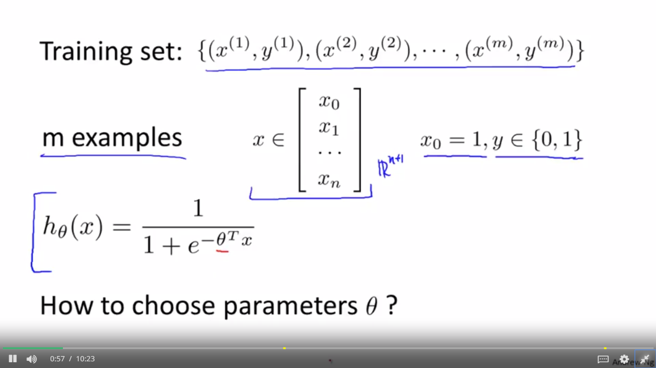 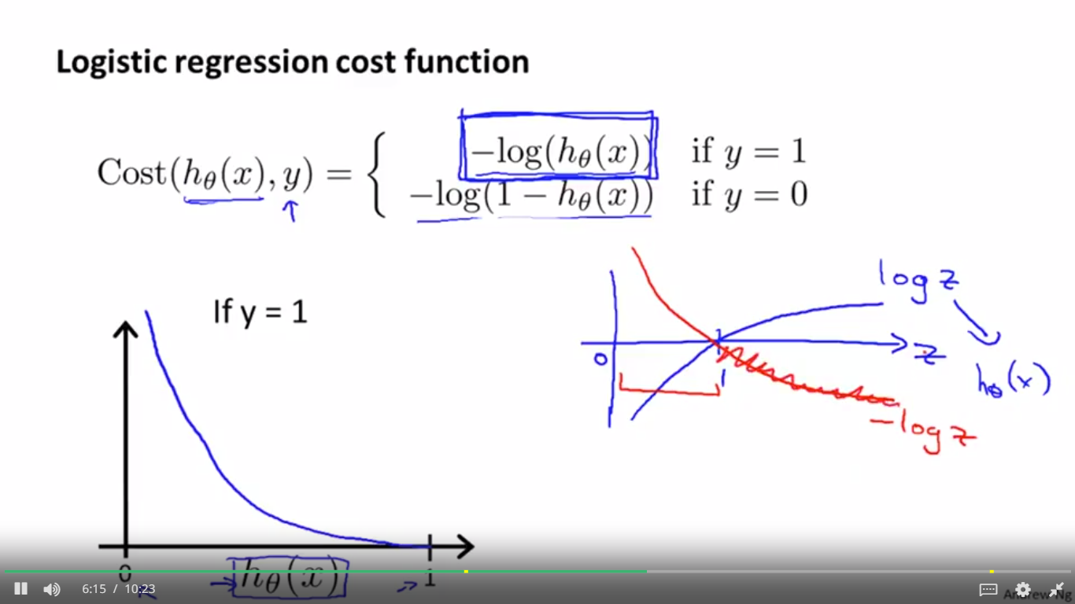 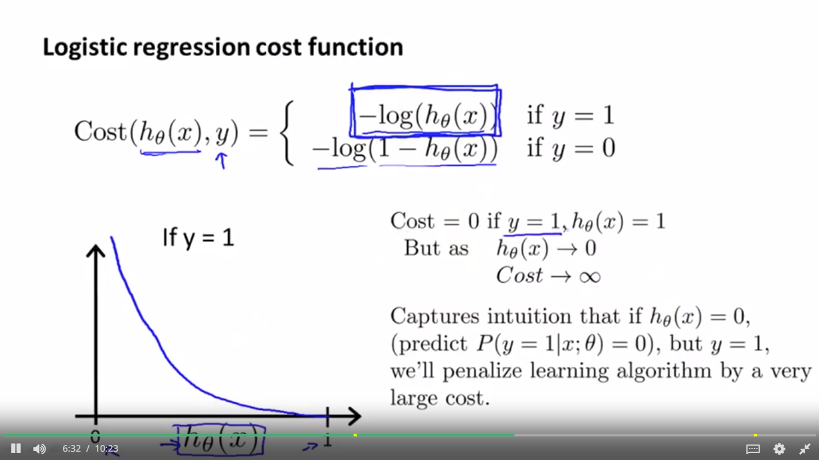 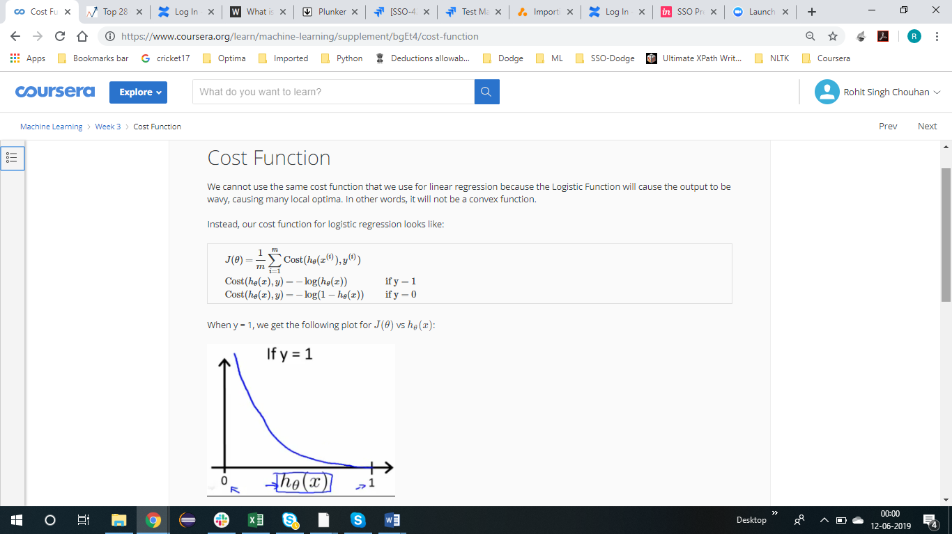 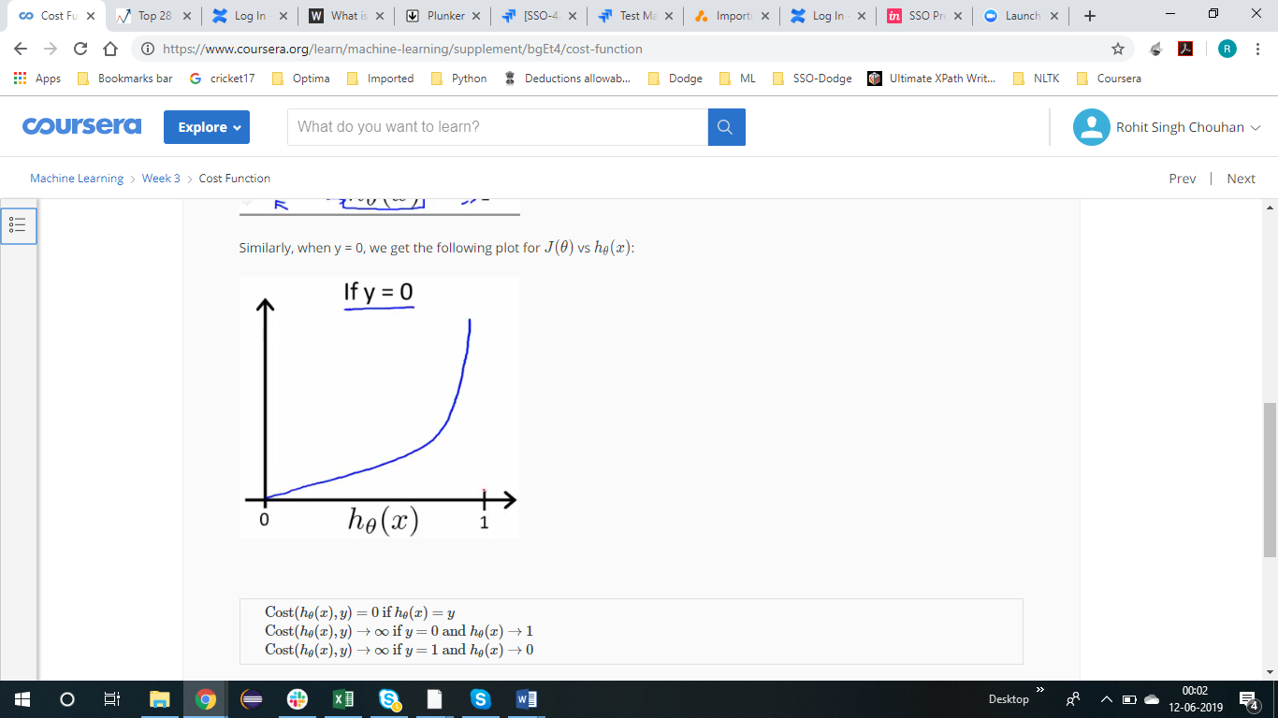 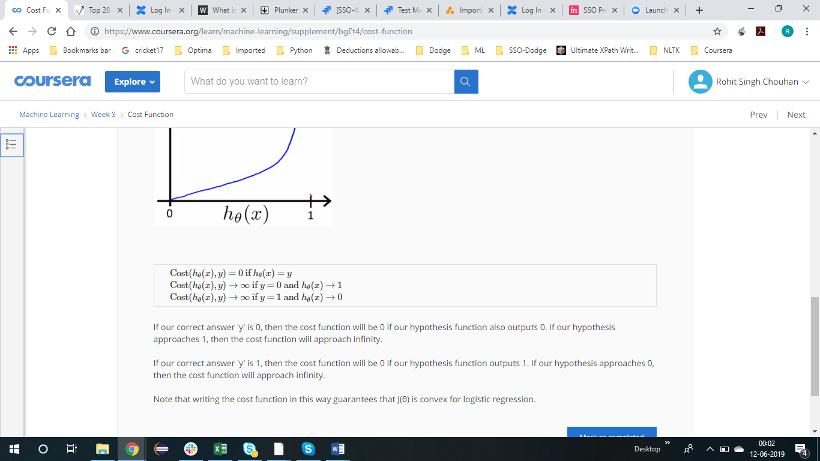

LOGISTIC REGRESSION COST FUNCTION

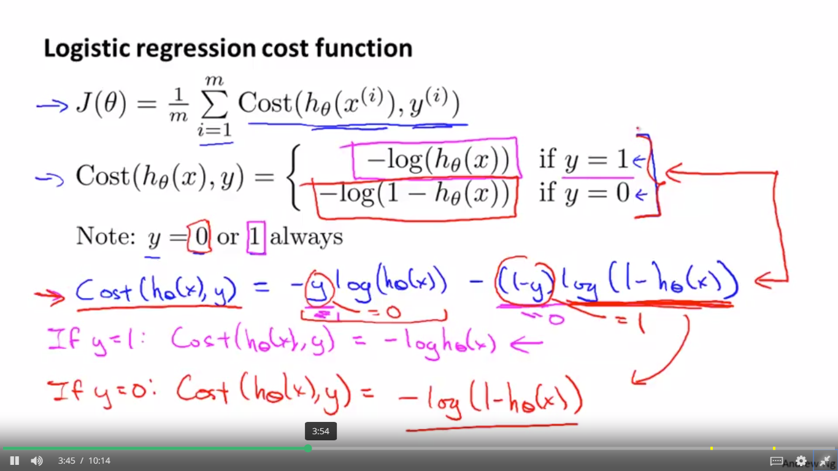

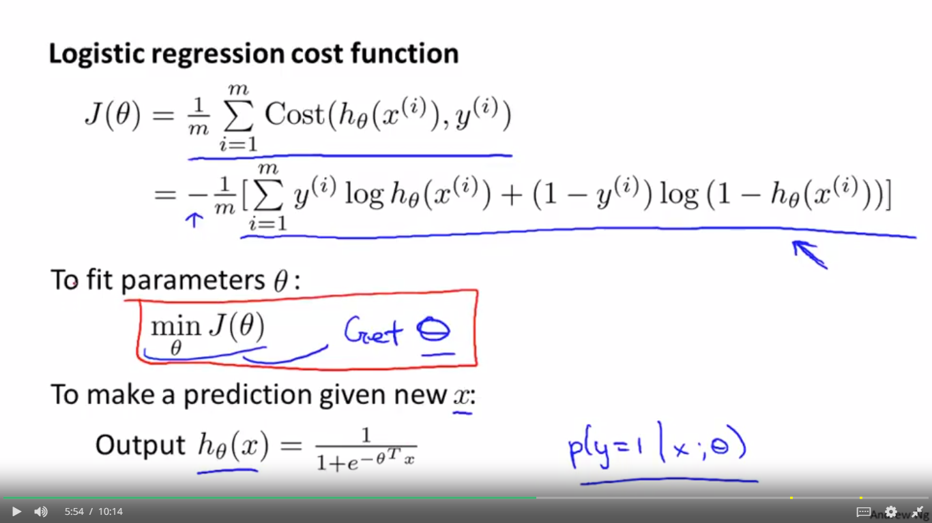

SIMPLIFIED COST FUNCTION AND GRADIENT DECENT

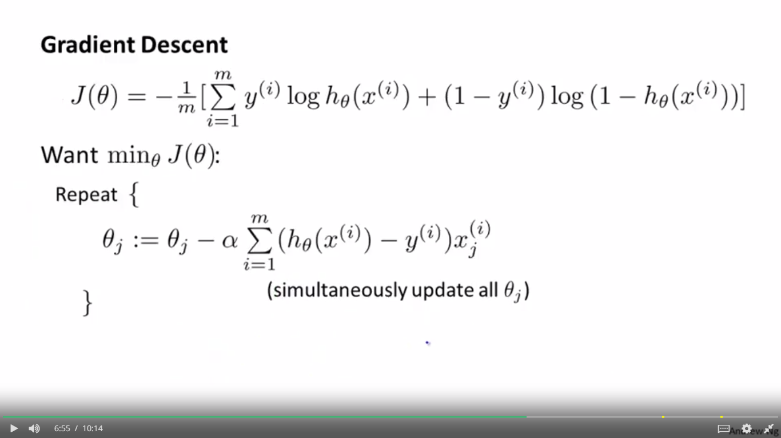

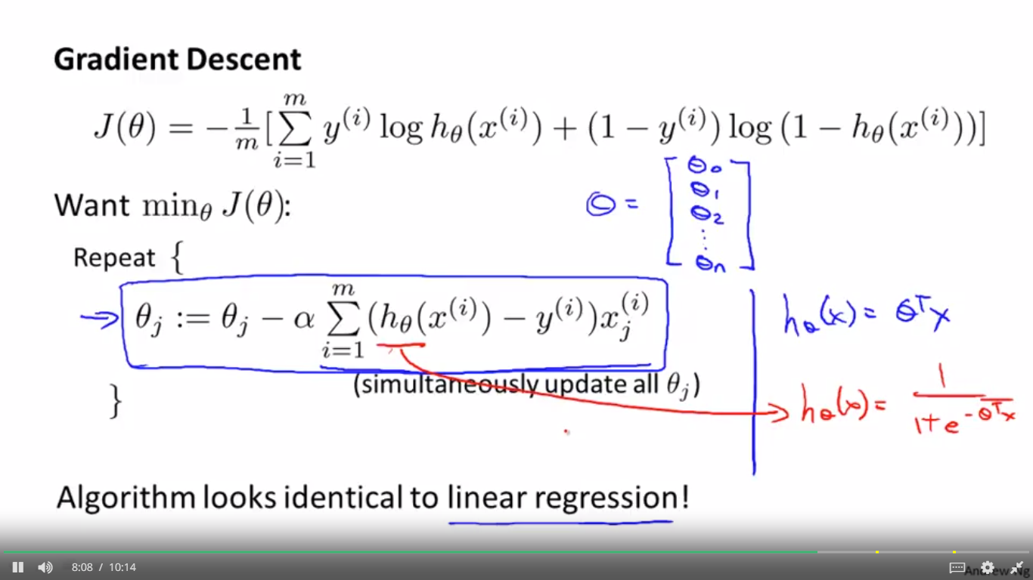

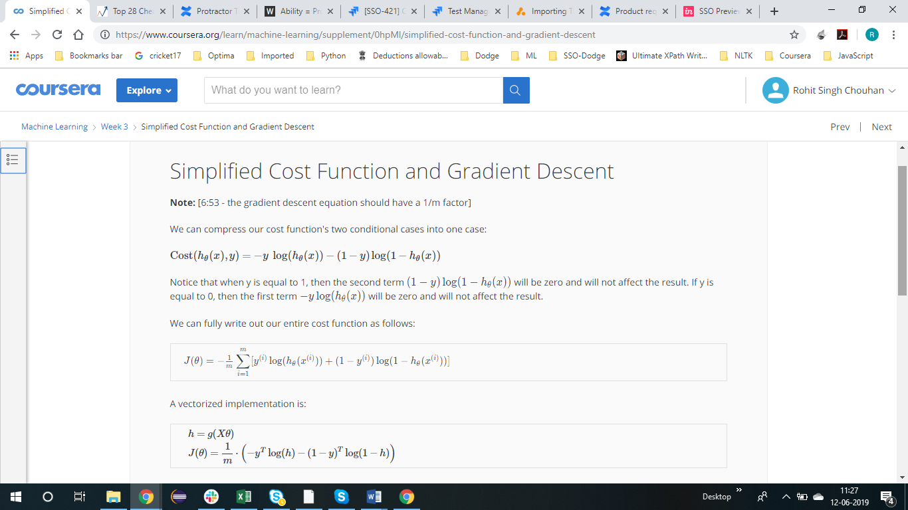 

ADVANCED OPTIMIZATION

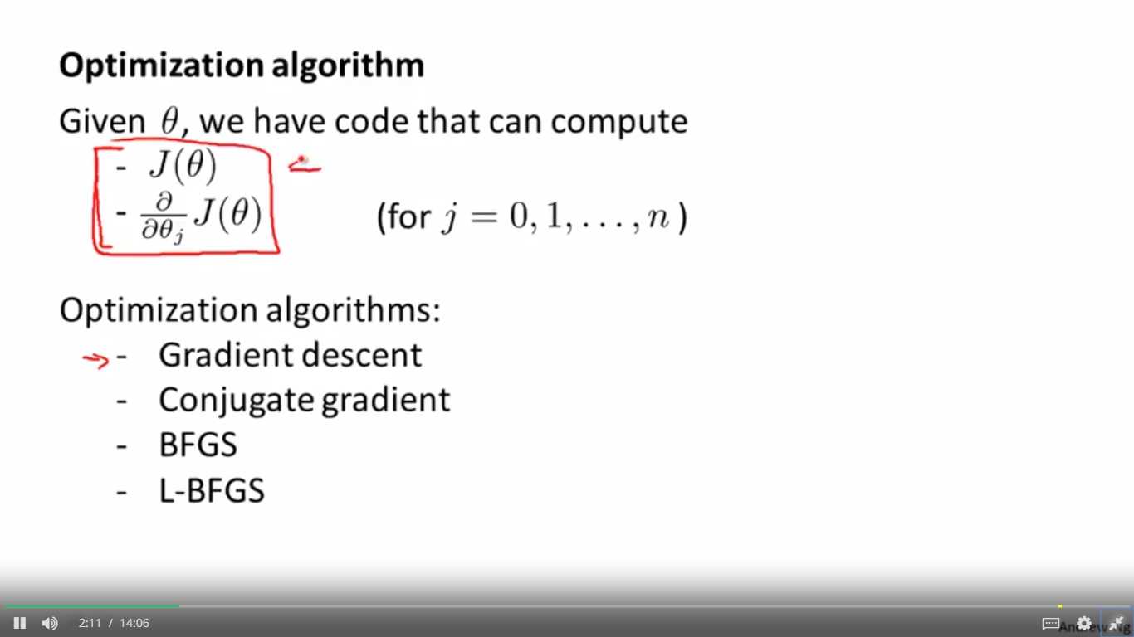

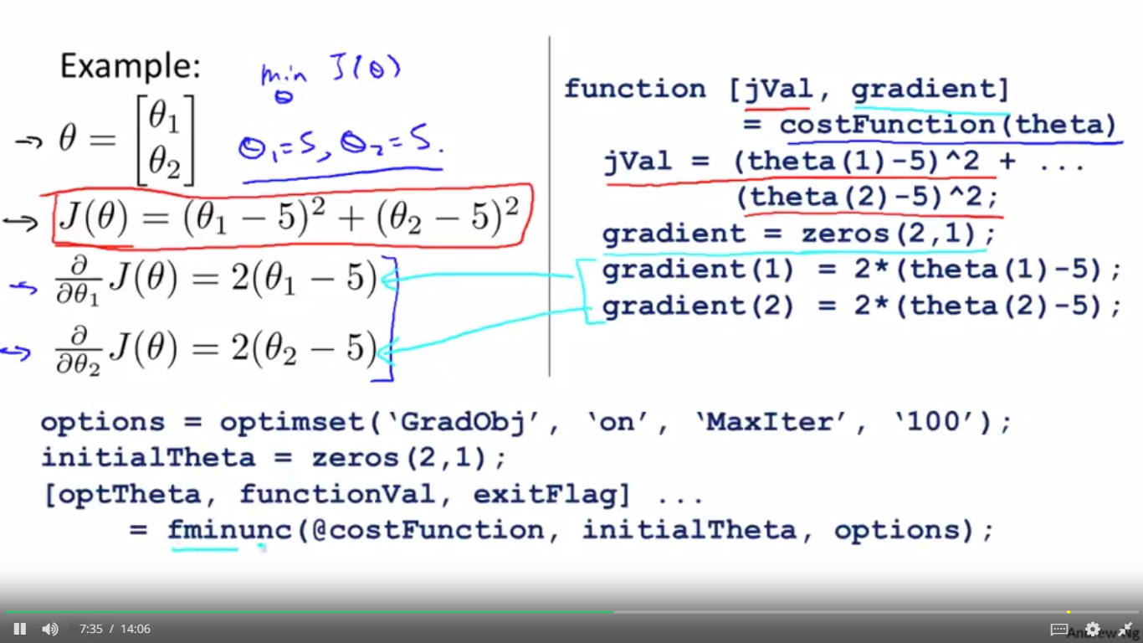

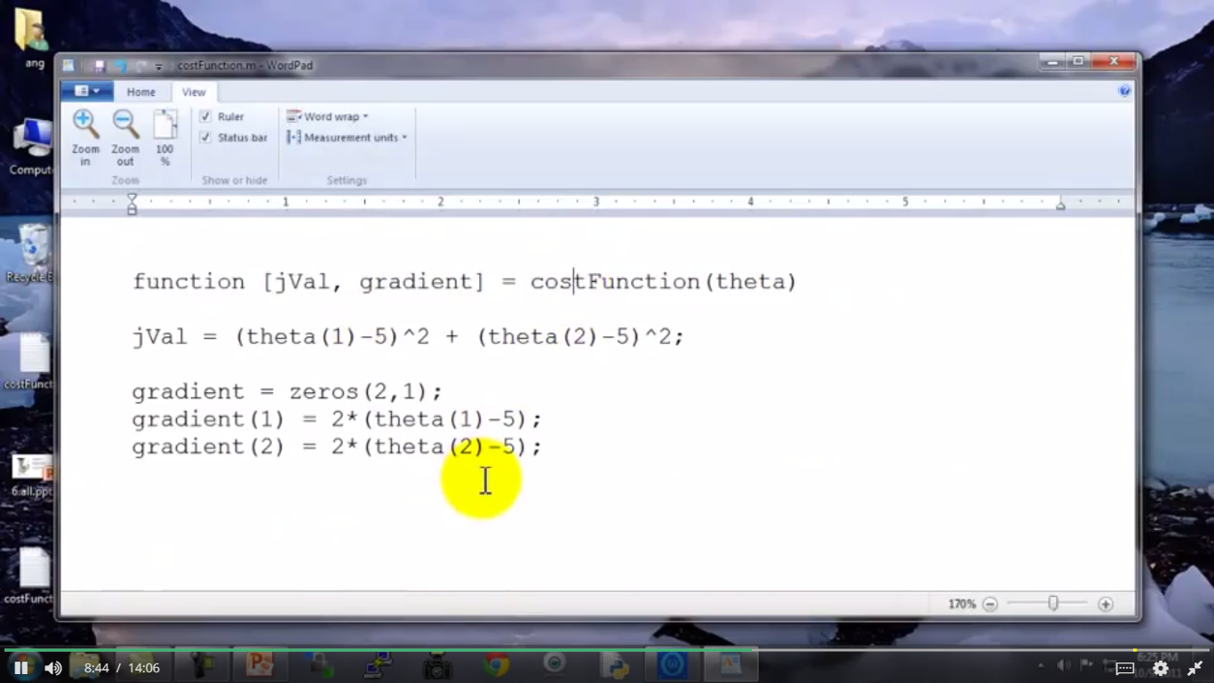

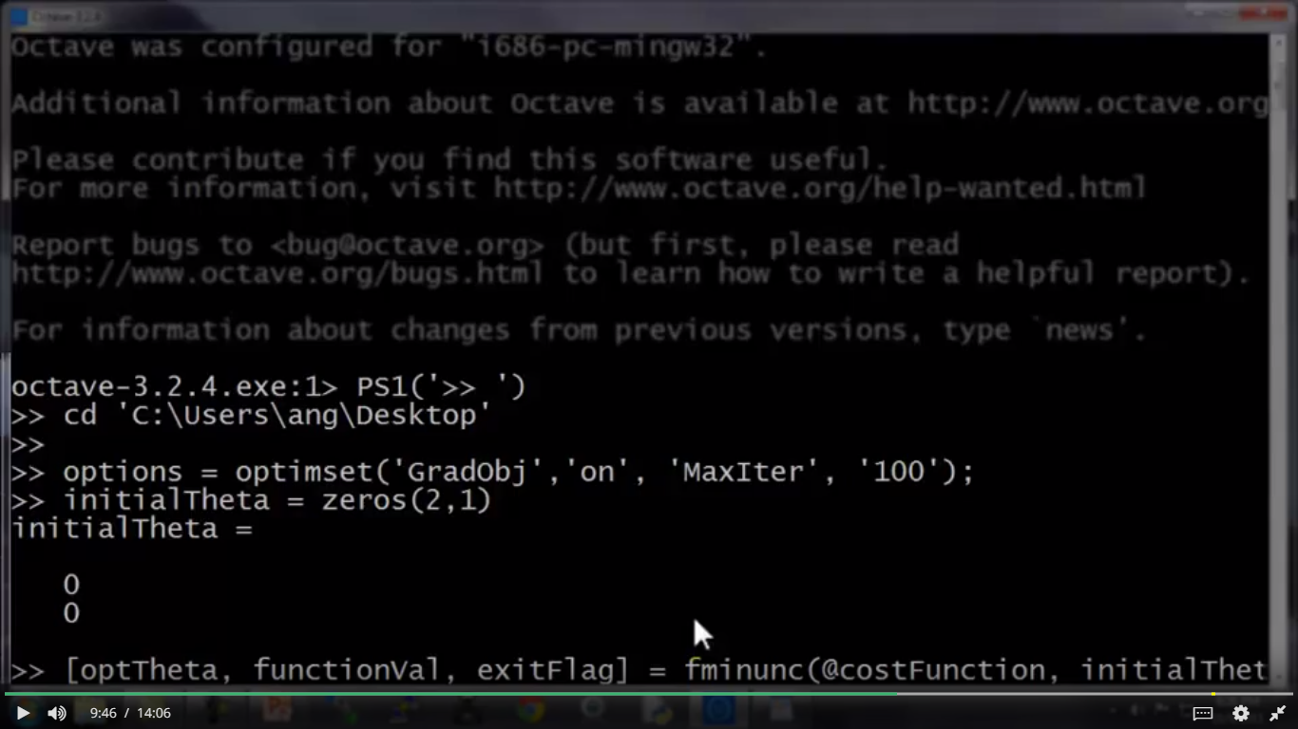

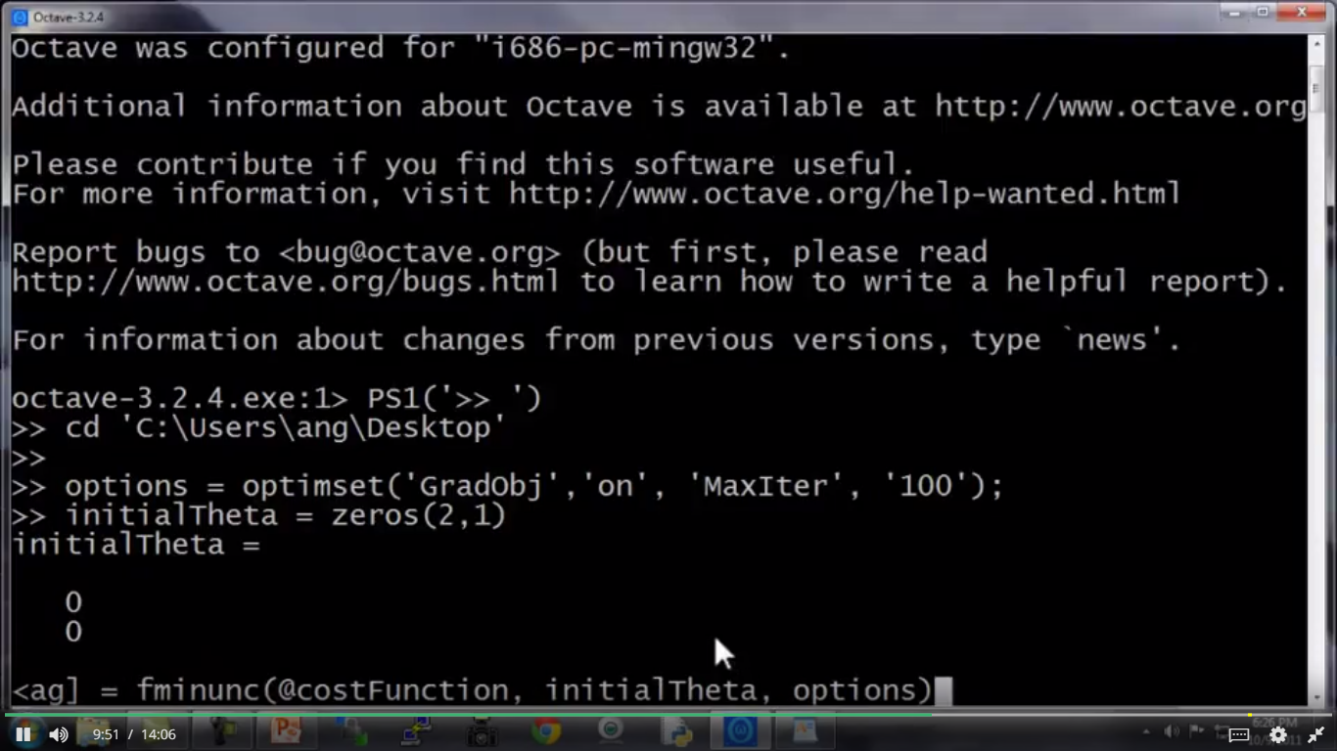

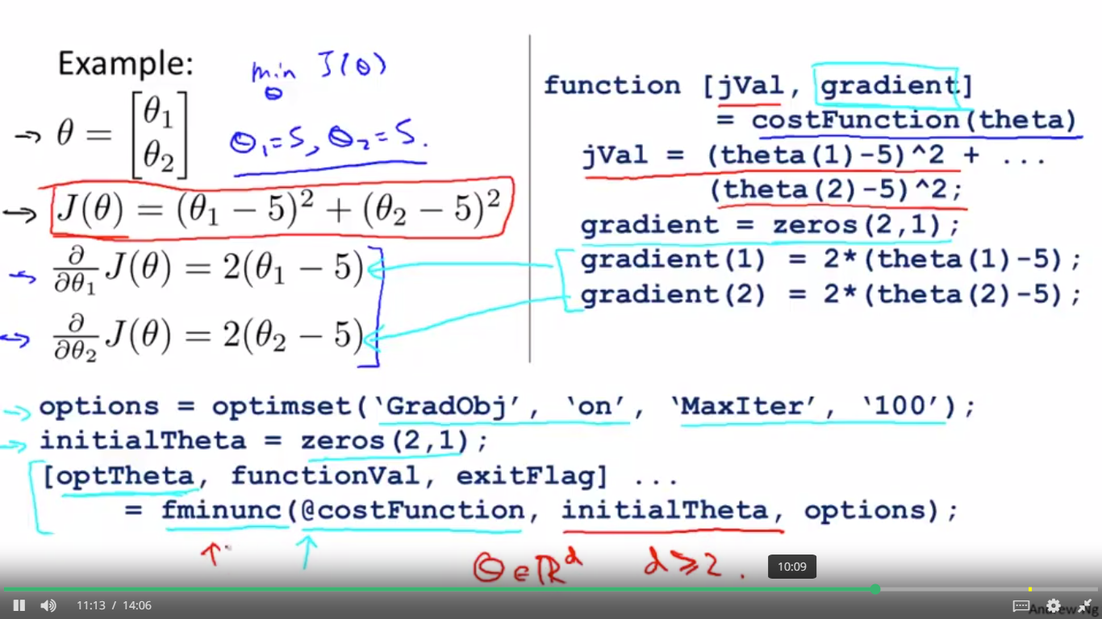

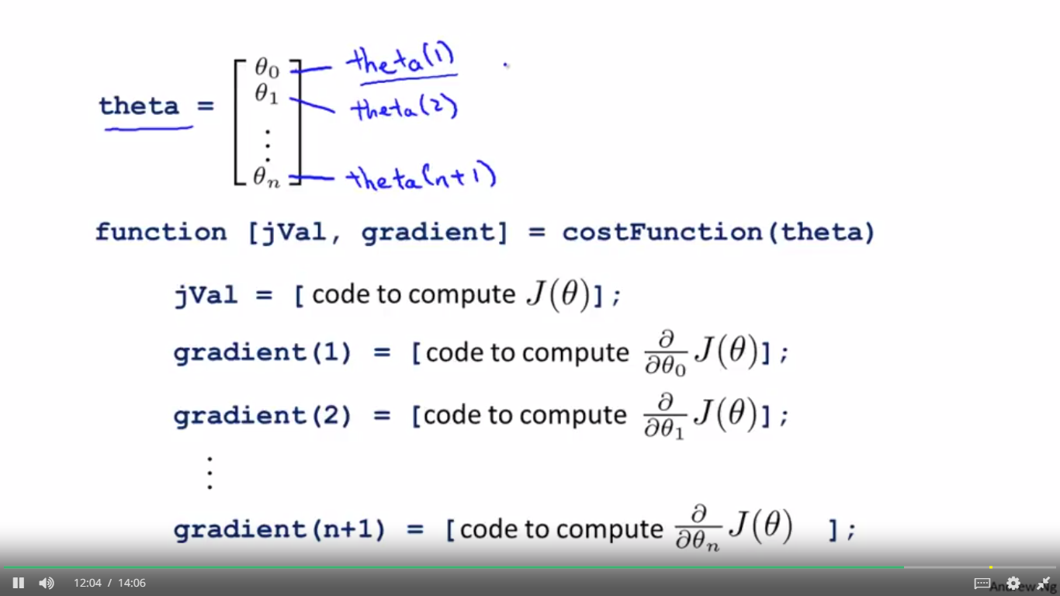

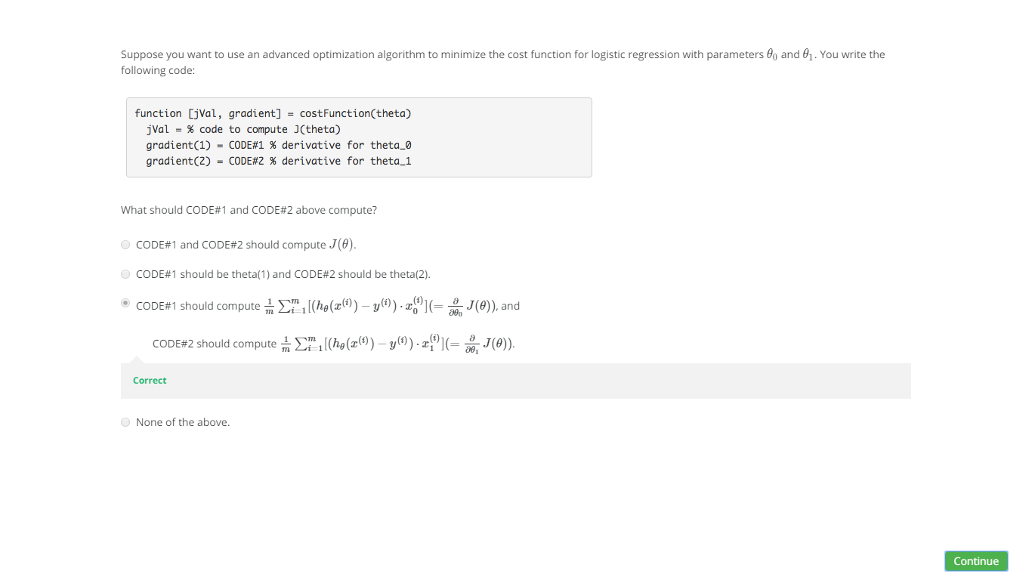

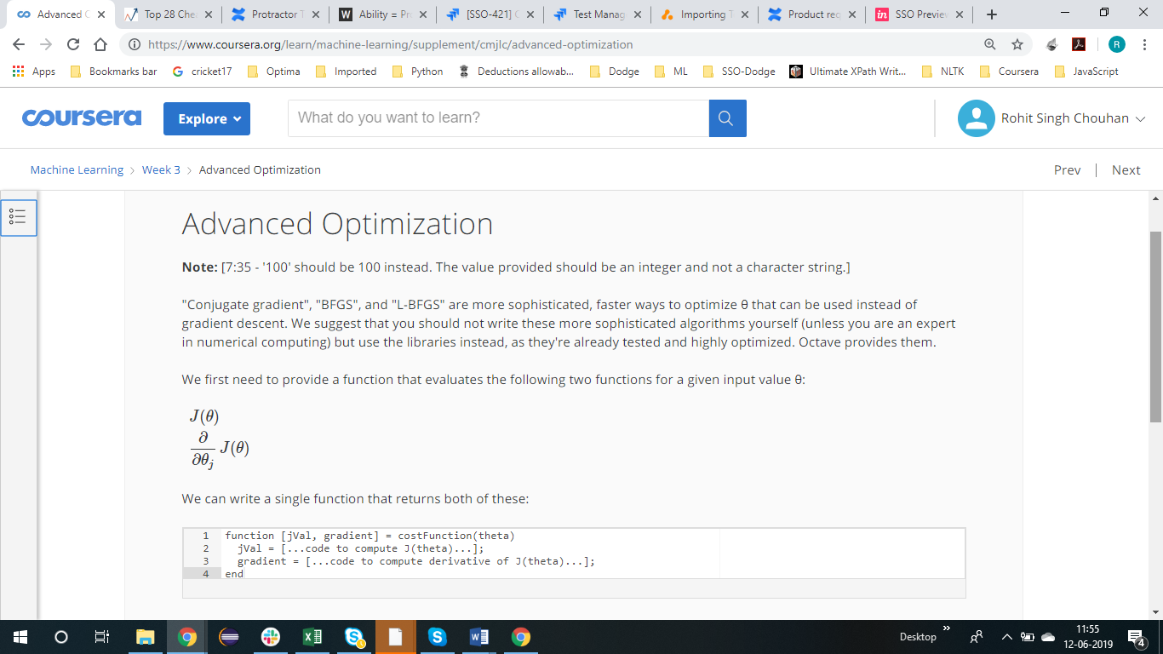

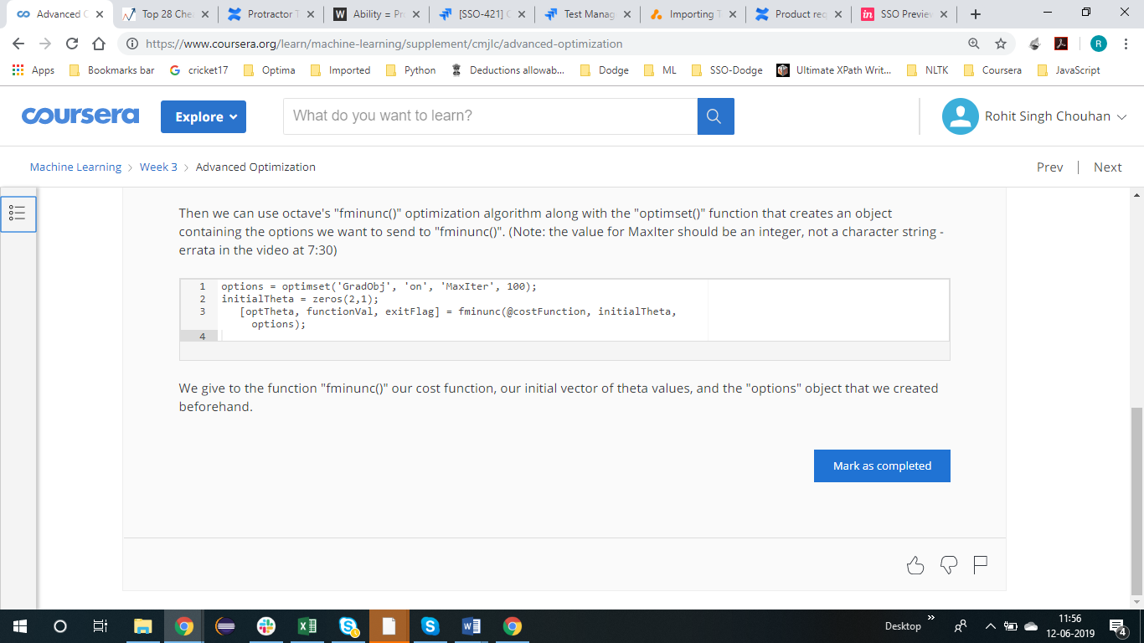

MULTICLASS CLASSIFICATION

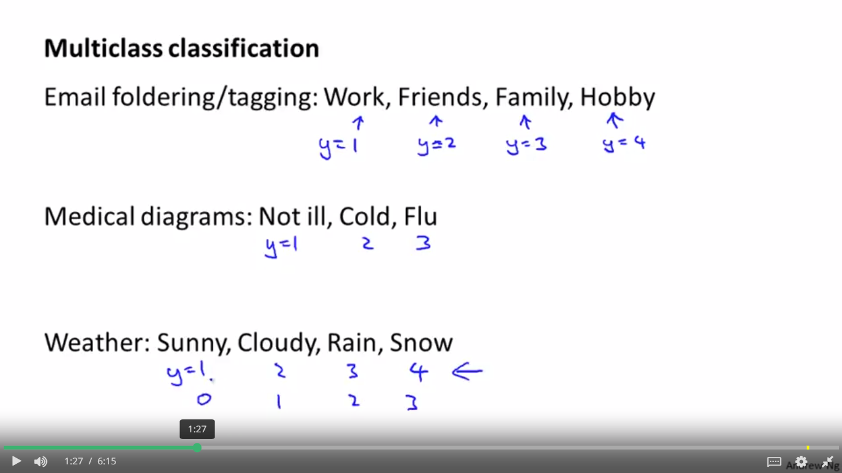

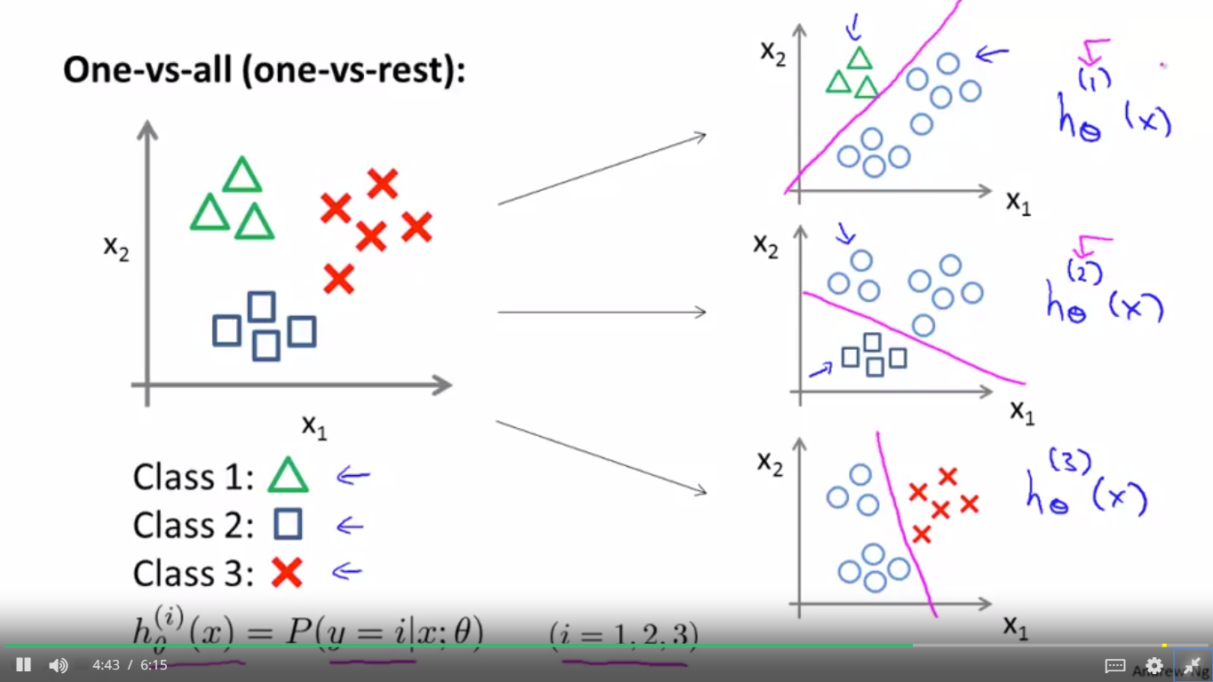

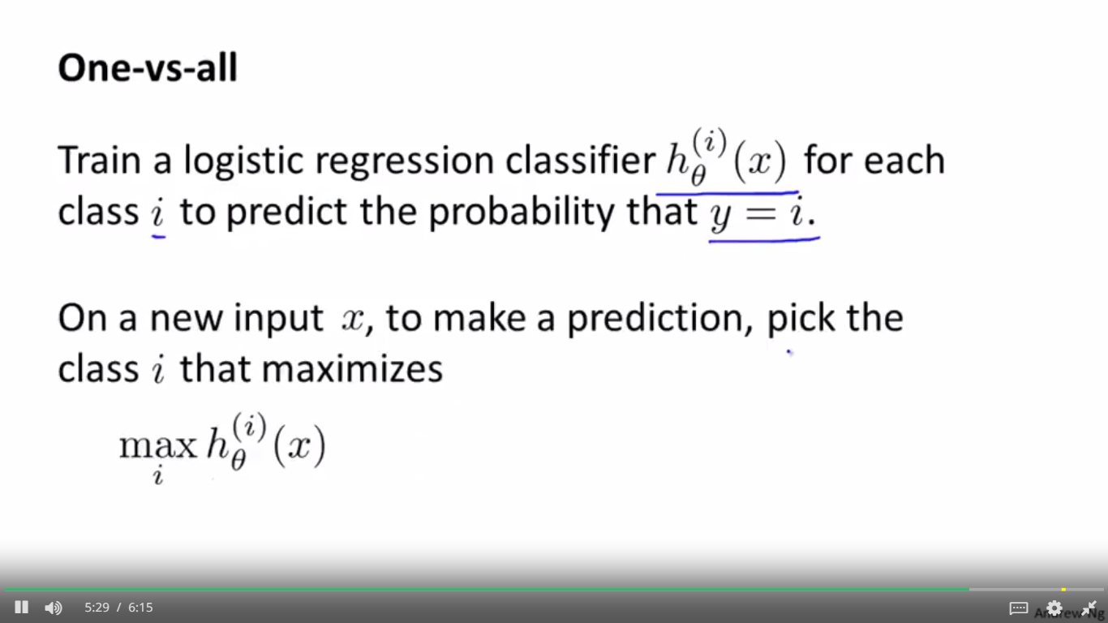

PROBLEM OF OVER FITTING

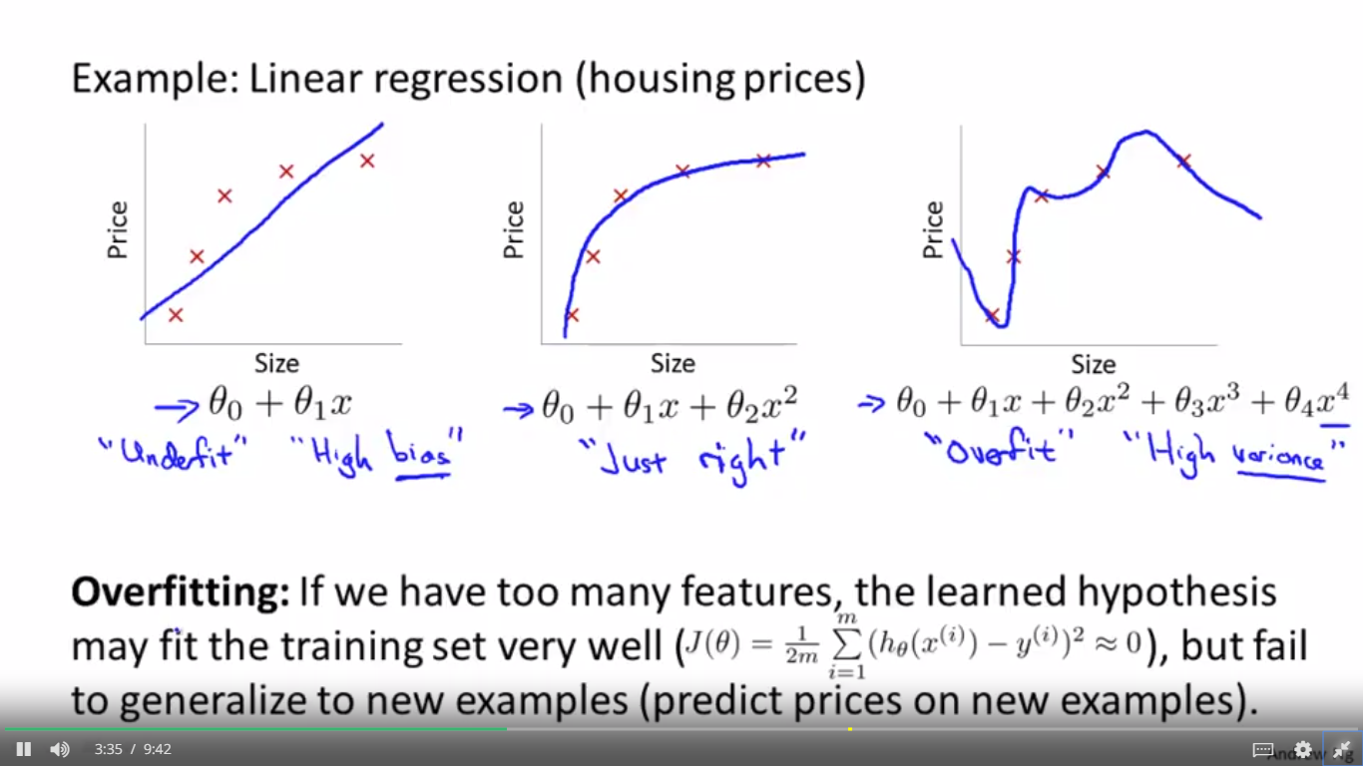

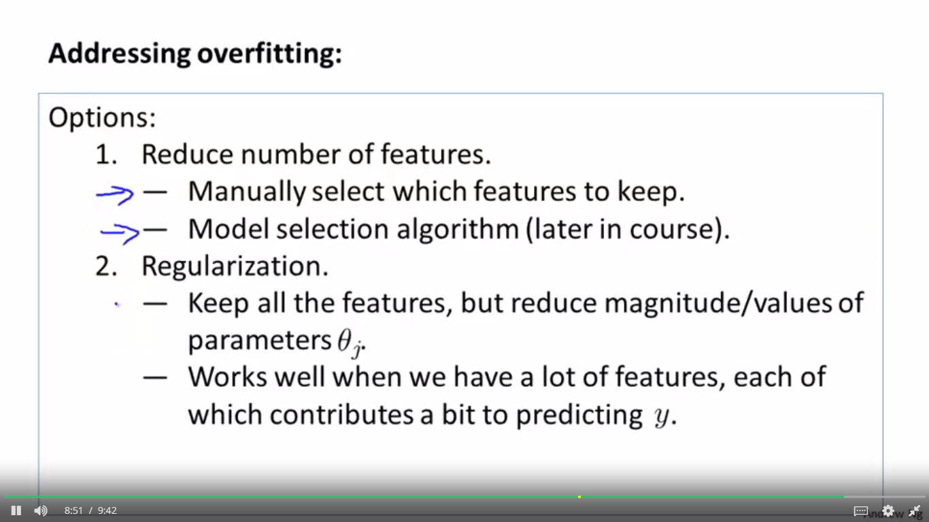

REGULARISATION

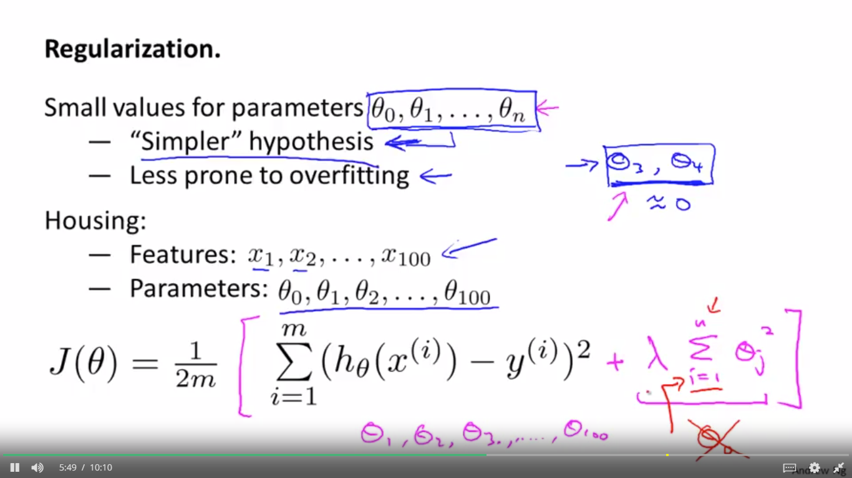

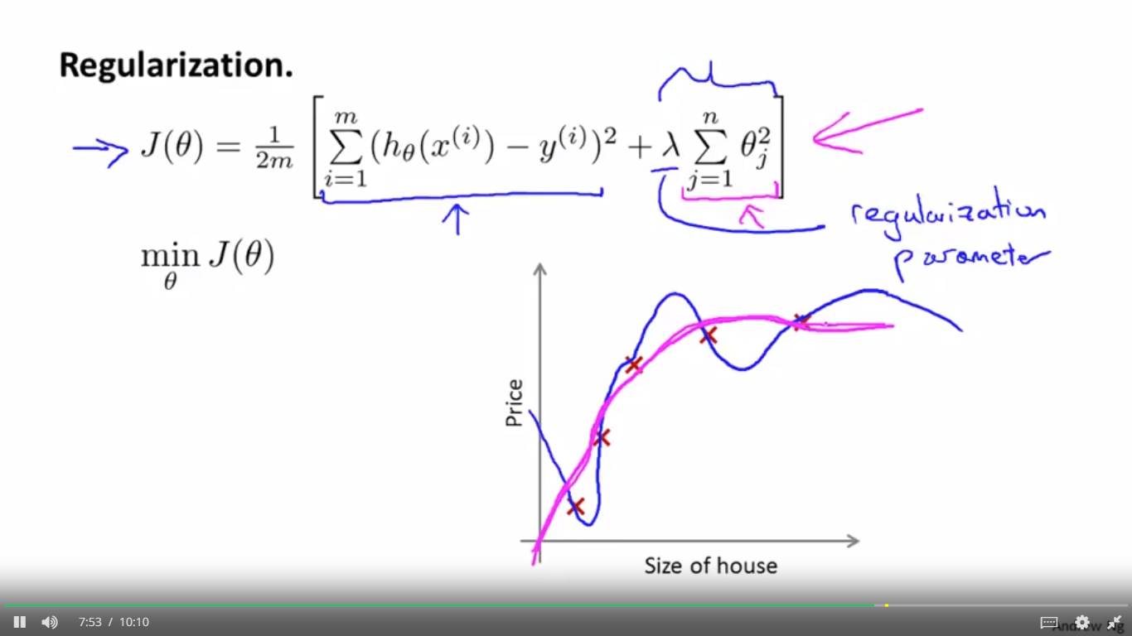

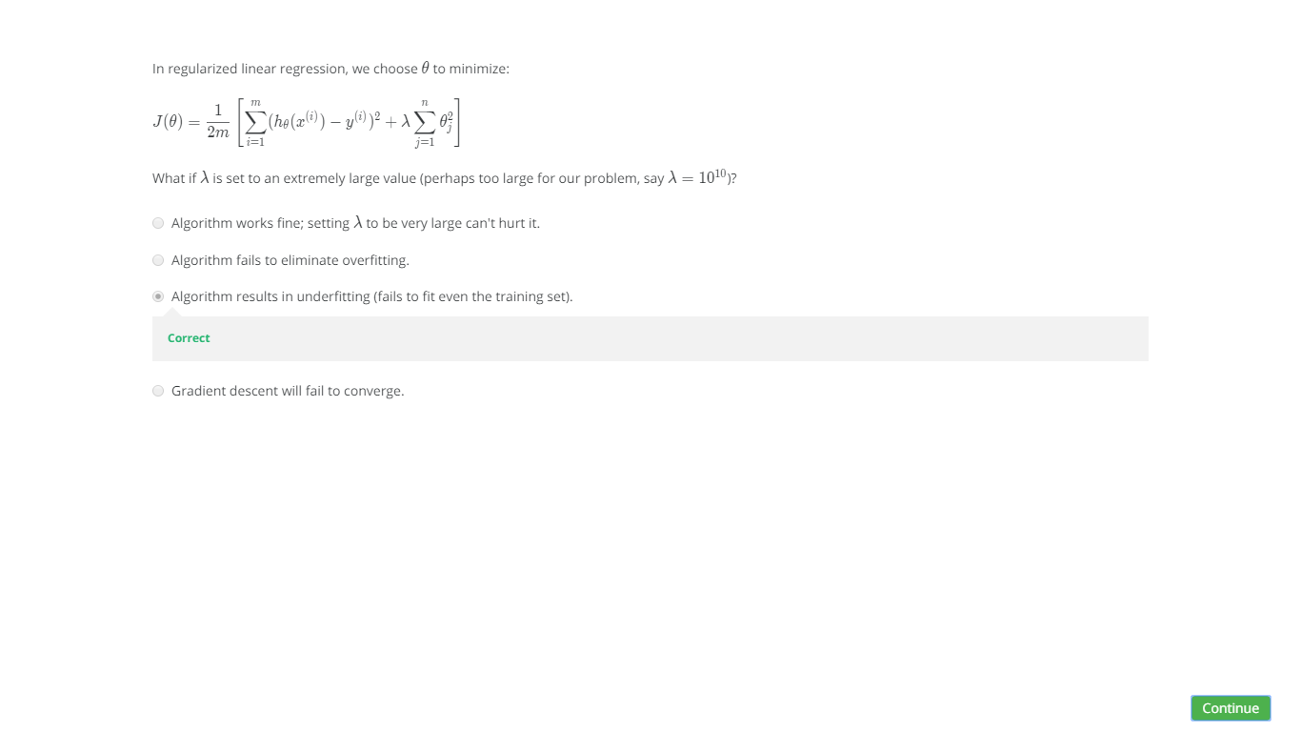

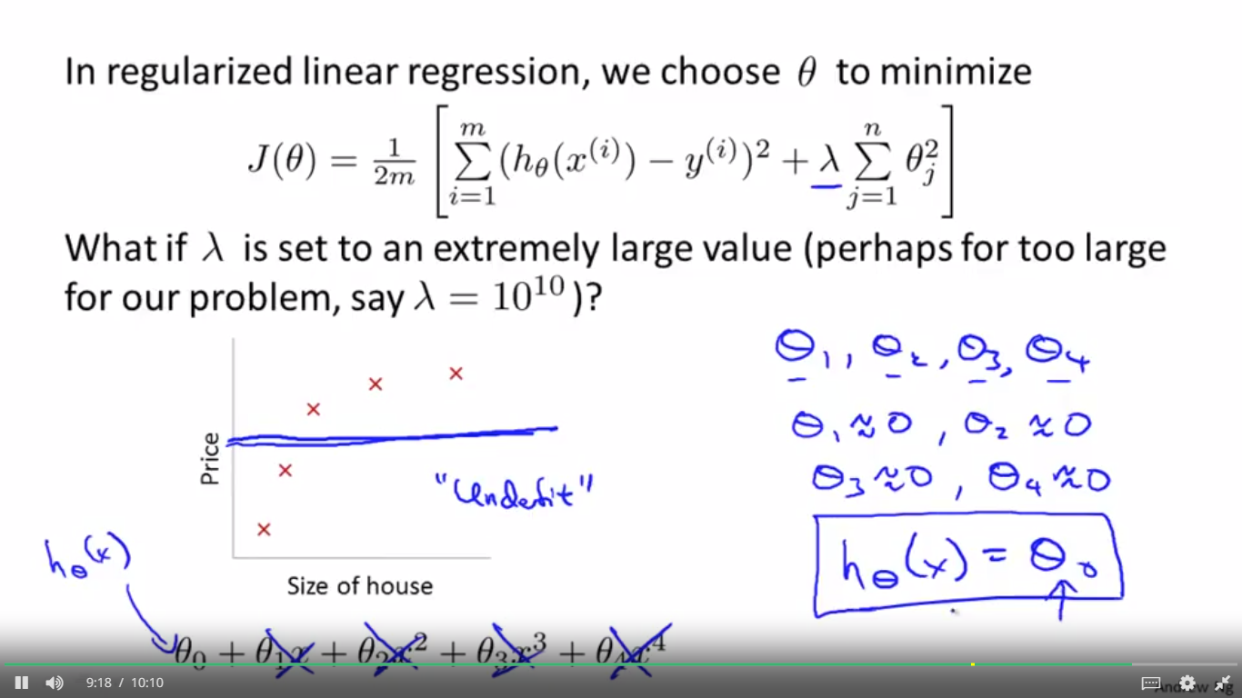

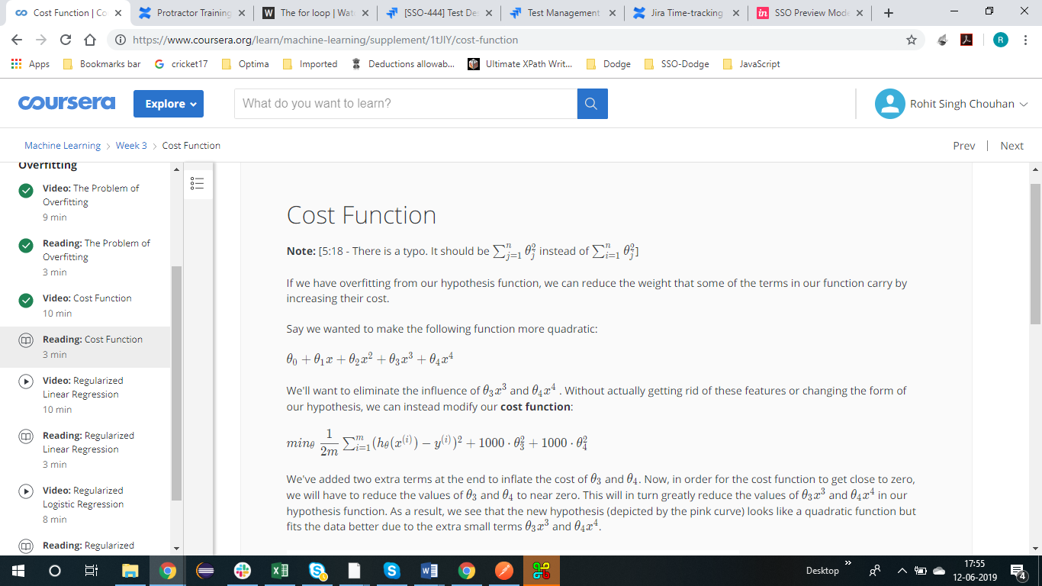

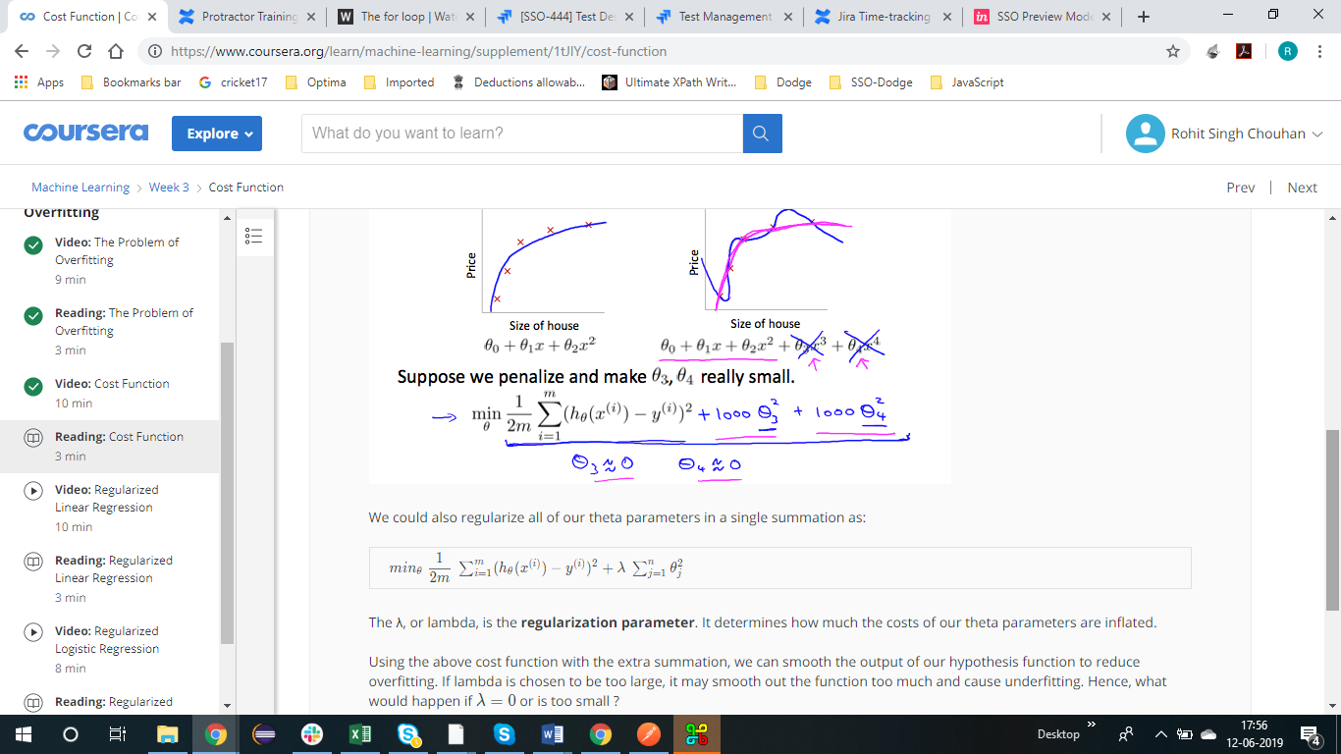

LINEAR REGRESSION REGULARISATION

FIRST ALGORITHM

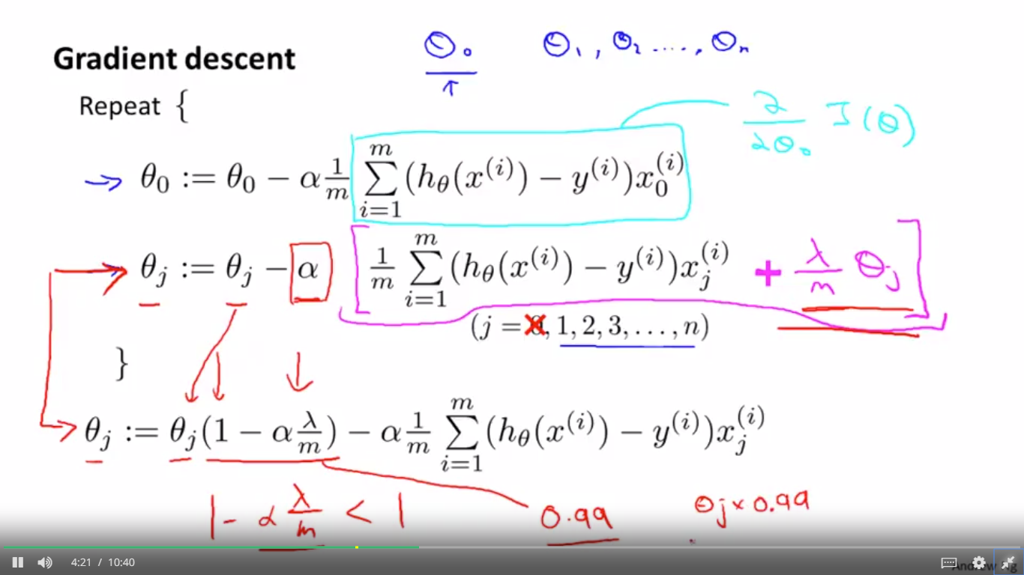

SECOND ALGORITHM

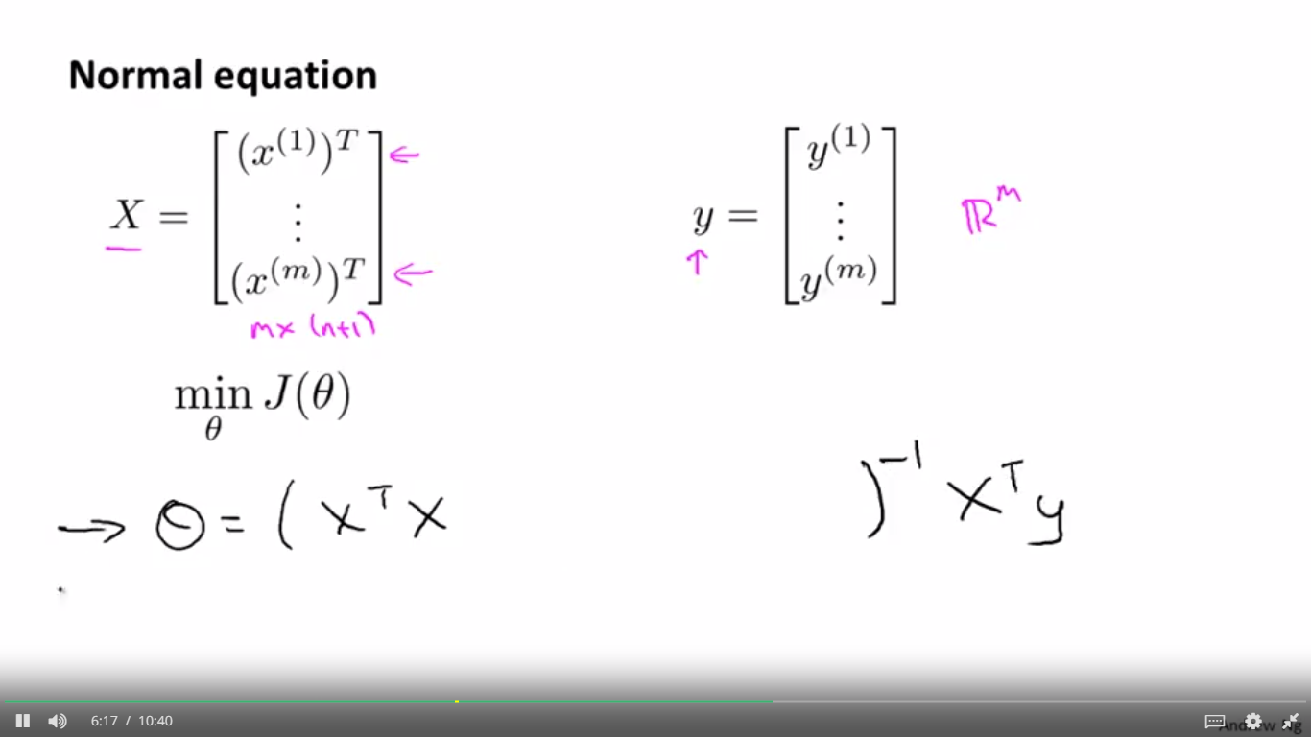

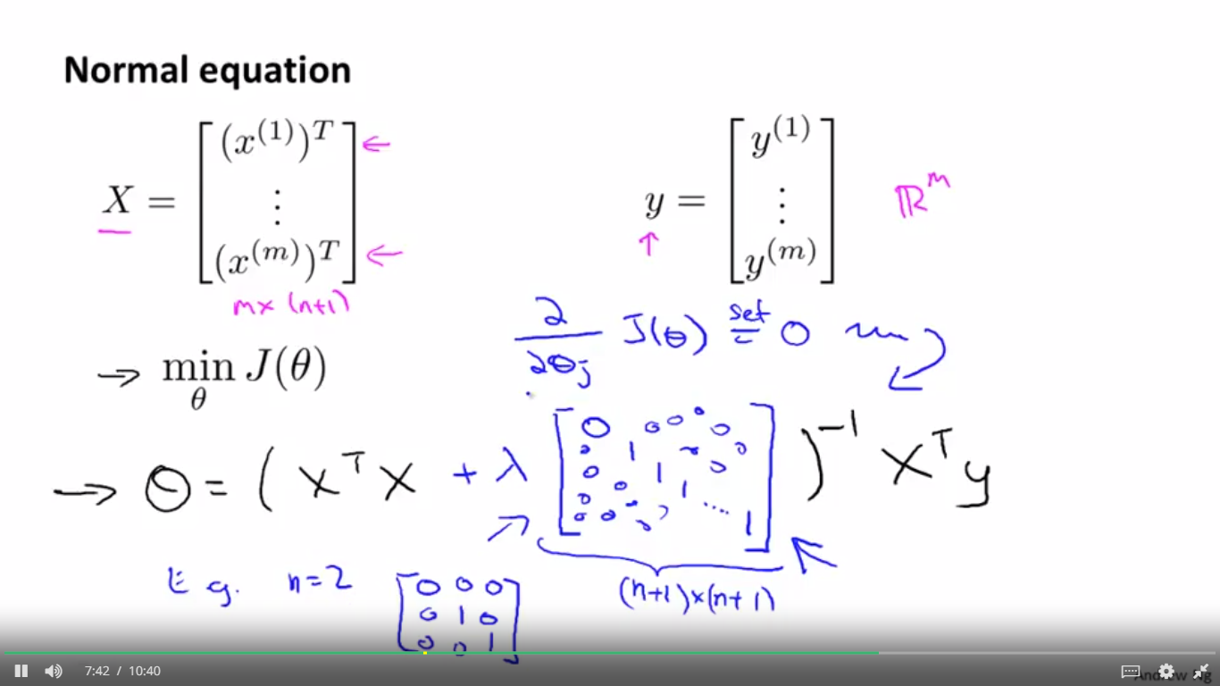

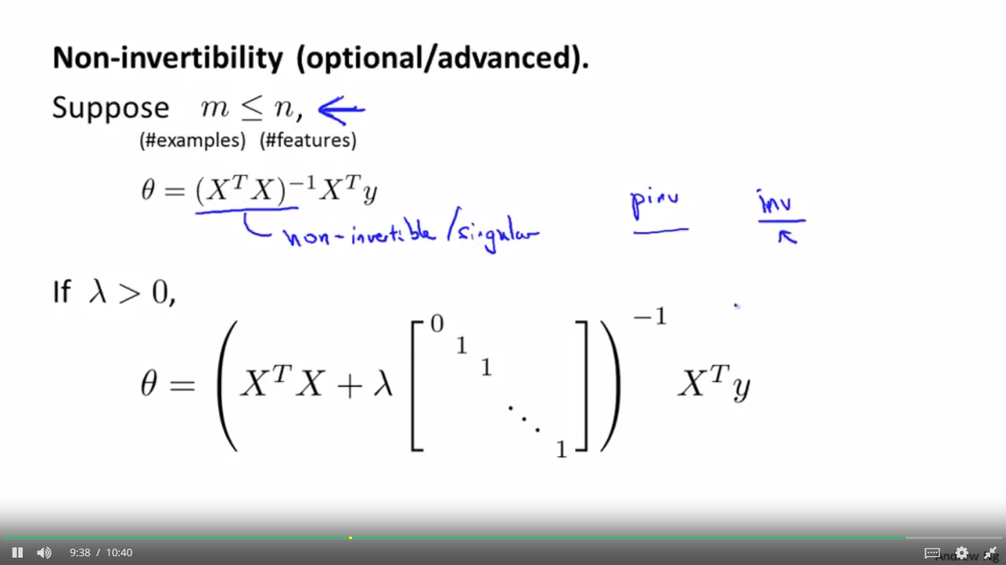

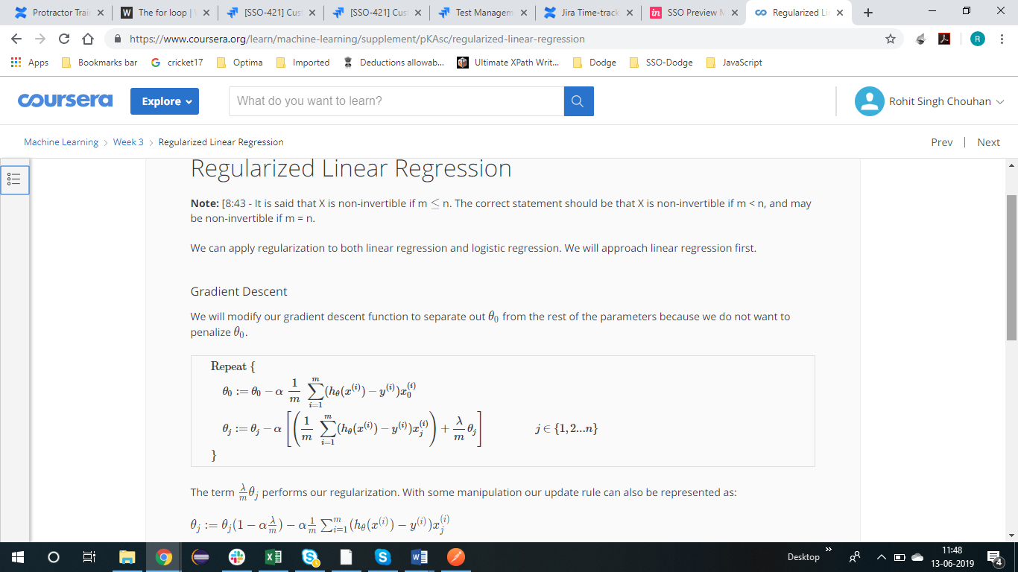

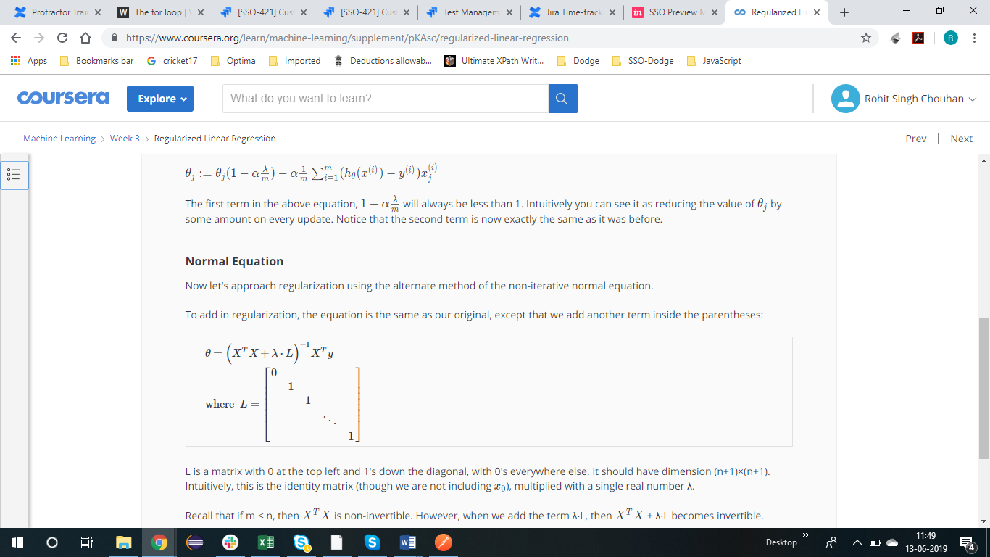

LOGISTIC REGRESSION REGULARISATION

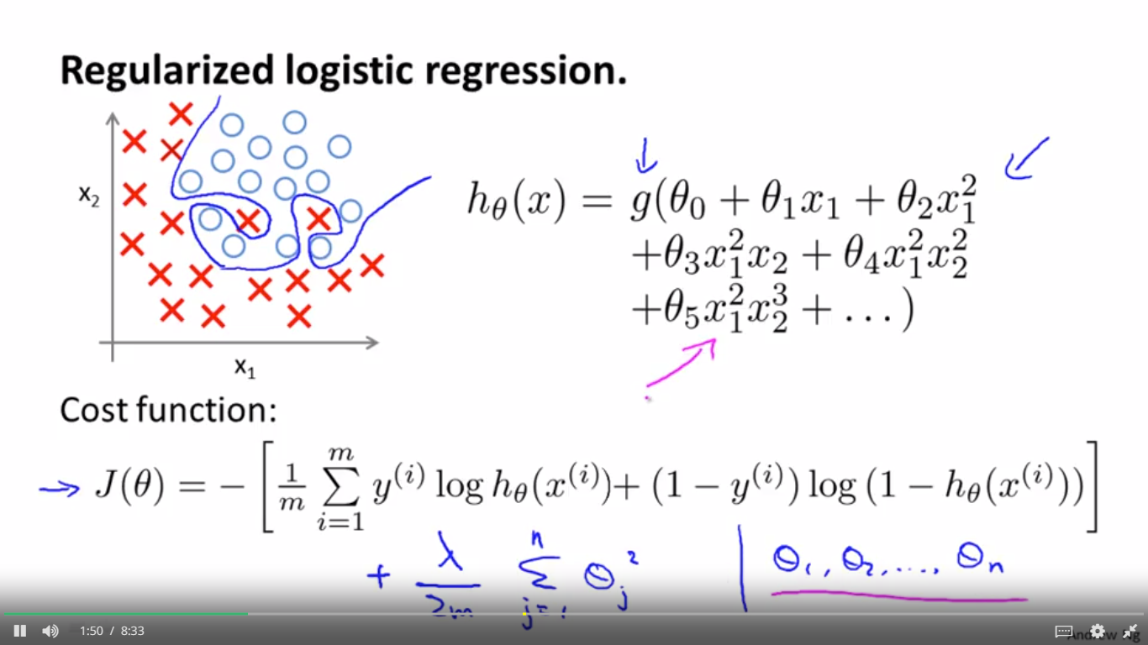

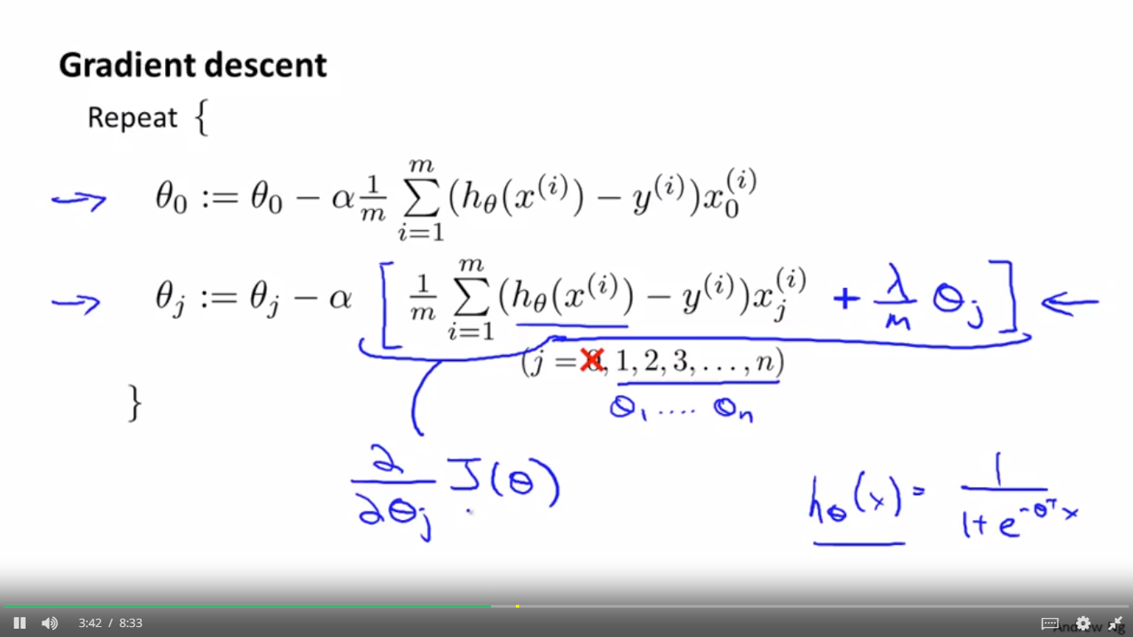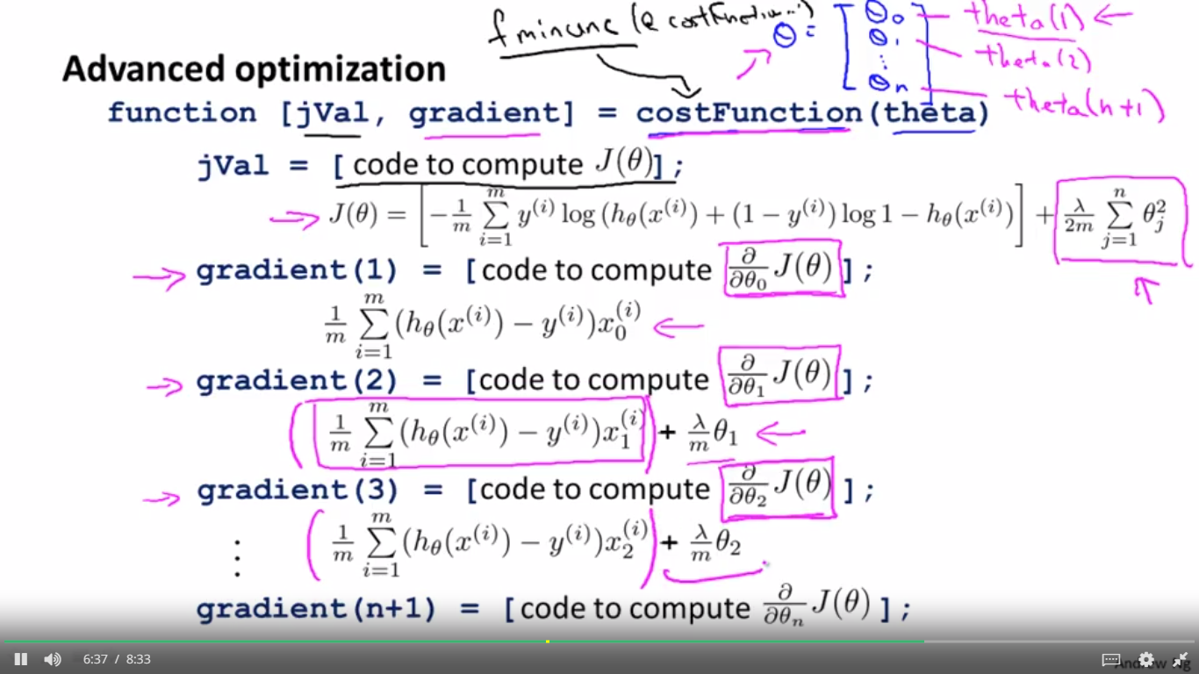

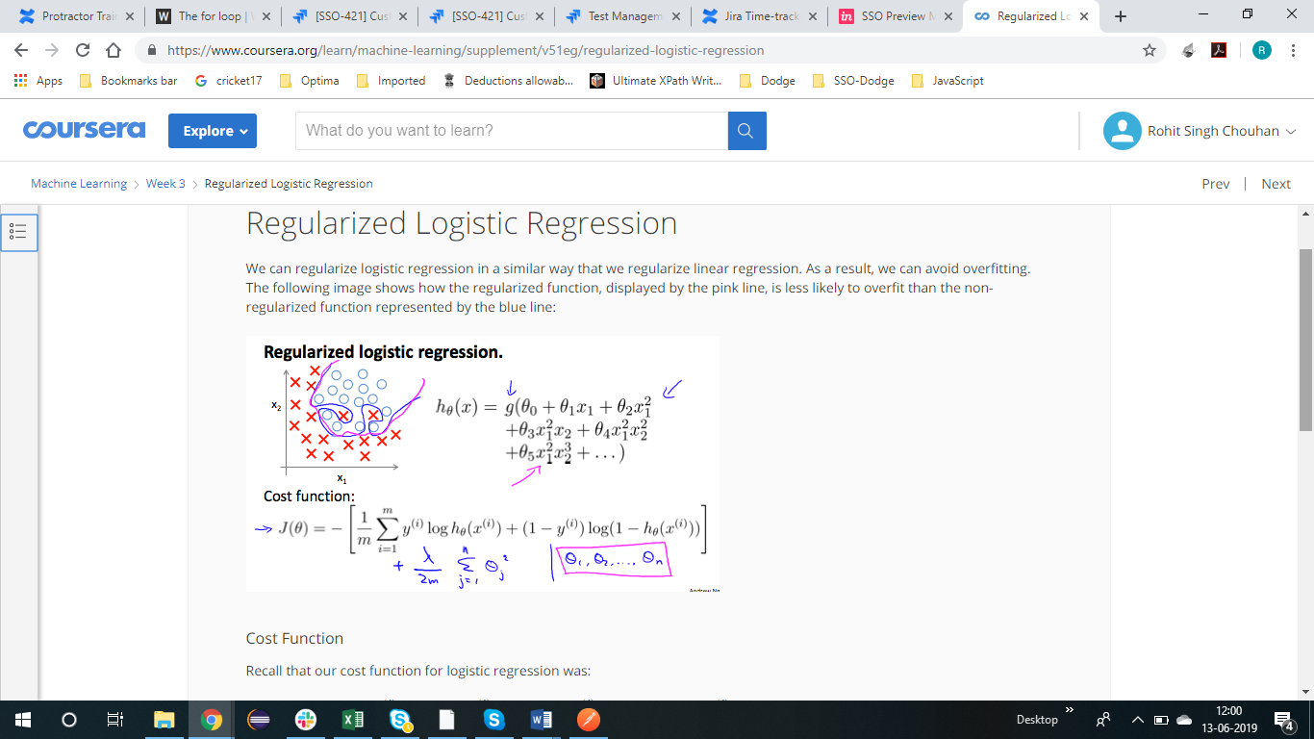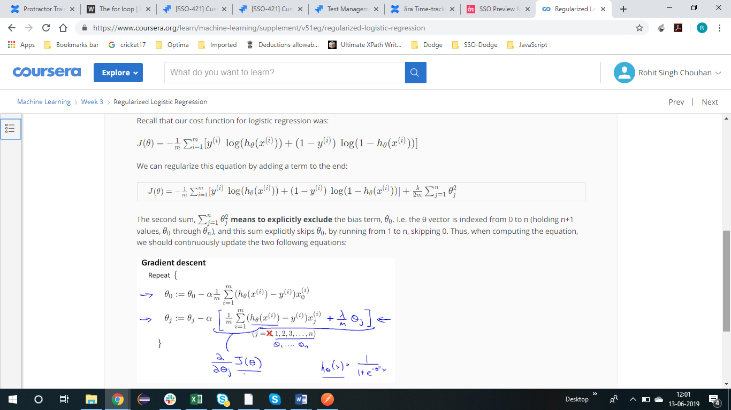

NEURAL NETWORK VDp0mSAMJRazkudL

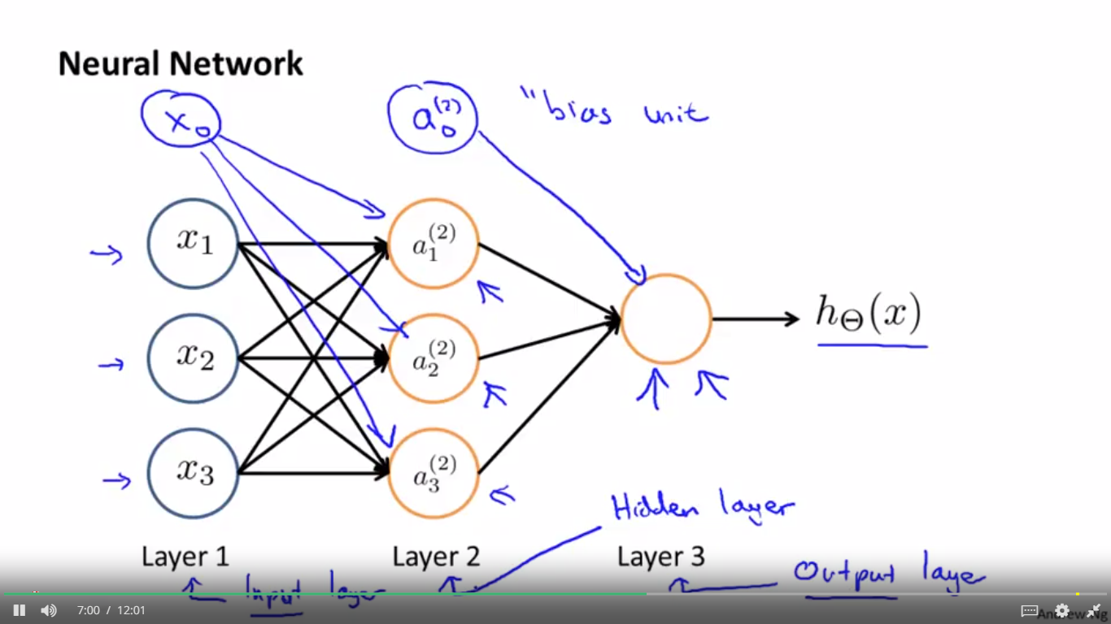

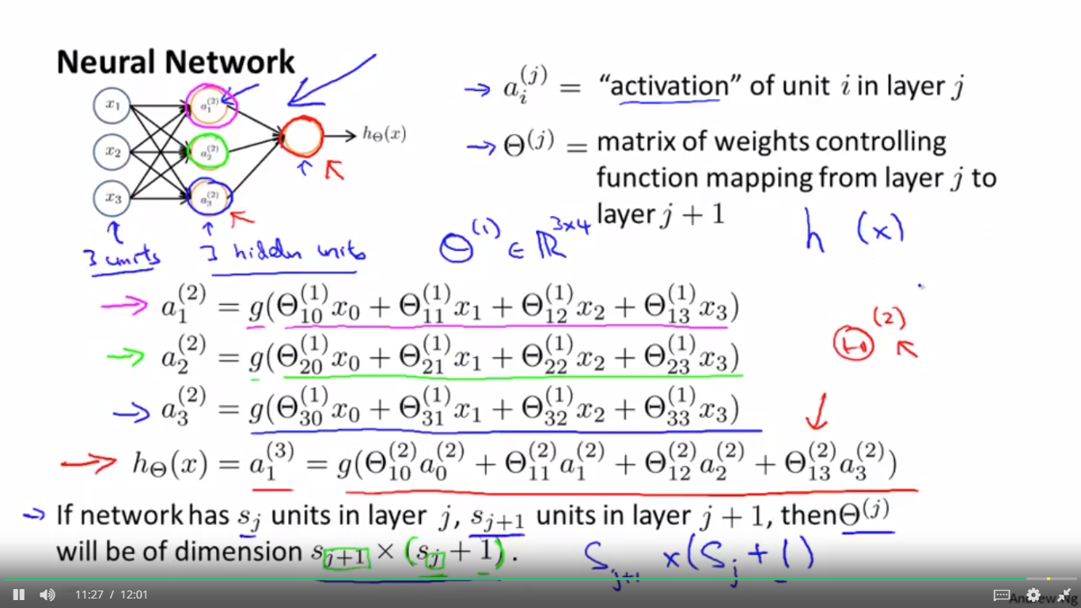

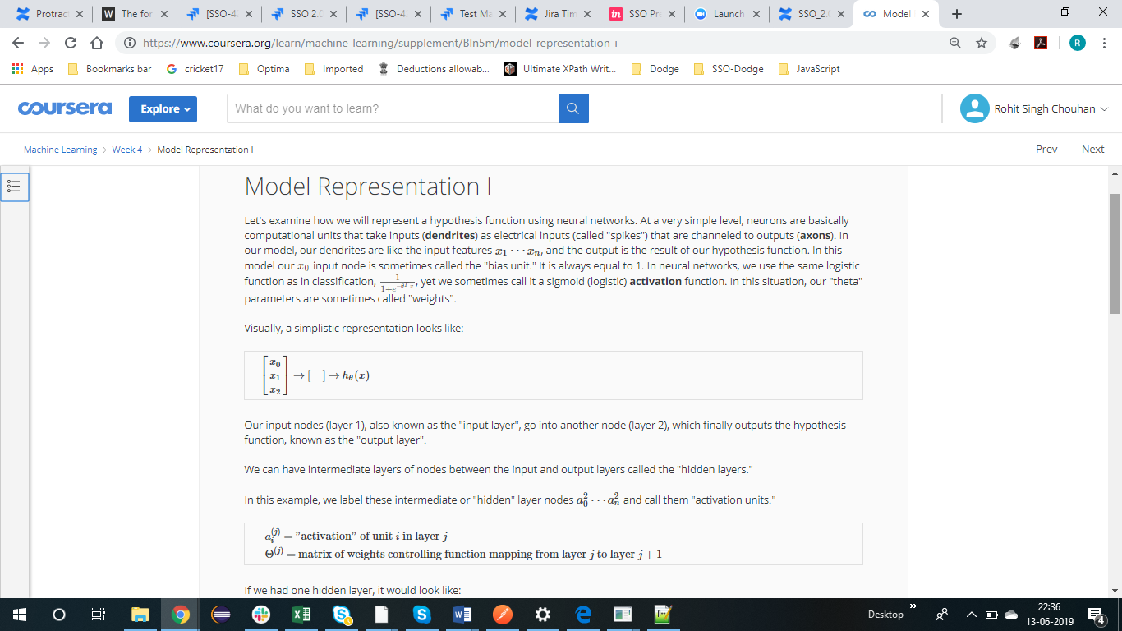

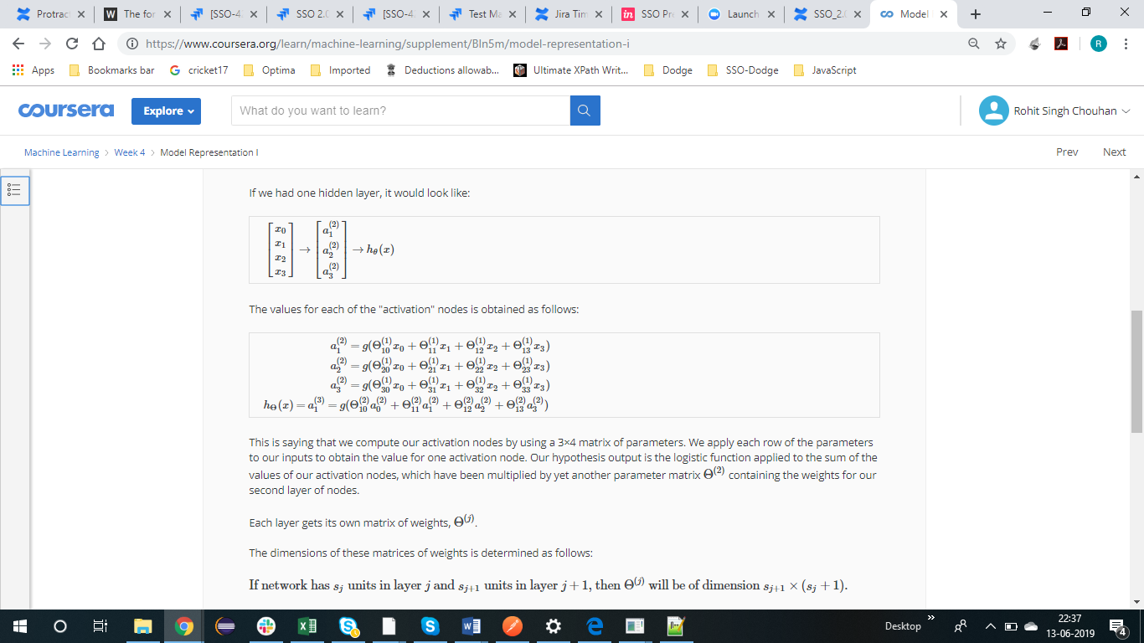

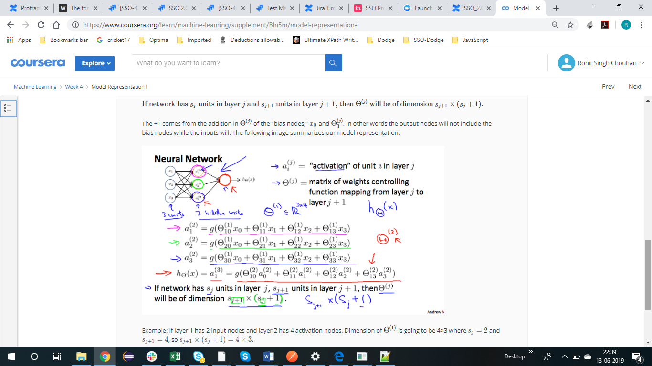

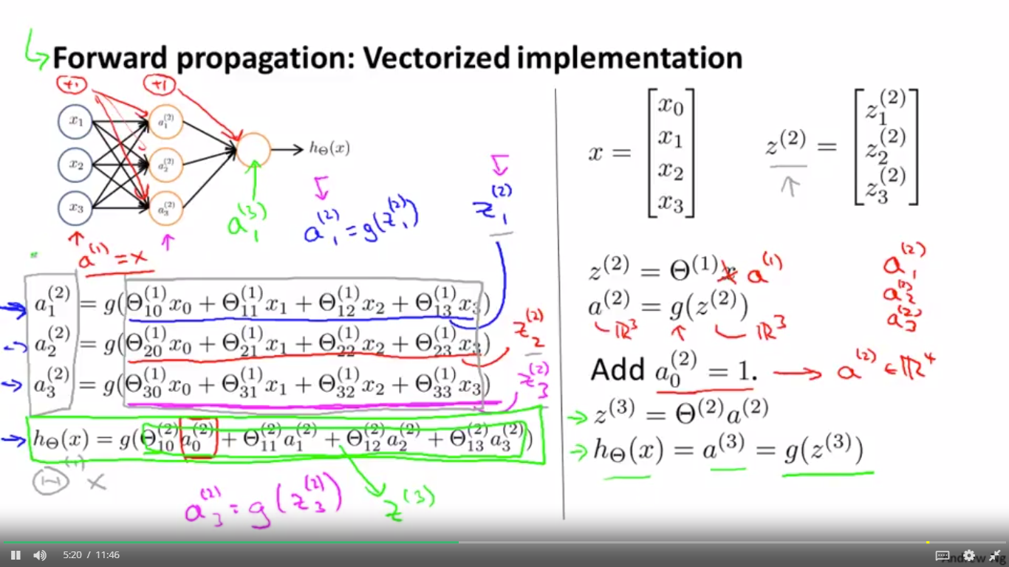

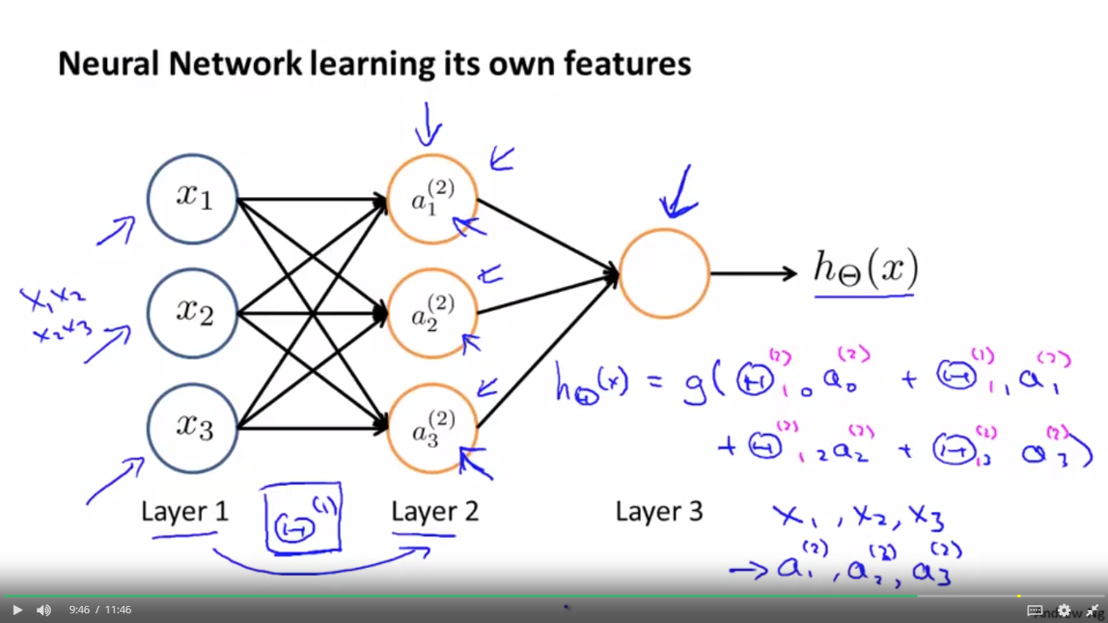

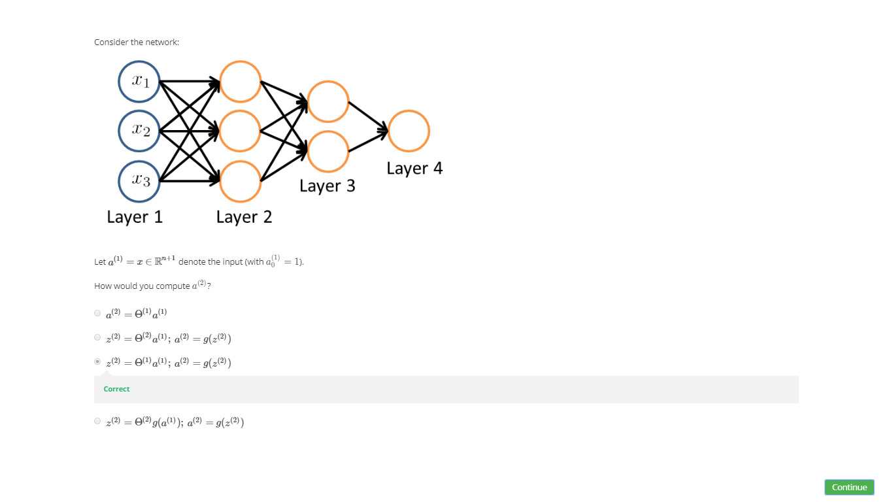

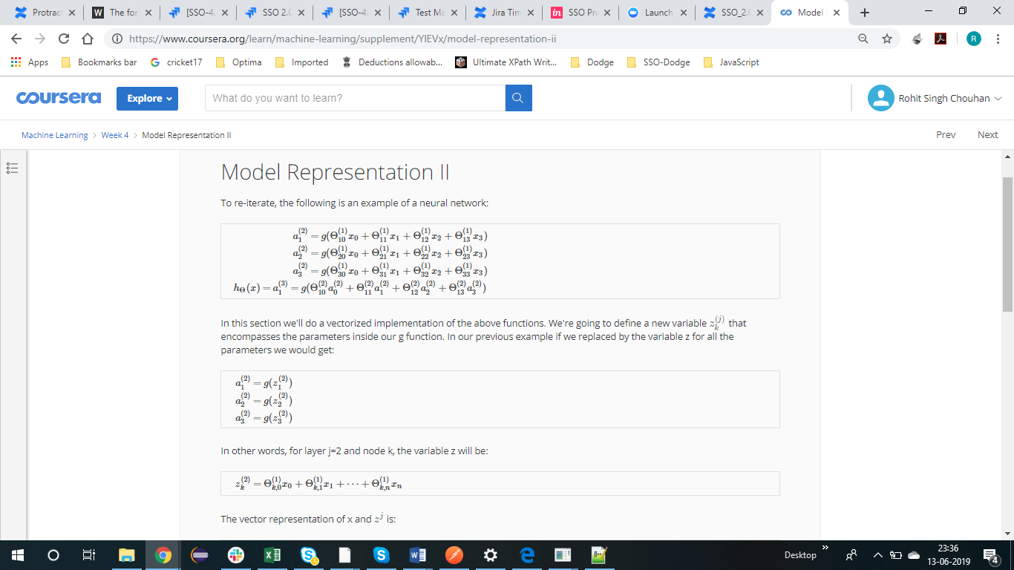

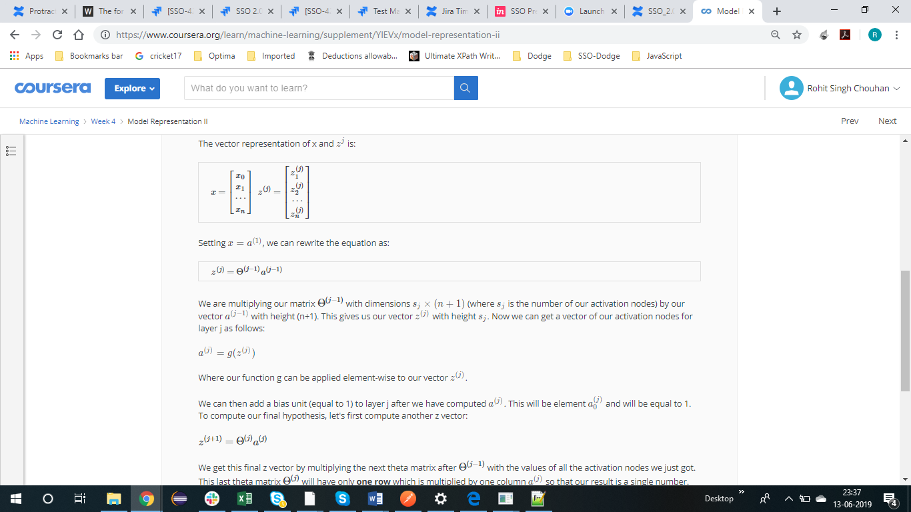

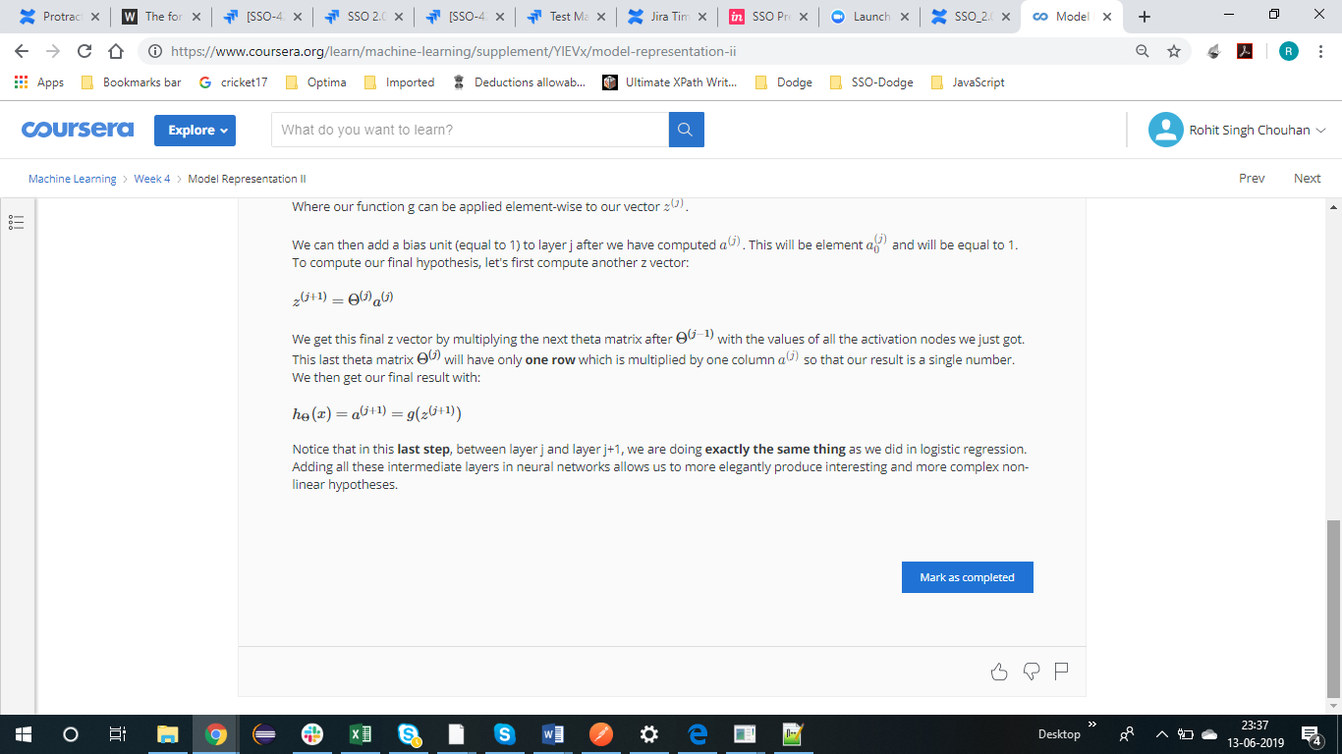

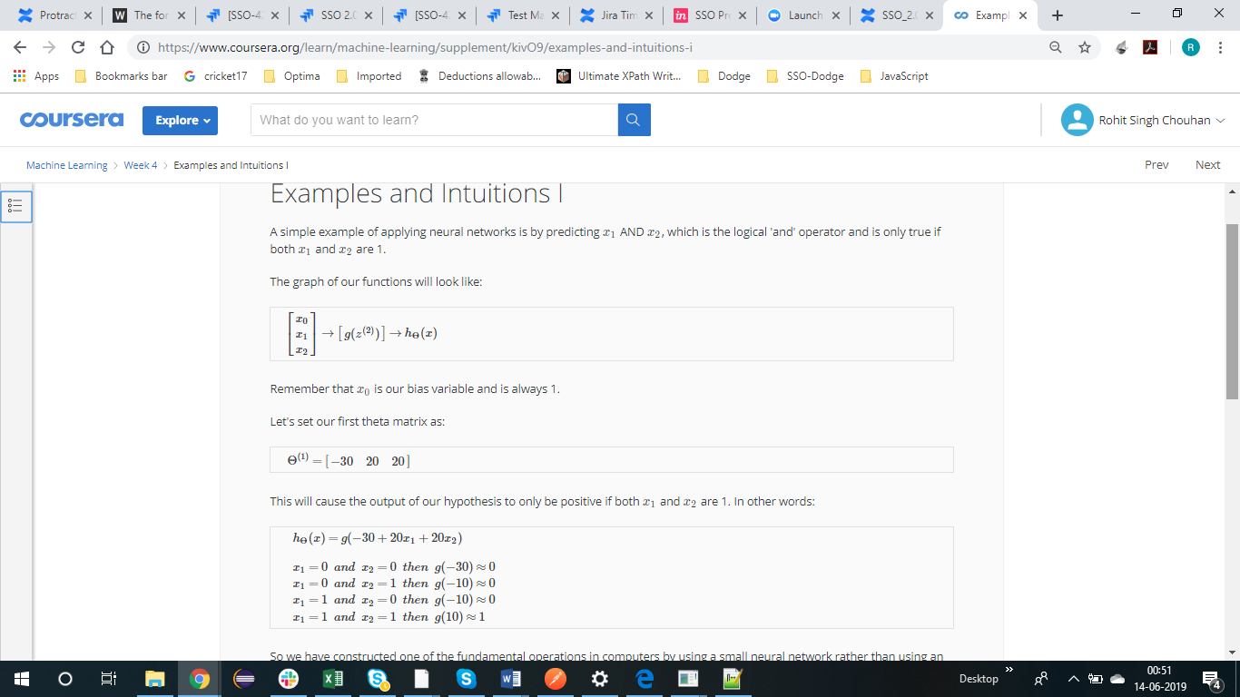

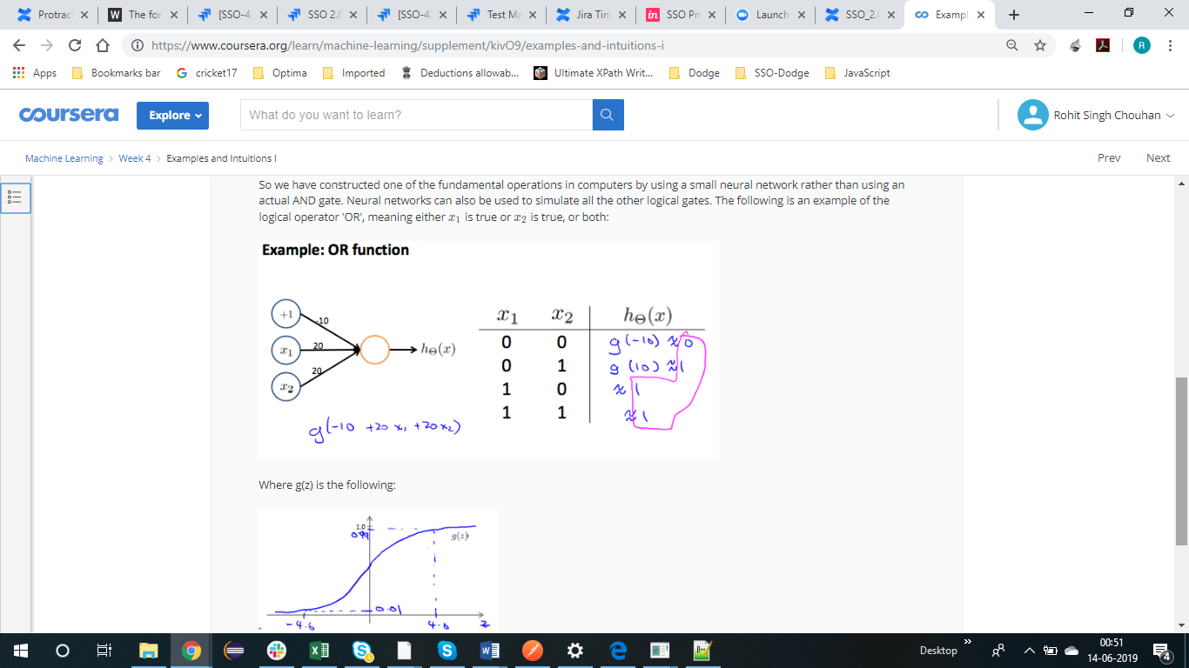

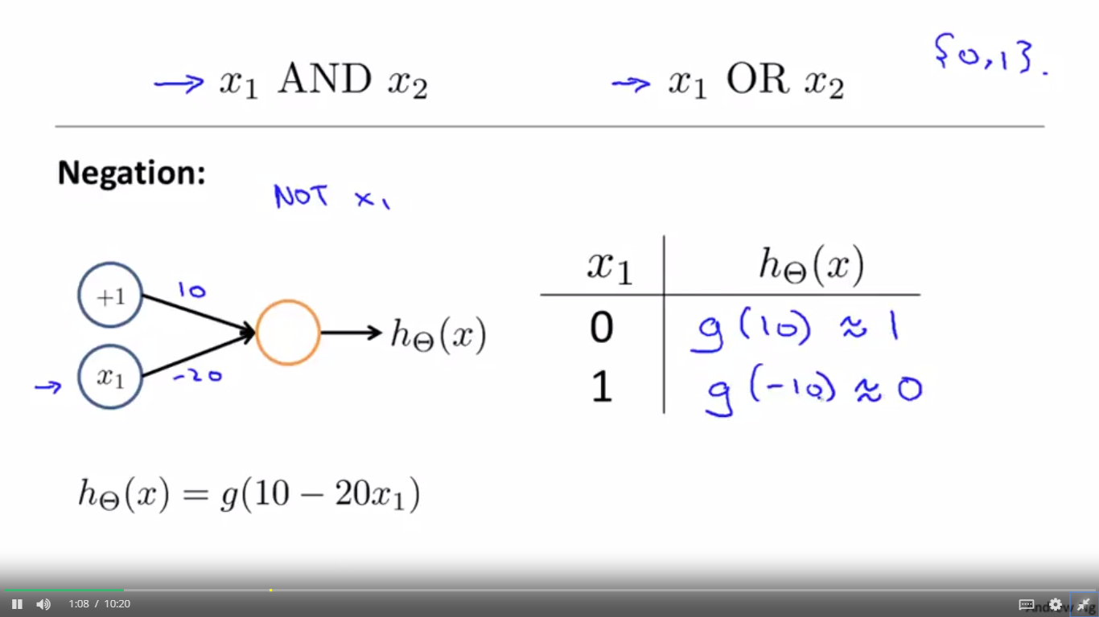

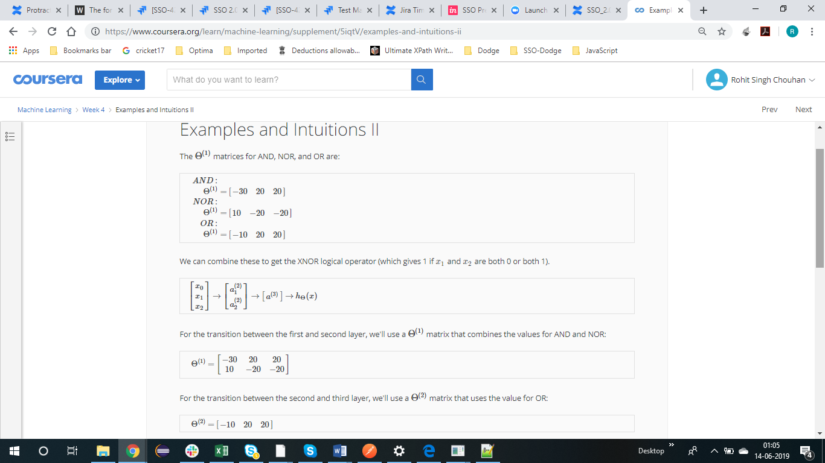

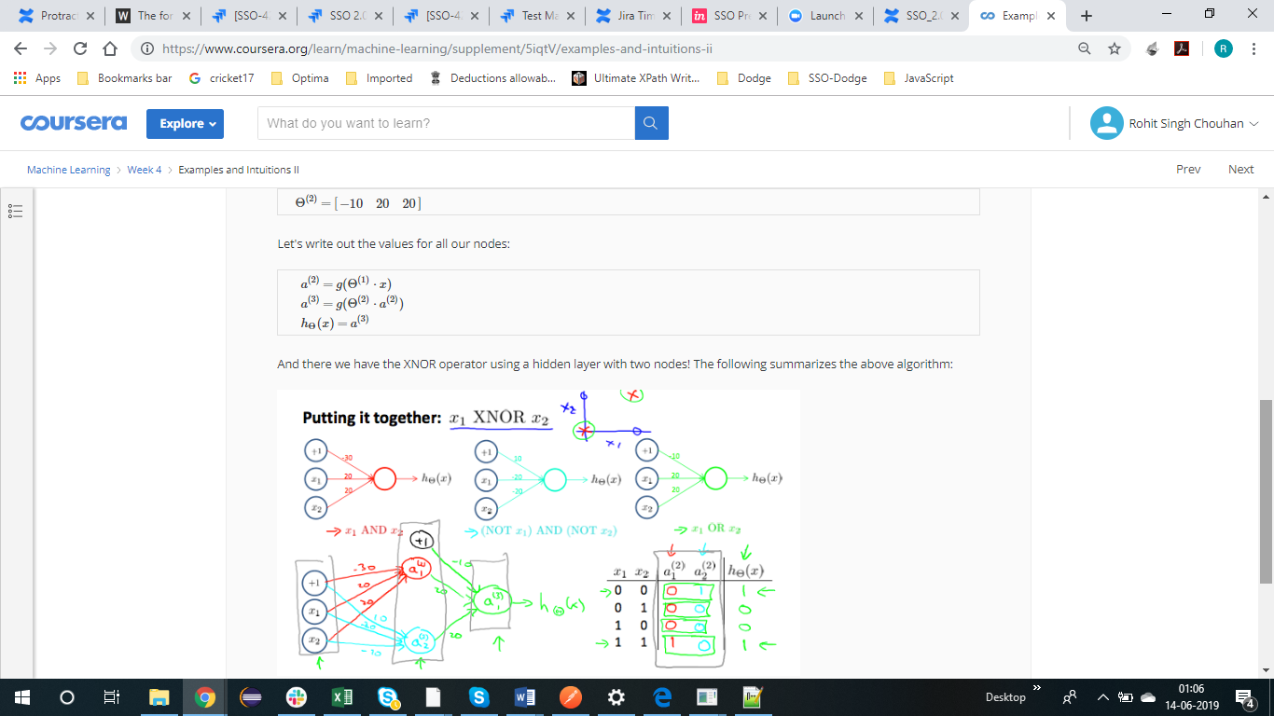

MULTI CLASS CLASSIFICATION USING NEURAL NETWORK

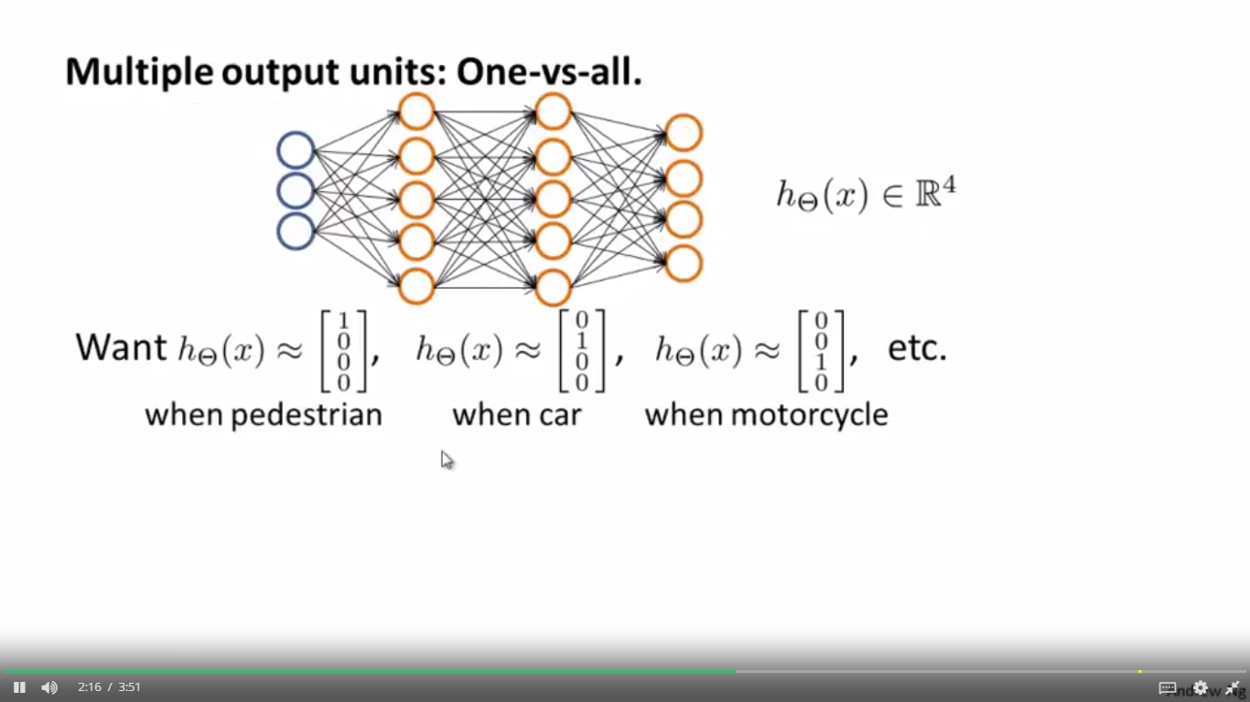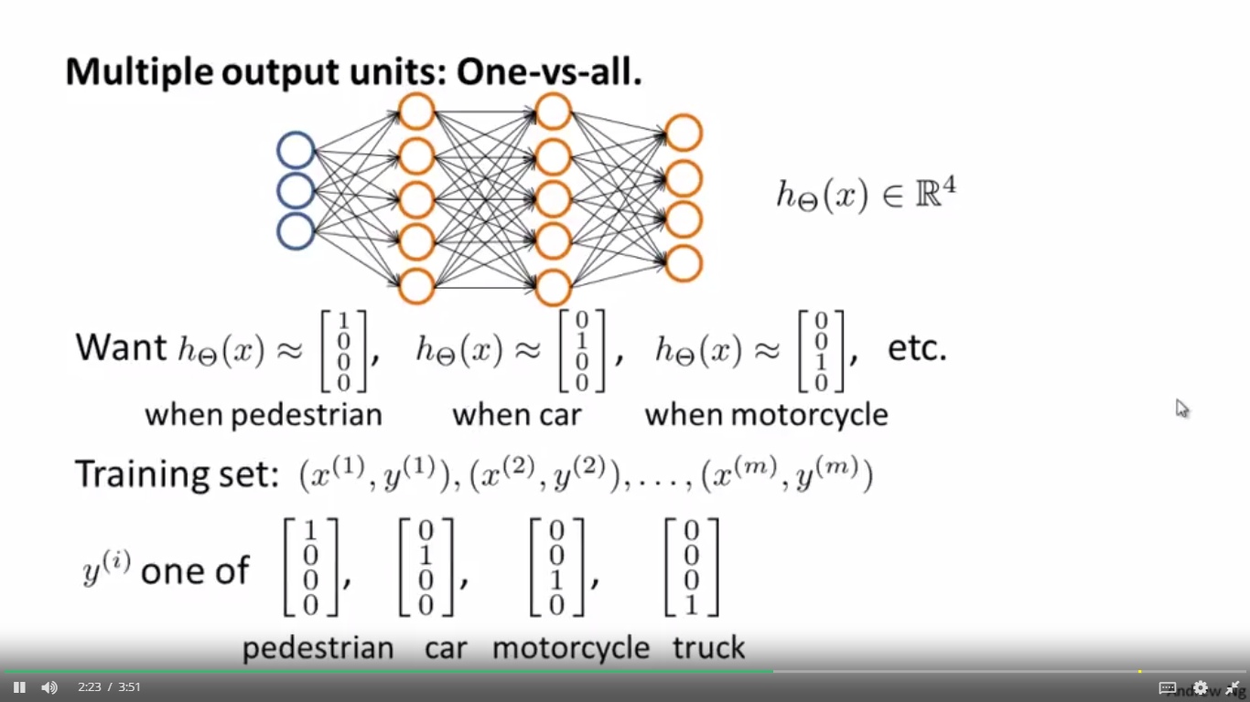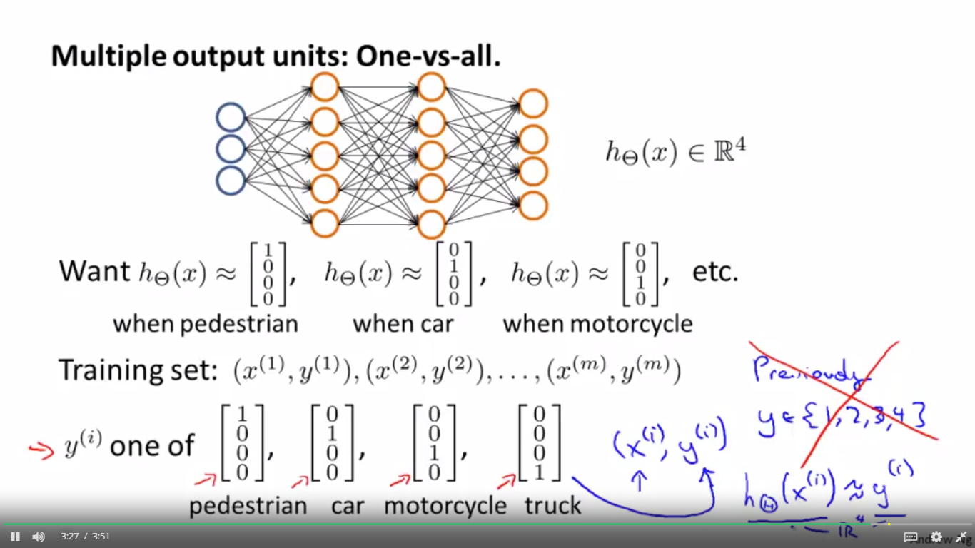



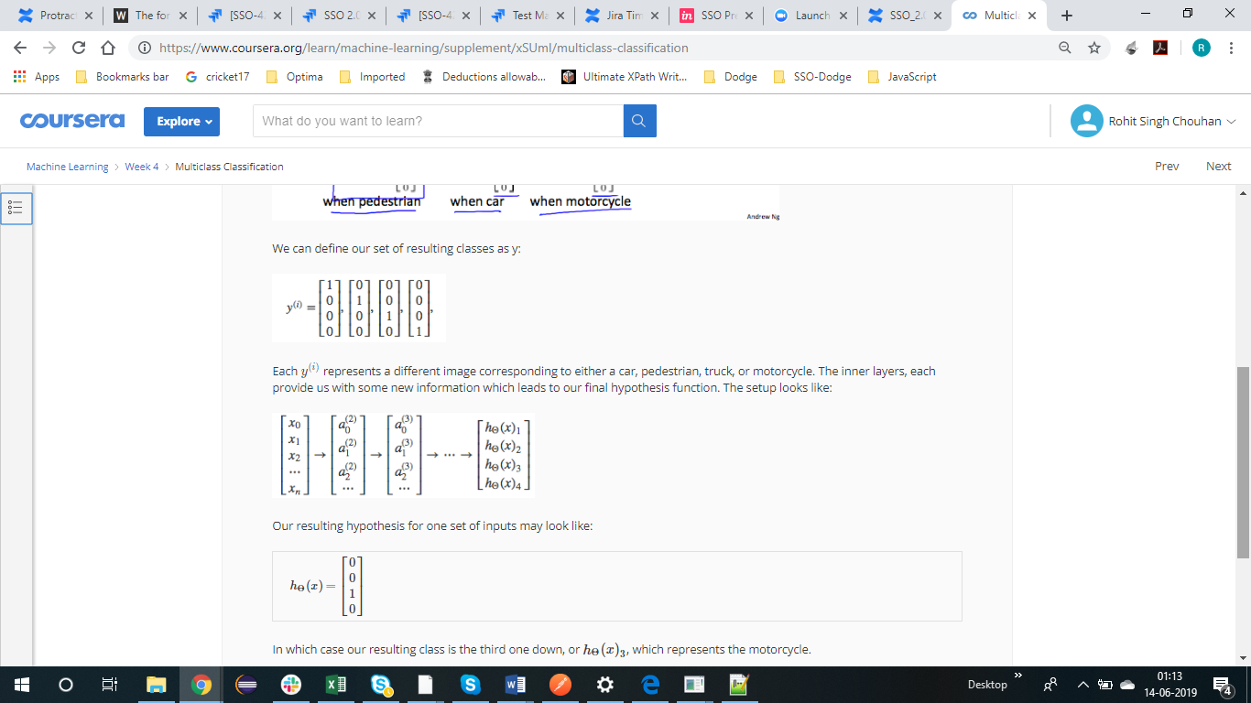

CALCULATE PARAMETER IN NEURAL NETWORK

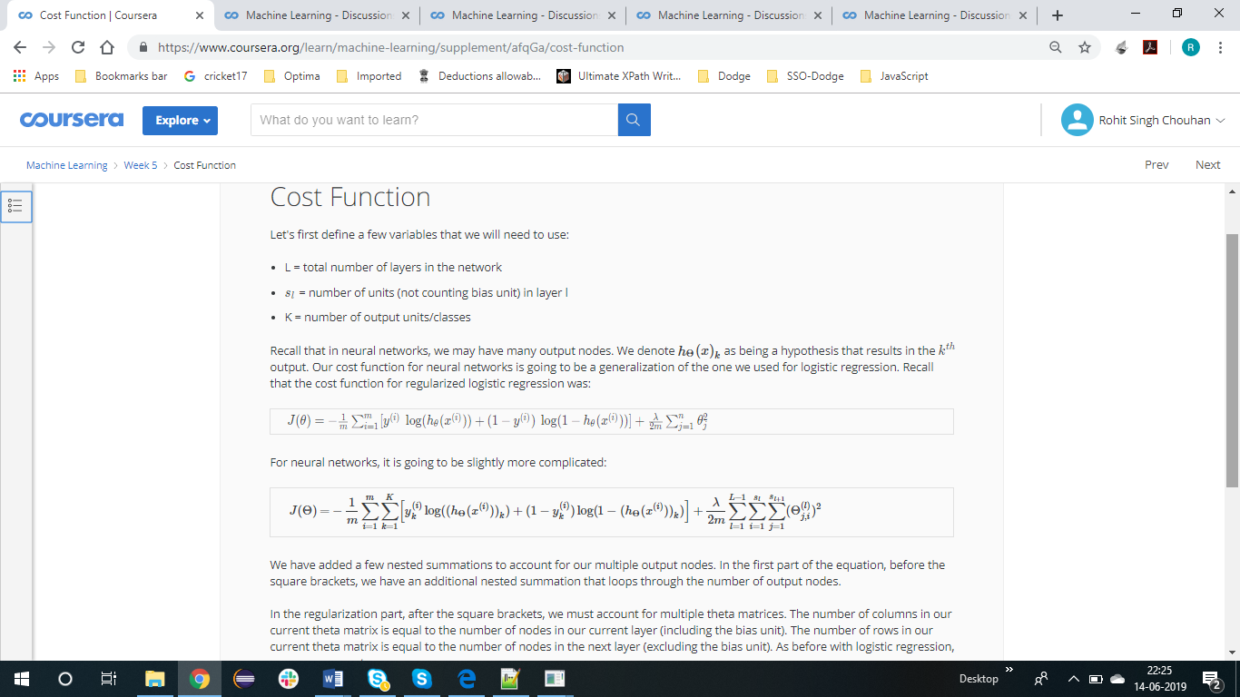

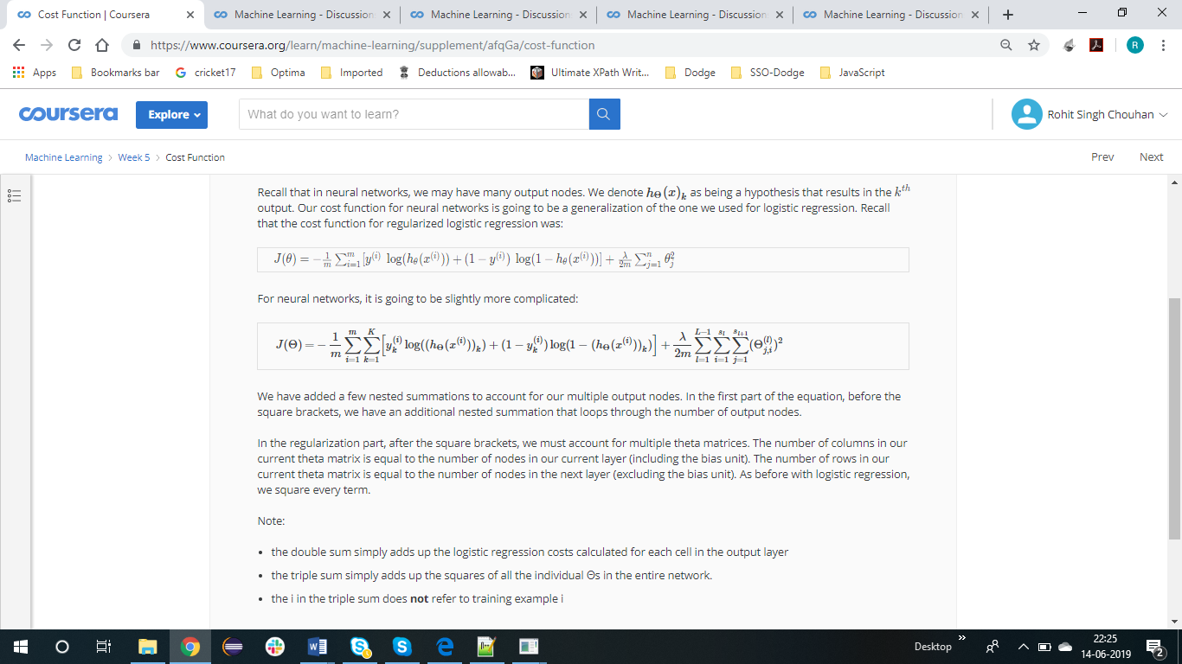

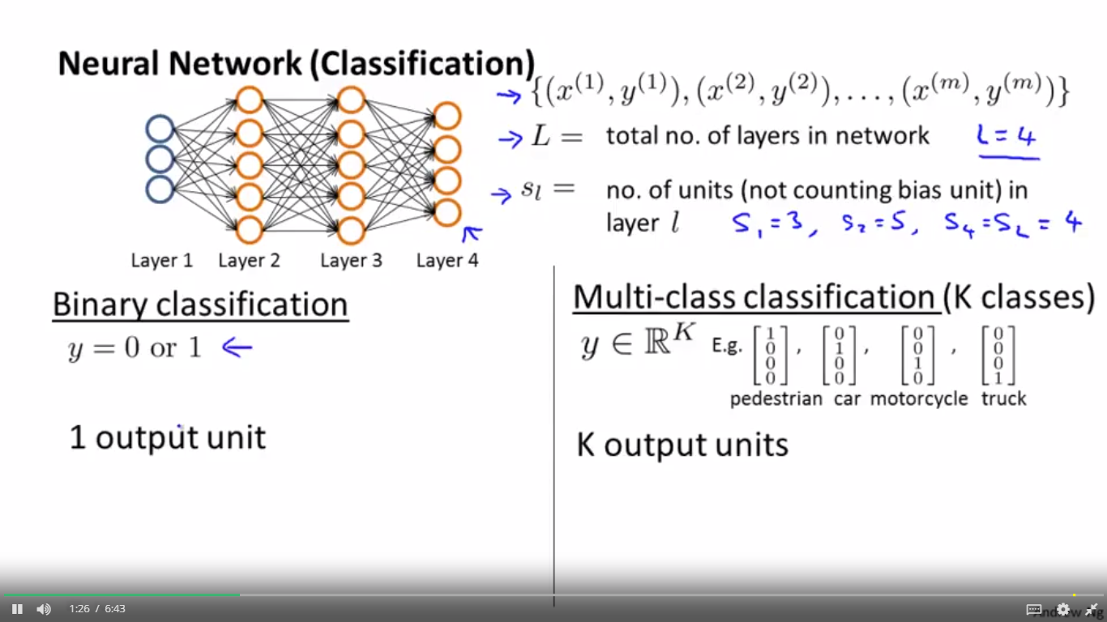

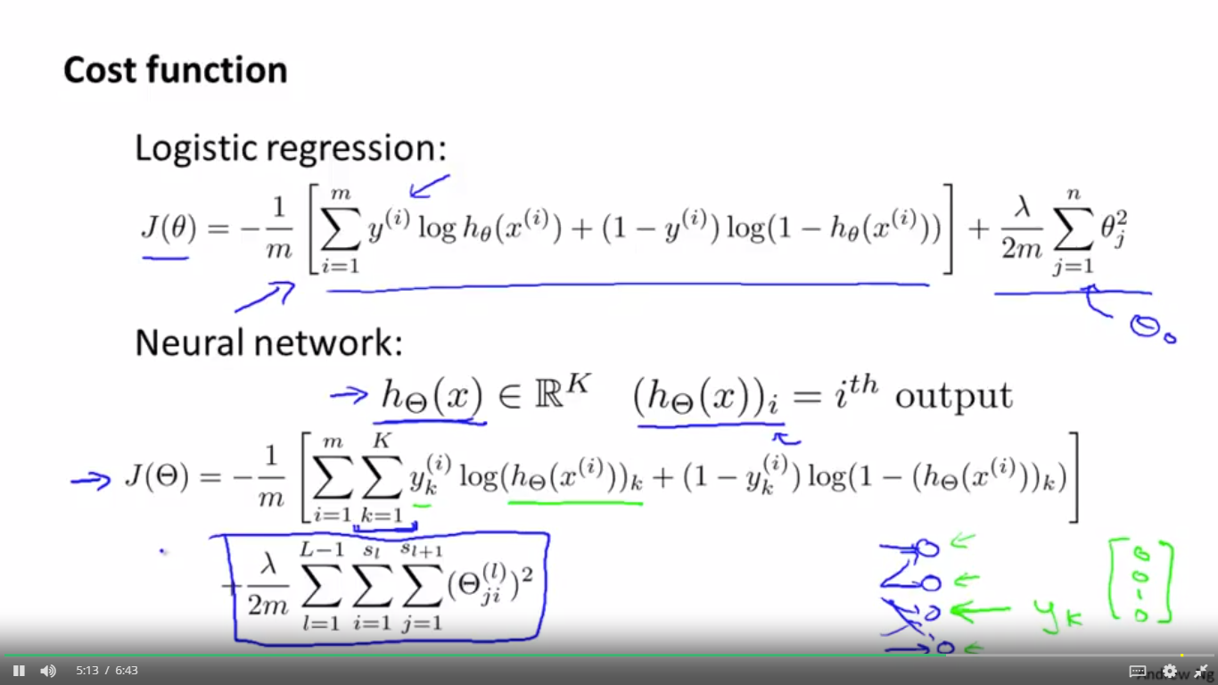

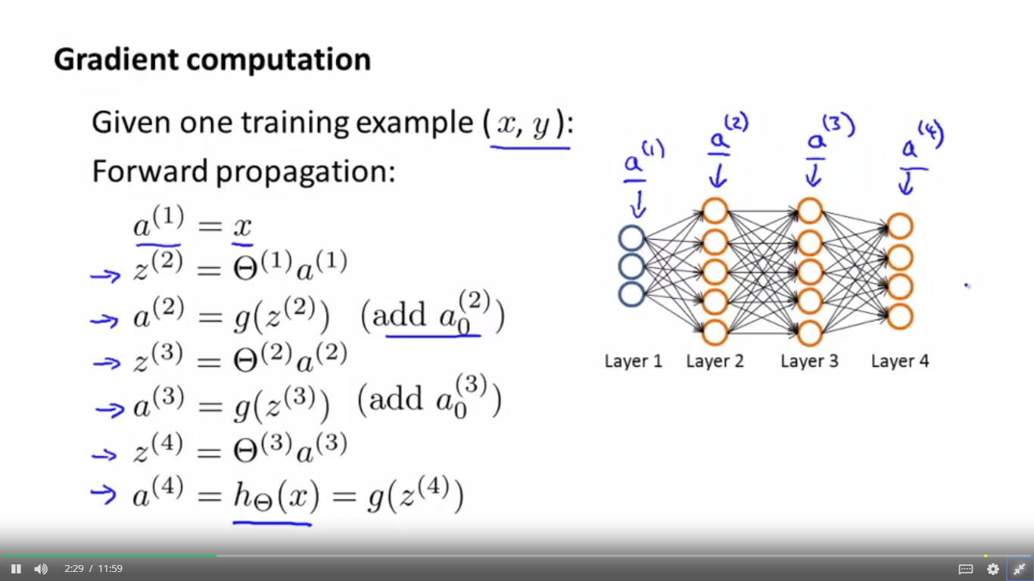

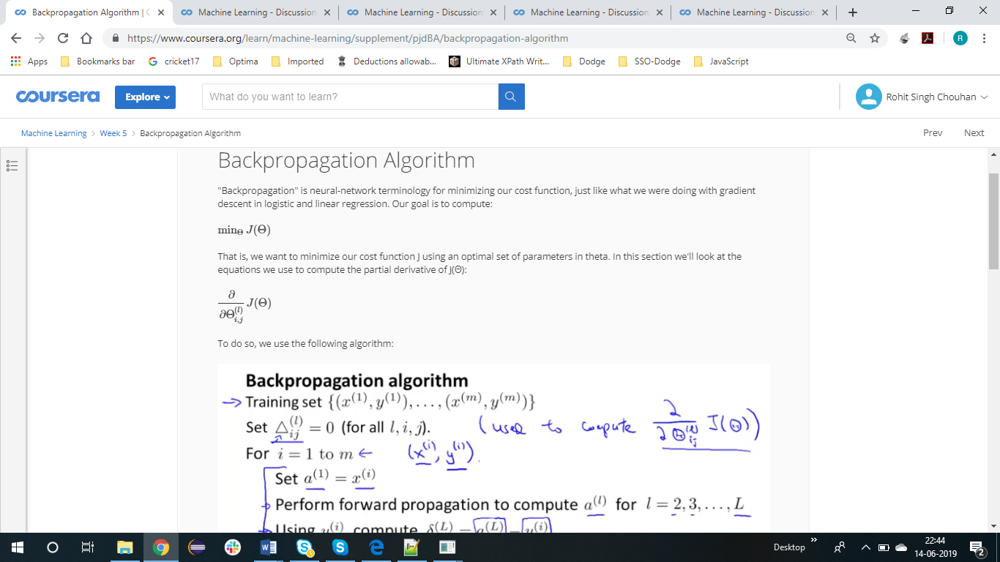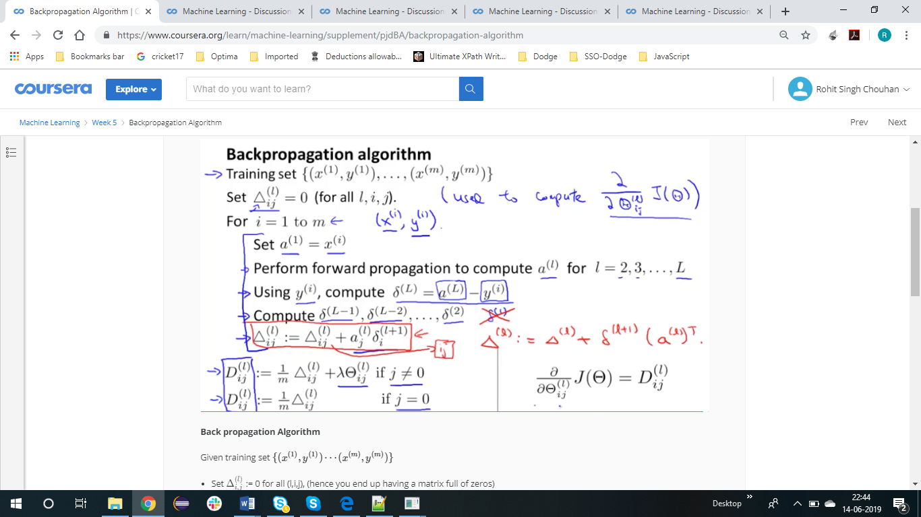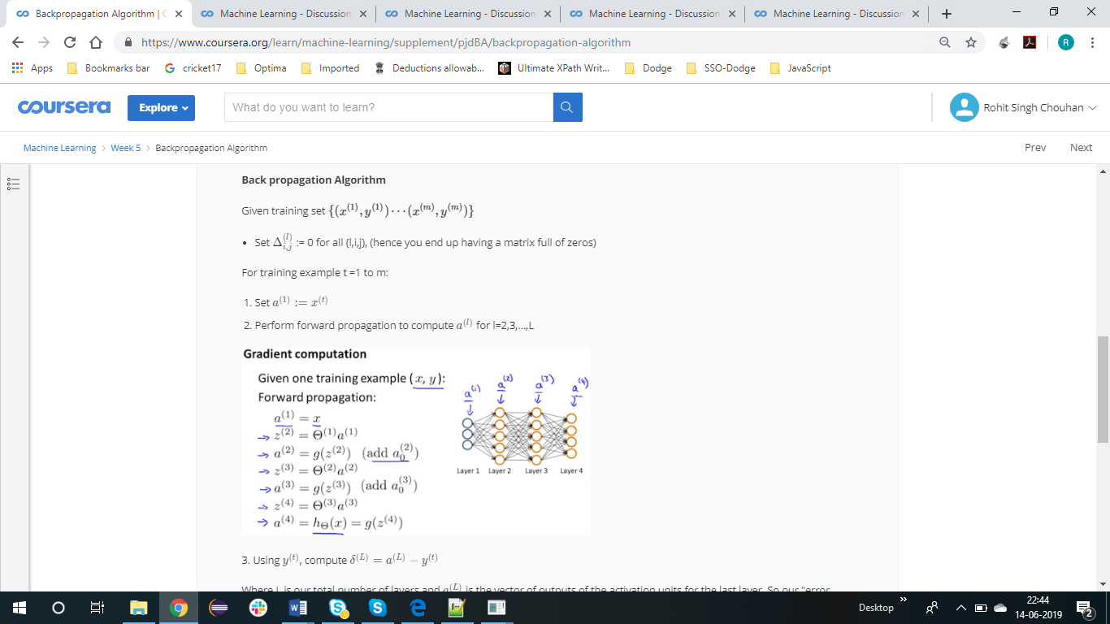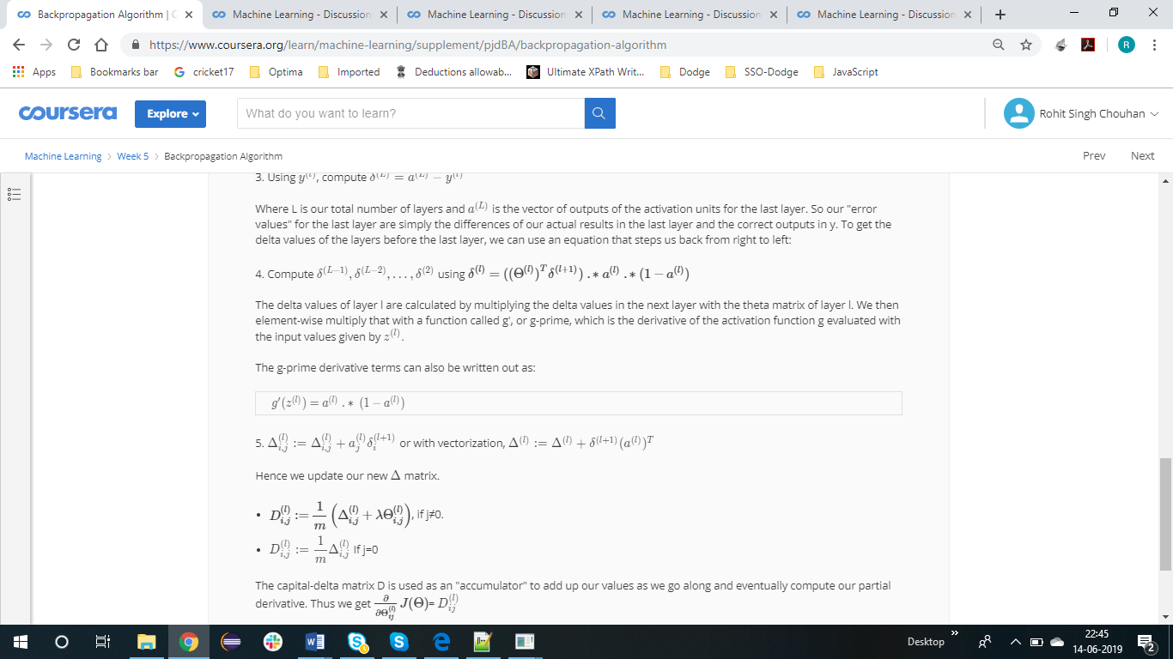

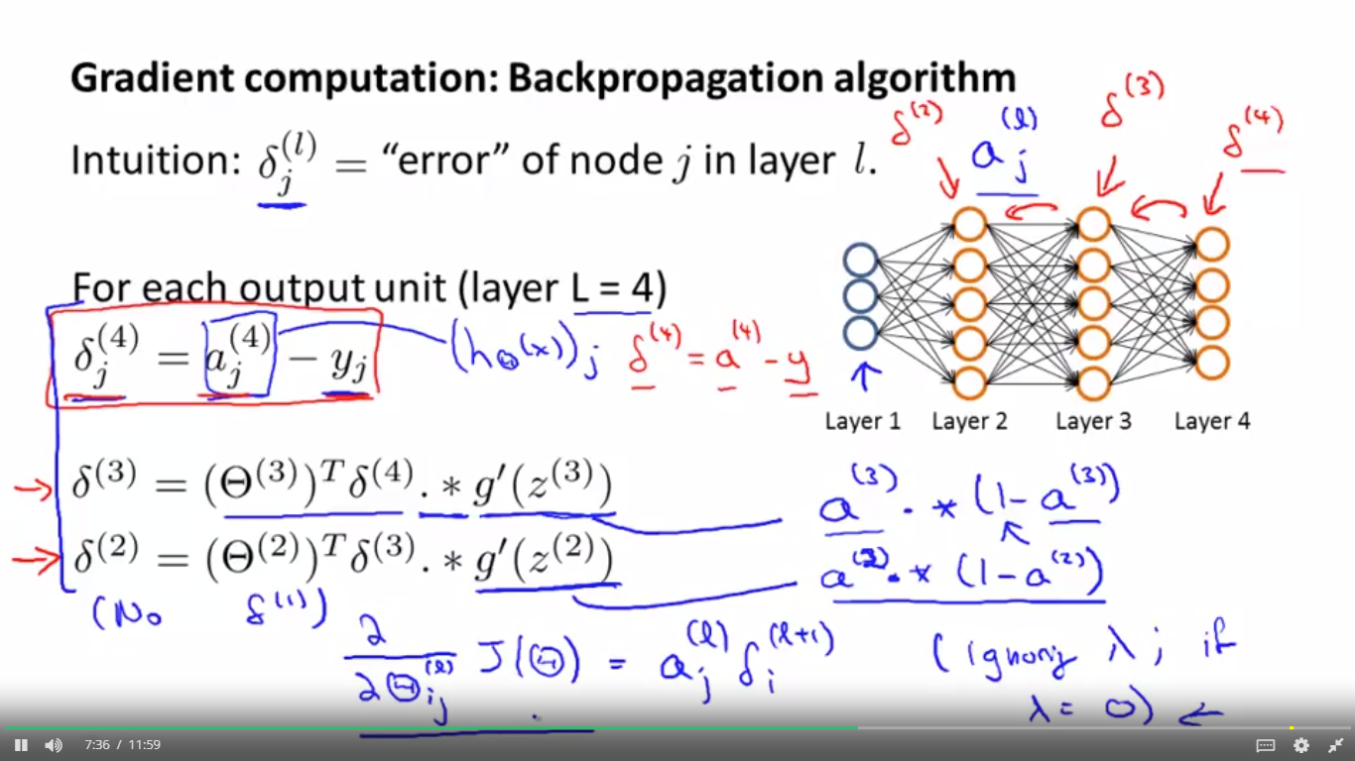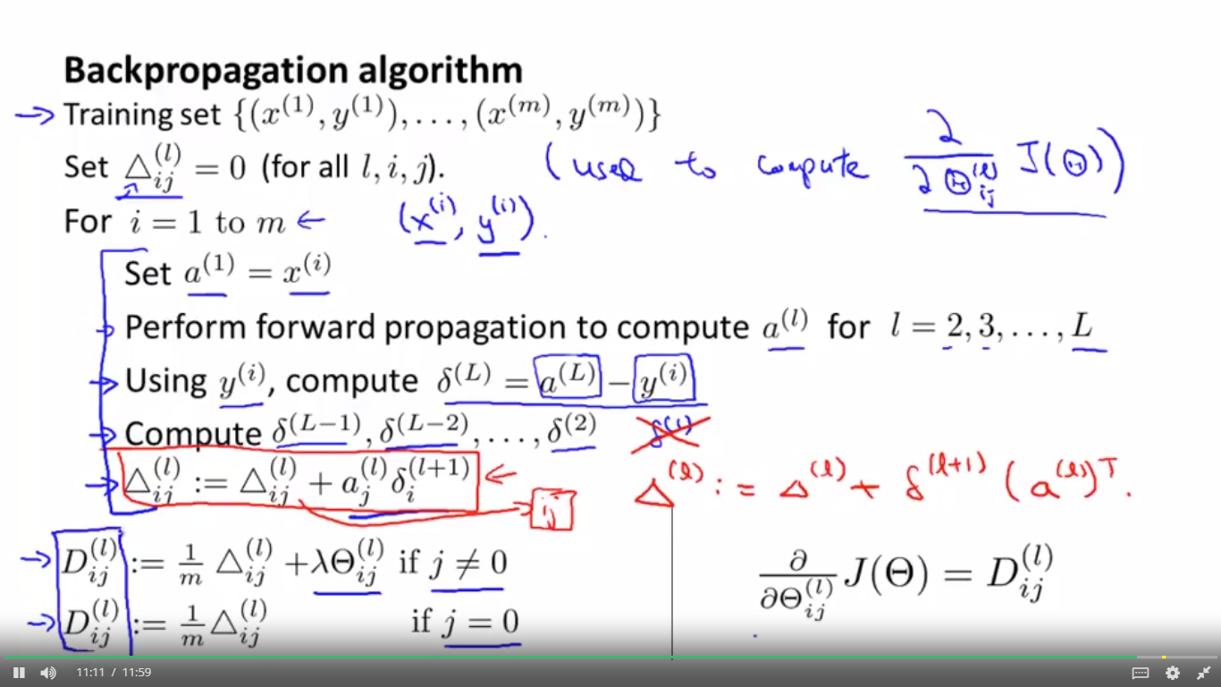

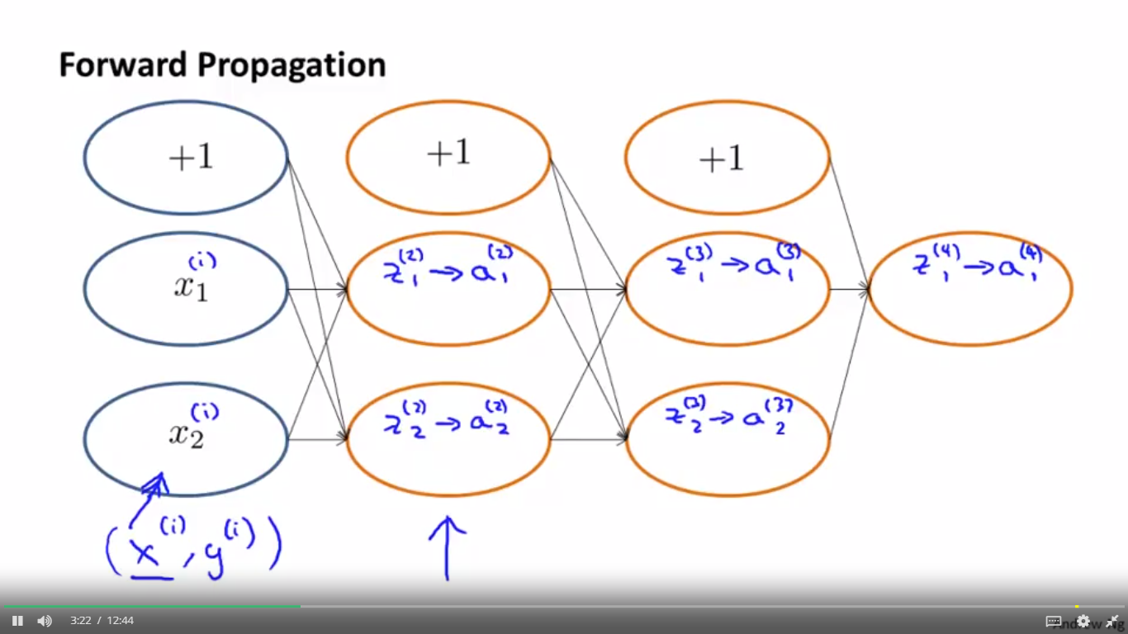

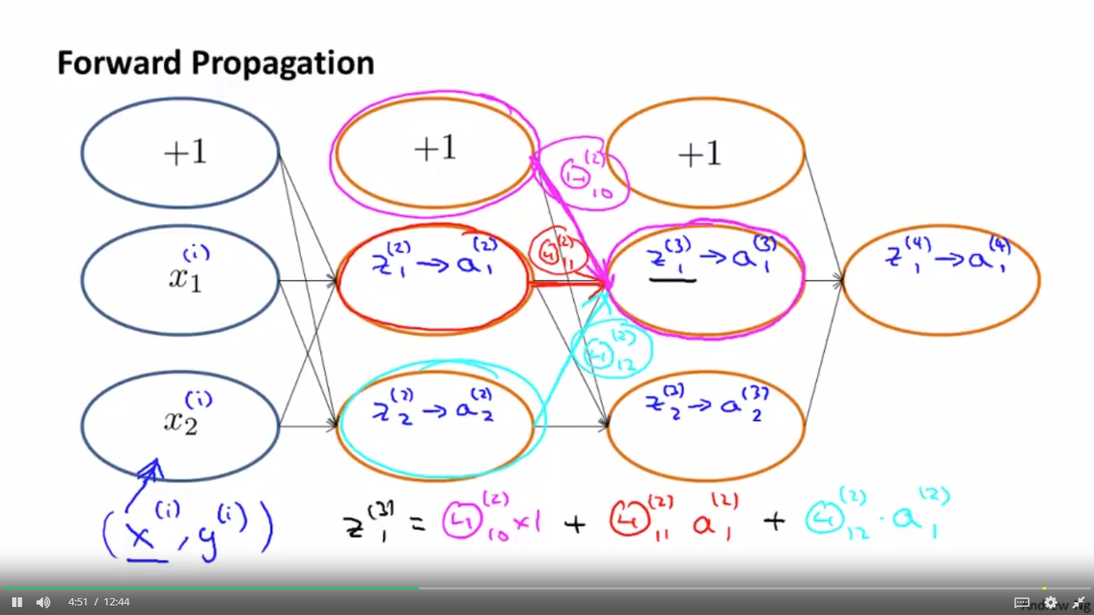

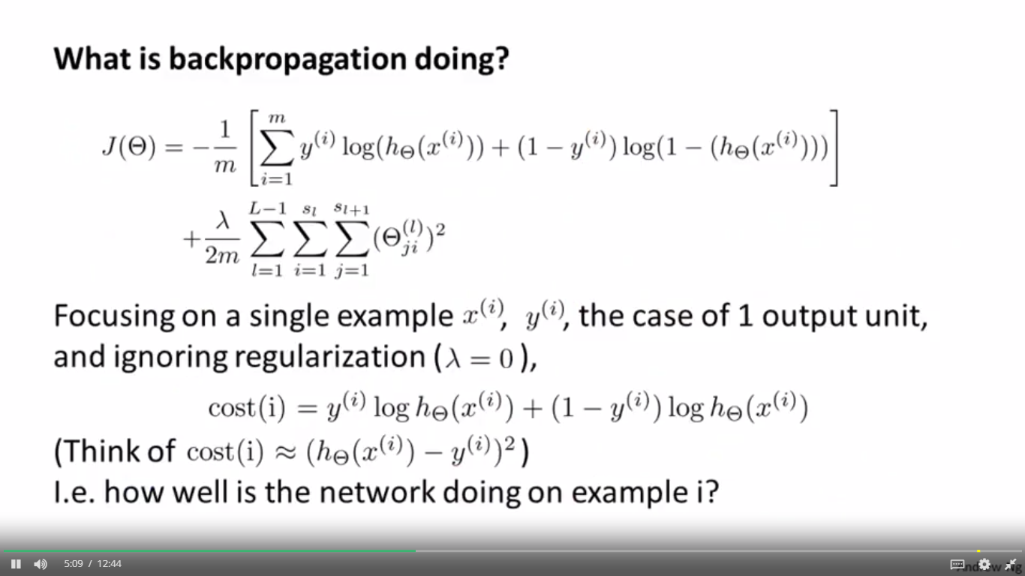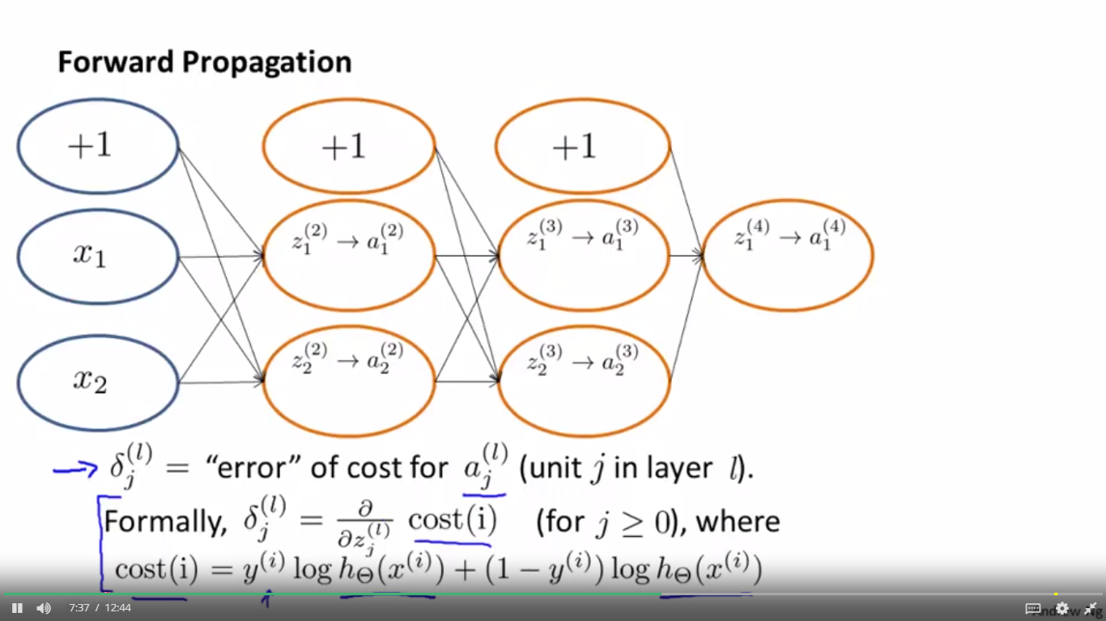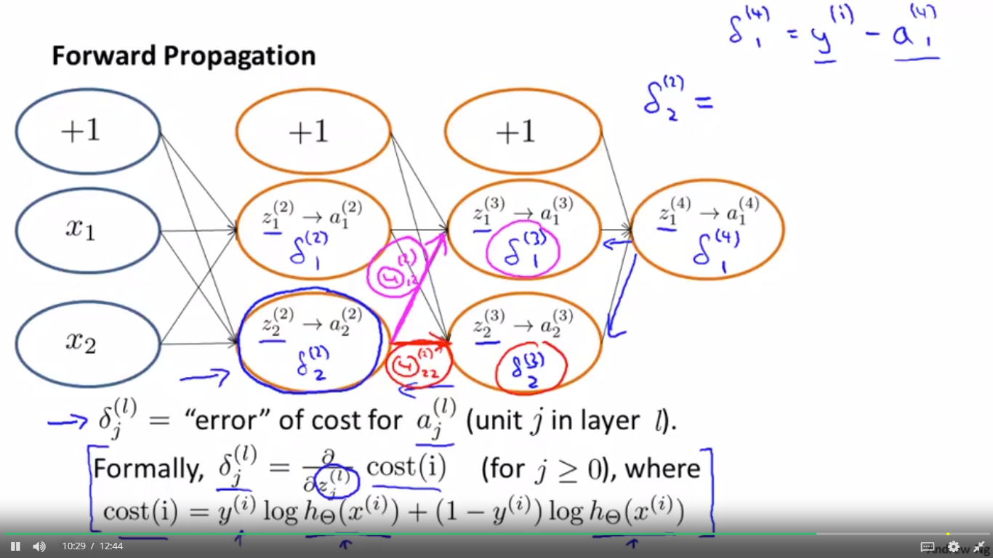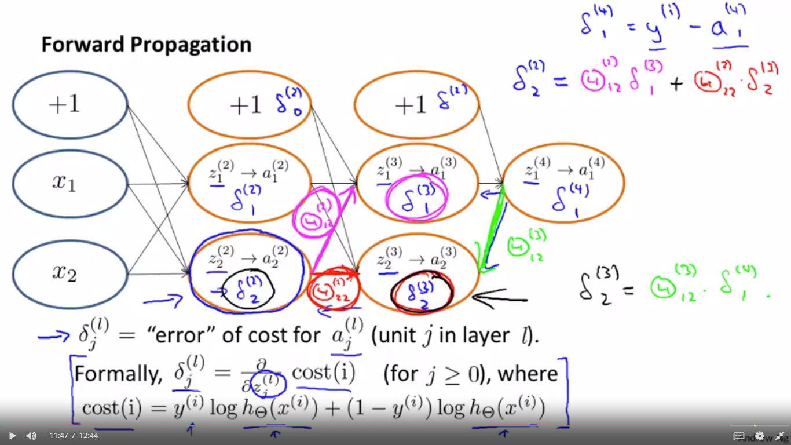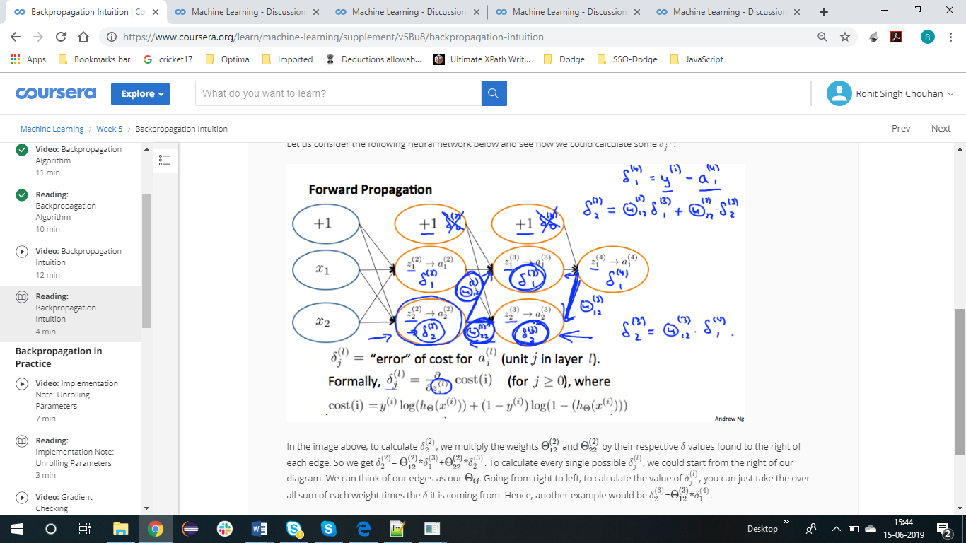

BACK PROPOGATION in PRACTICE

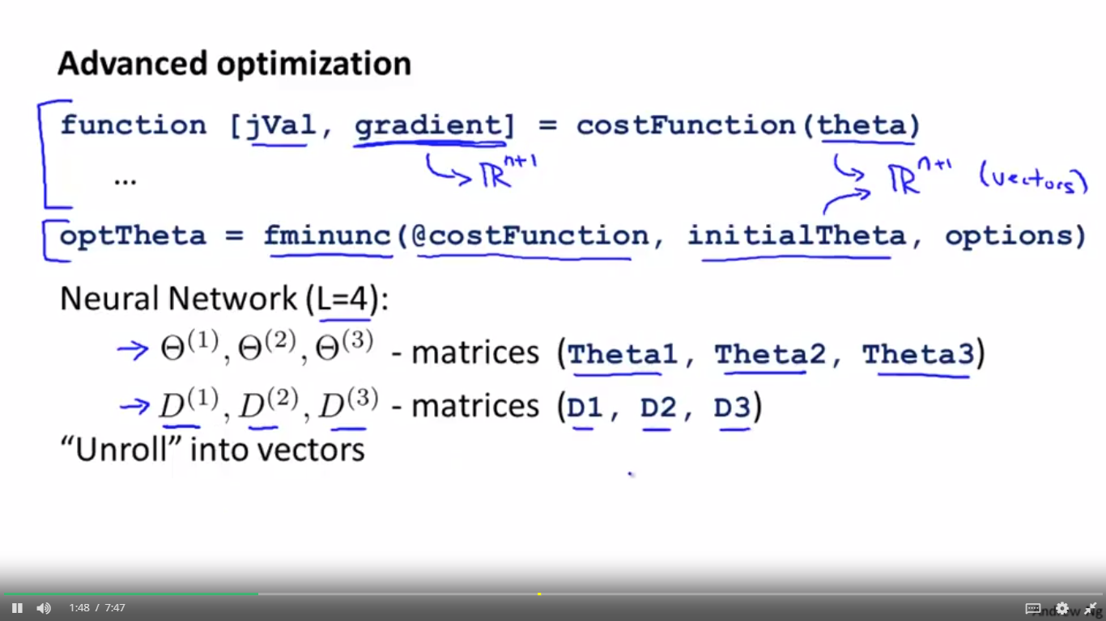

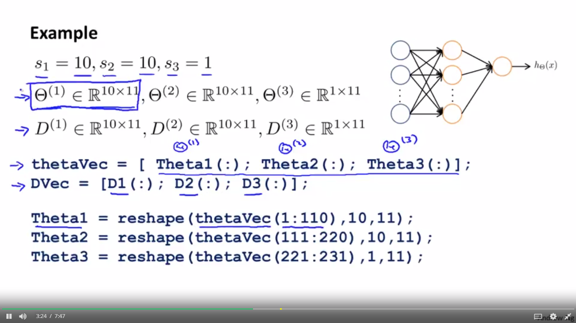

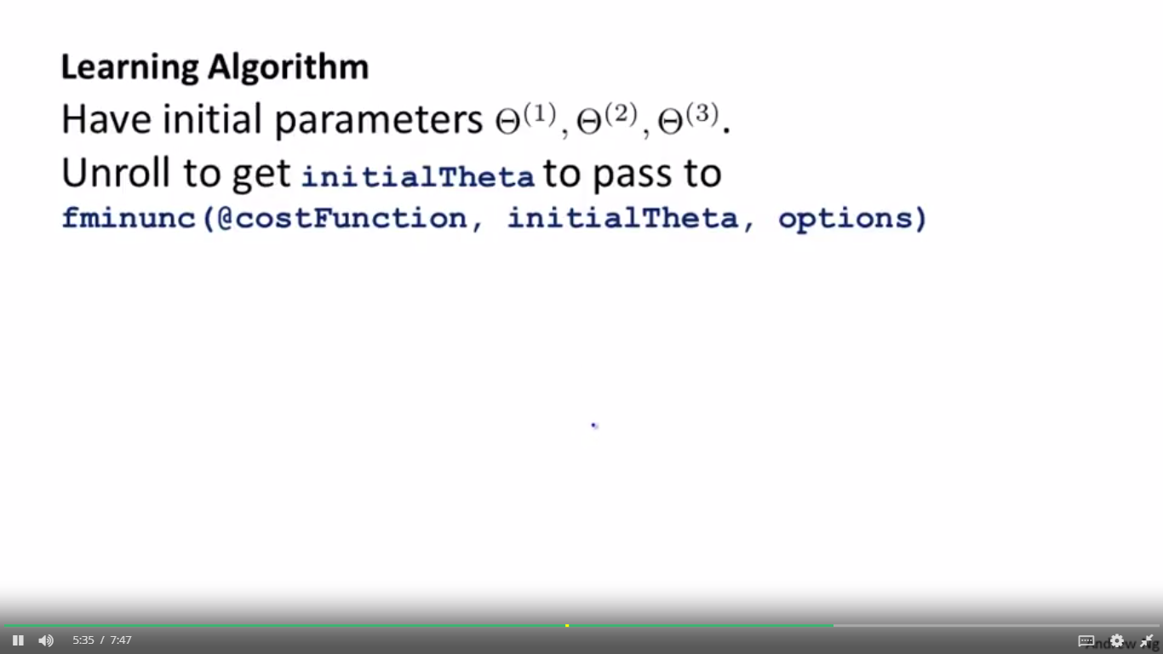

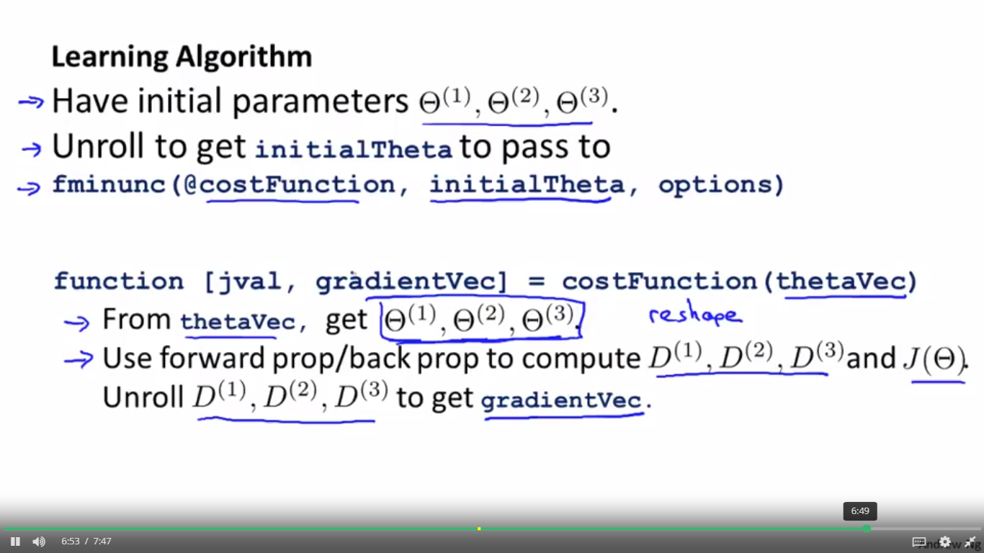

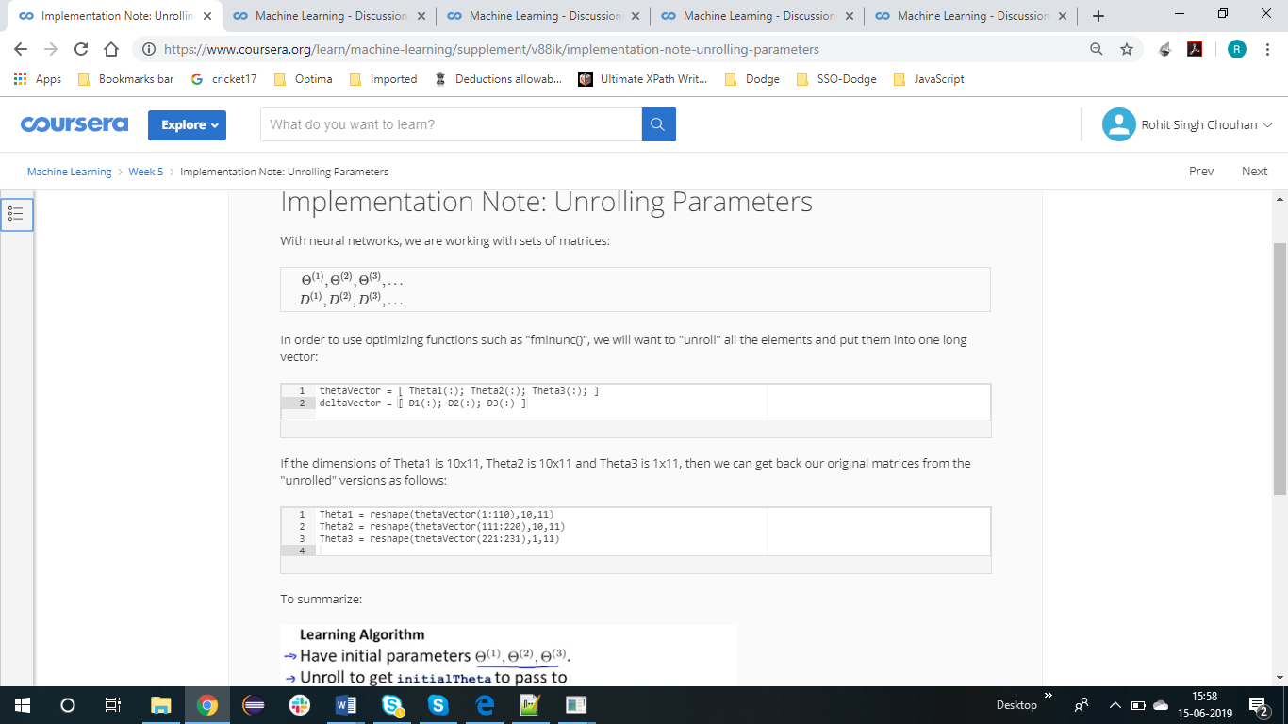

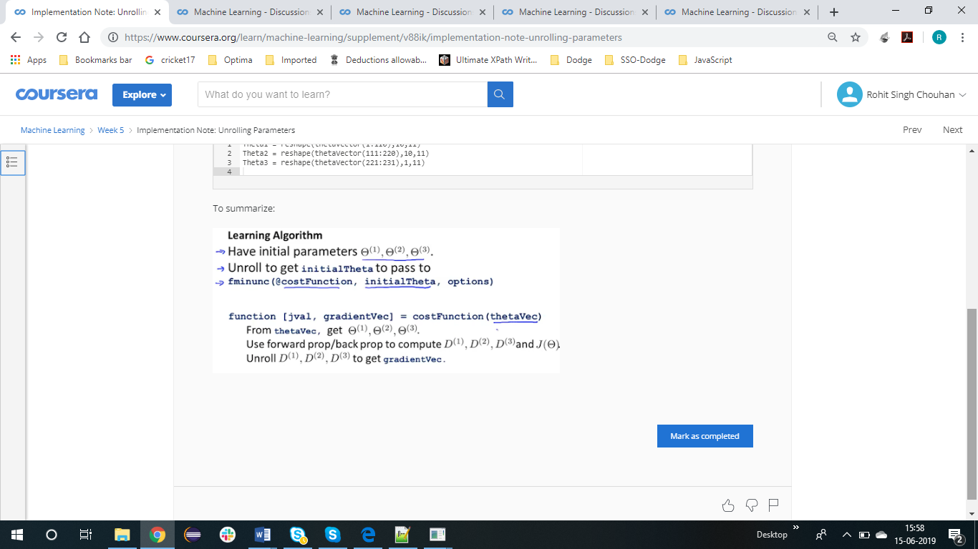

GRADIENT CHECKING

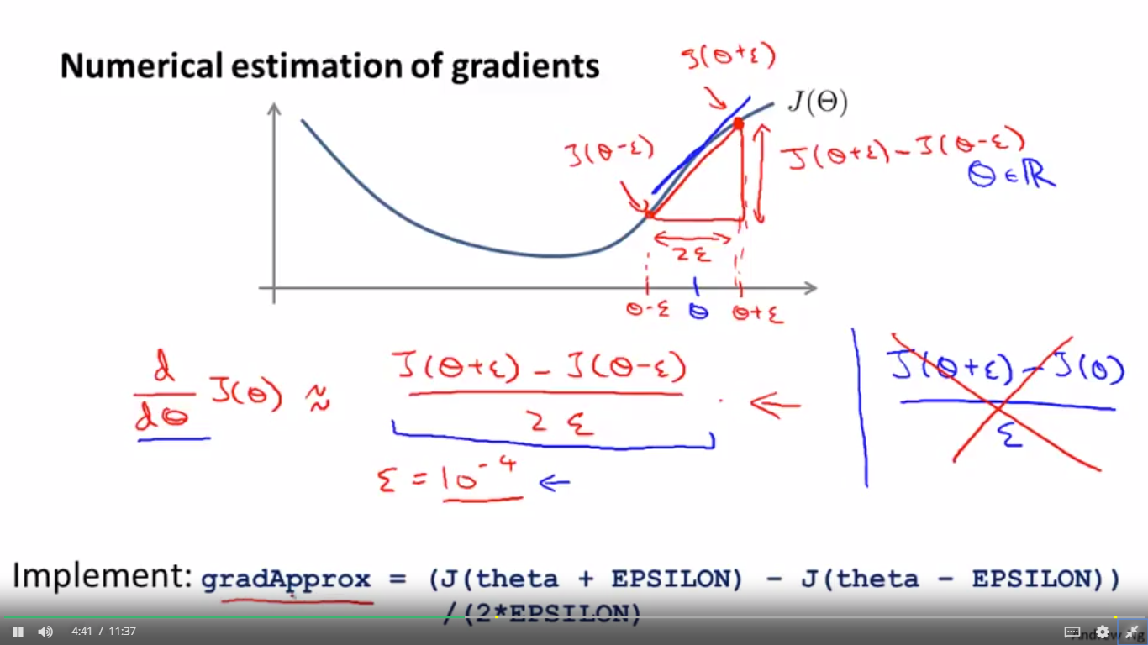

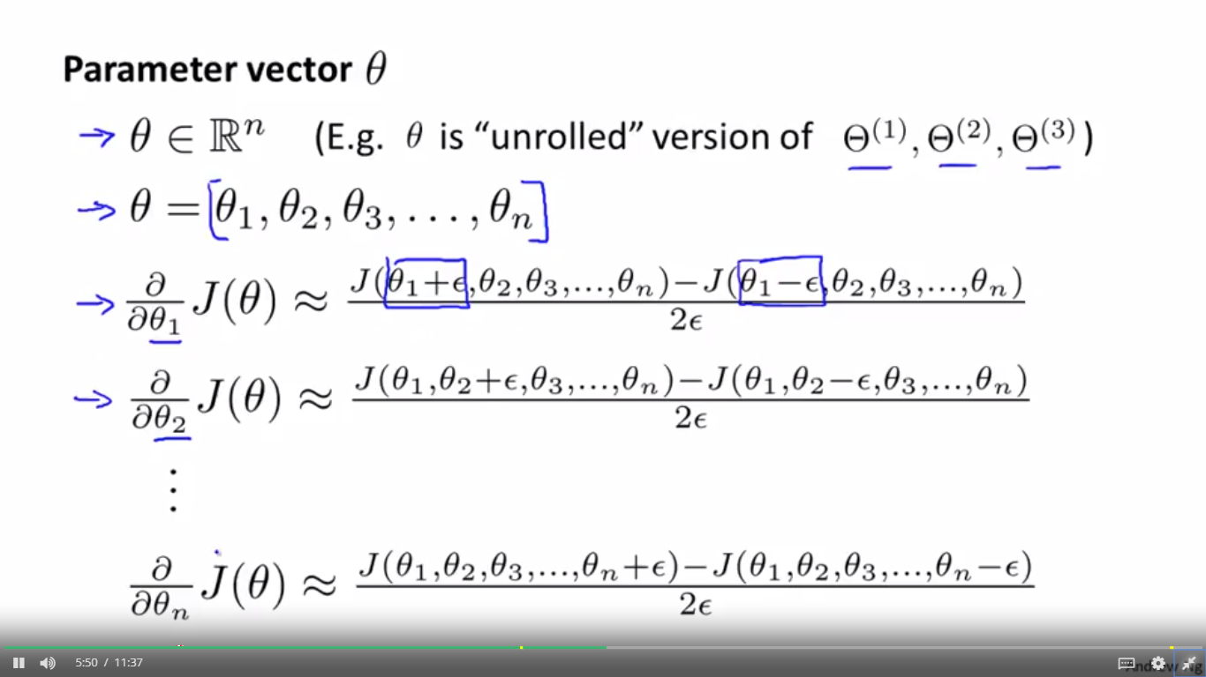

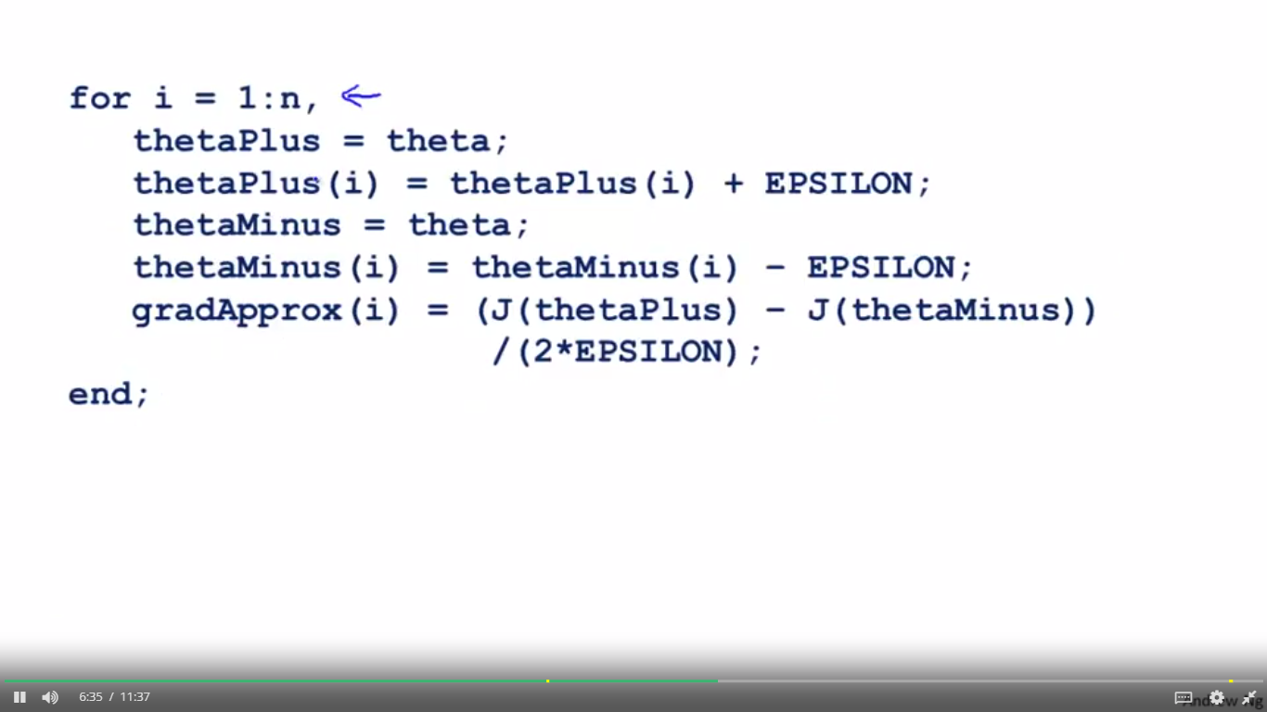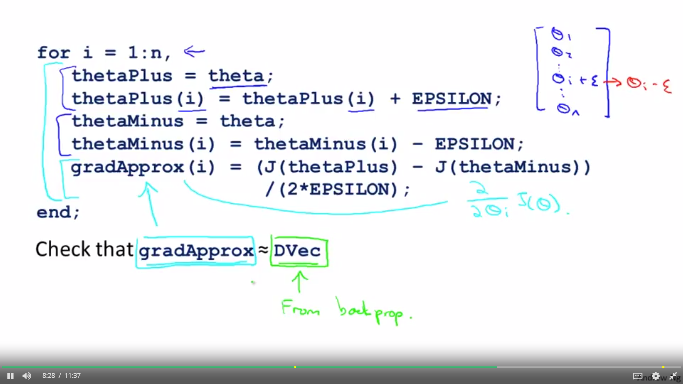

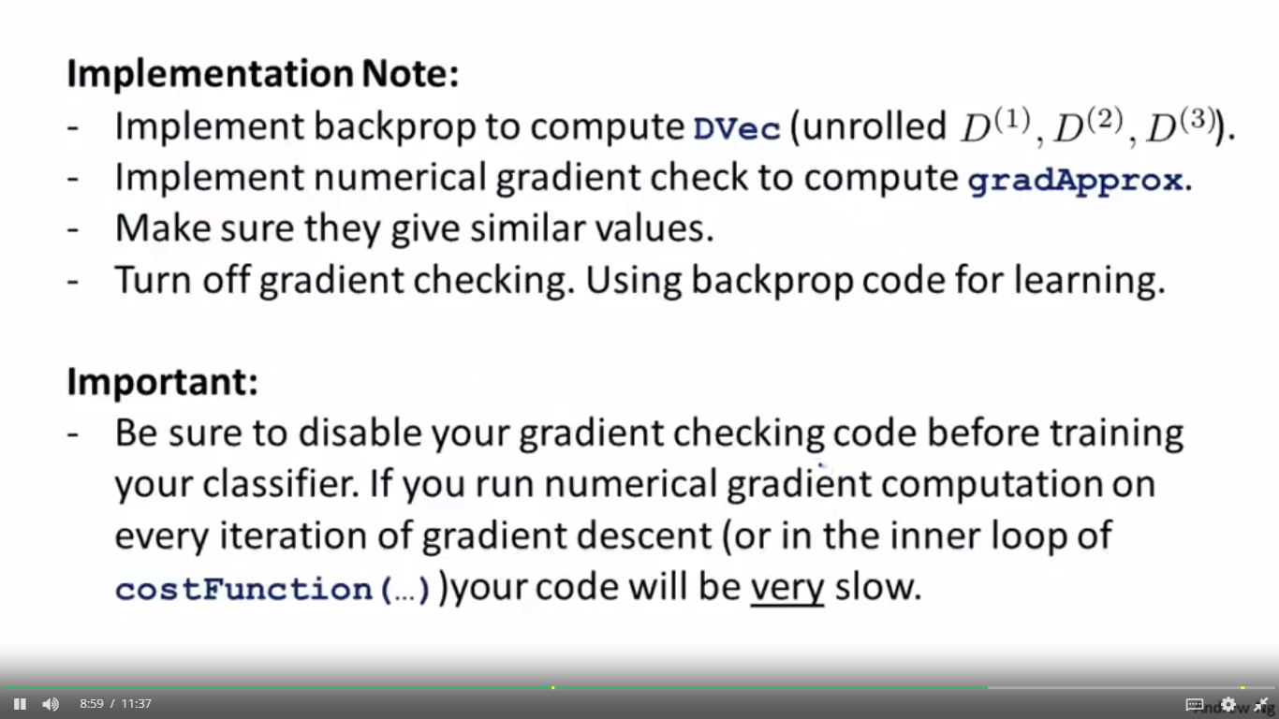

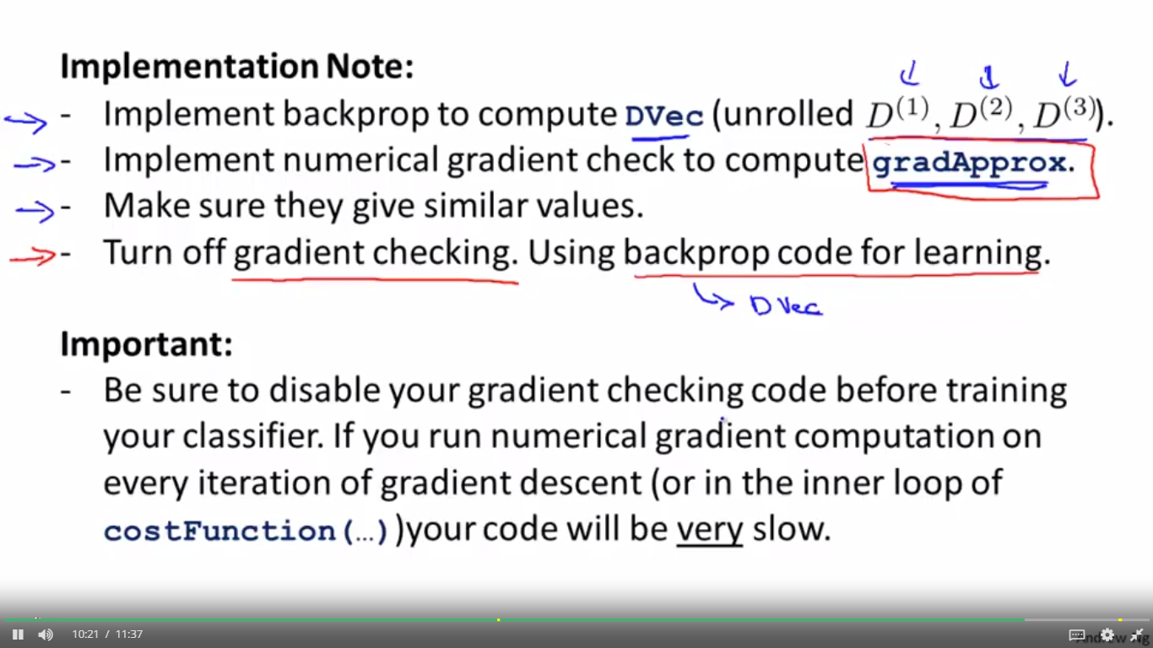



RANDOM INITIALIZATION

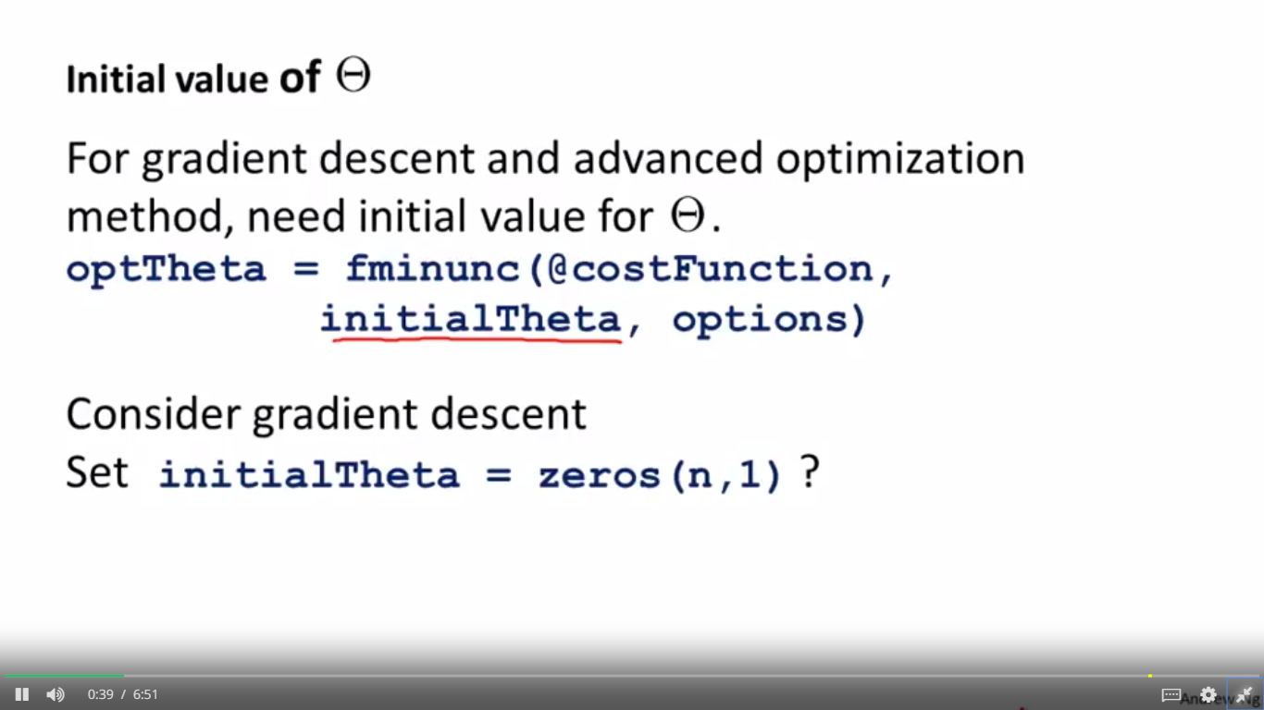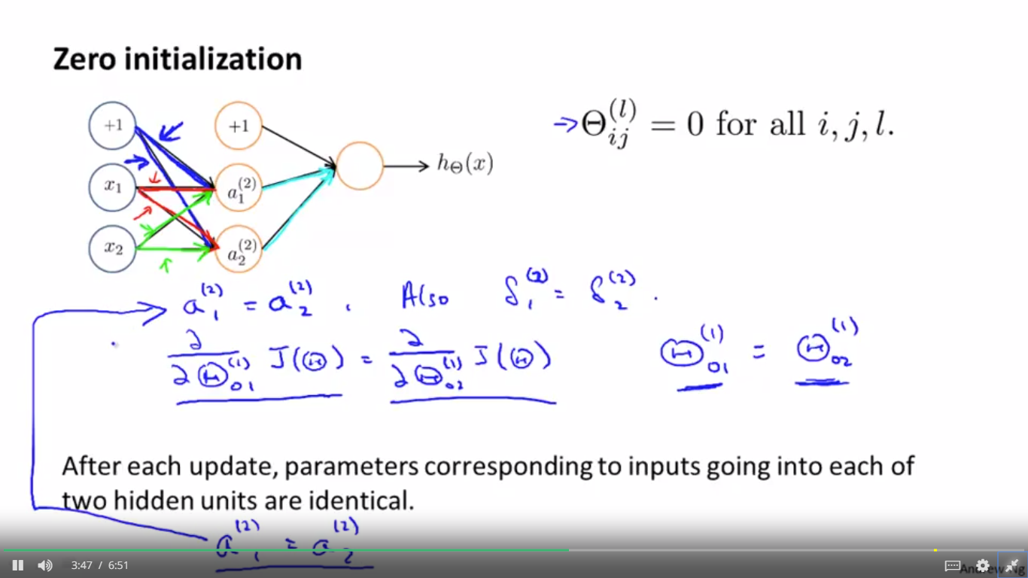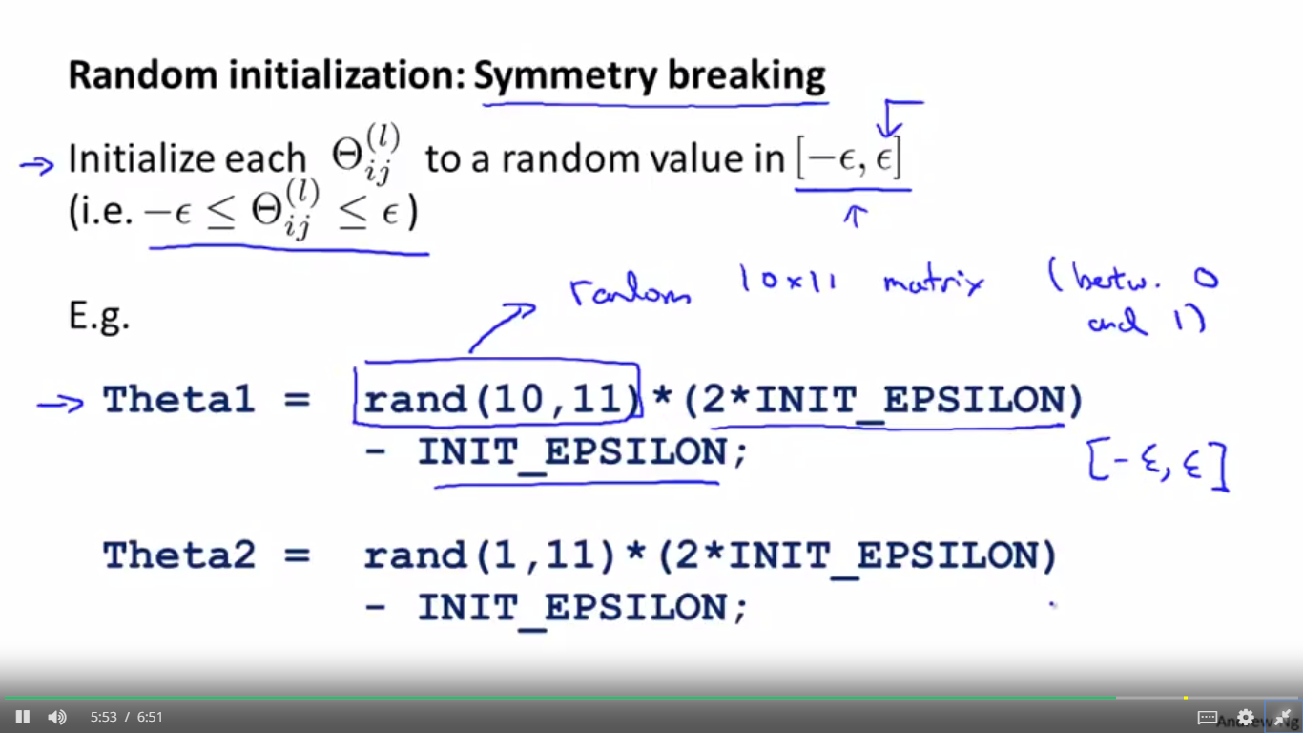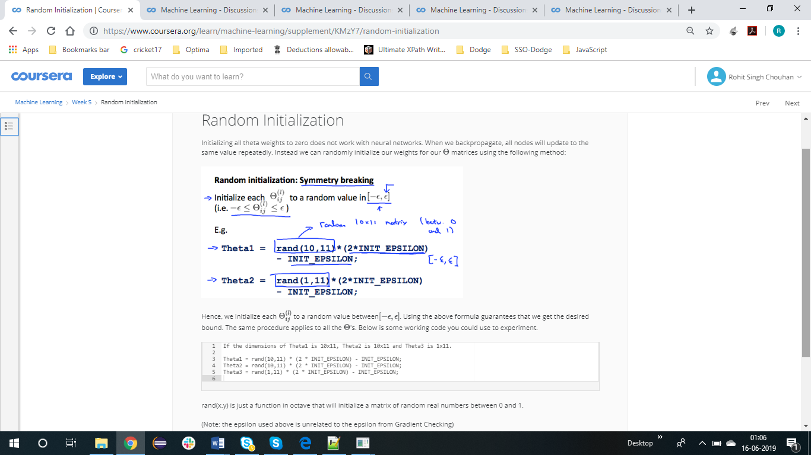

Training neual network

